

Requirement & Design Specification

FINORA - CHAIN ​​STORE MANAGEMENT SYSTEM
Version: 1.0

– Hanoi, July 2026 –

Record of Changes
Version | Date | A*  M, D | In charge | Change Description
V1.0 | 20/5/2026 | A | ChiHTH | I. Overview  1.0 Context Diagram
V1.0 | 20/5/2026 | A | ChiHTH | I. Overview  1.1 Actor
V1.0 | 20/5/2026 | A | ChiHTH | I. Overview  2.2 Screen Descriptions
V1.0 | 20/5/2026 | A | DungLD | Screen Flow
V1.0 | 20/5/2026 | A | DungLD | Use Case Description
V1.0 | 20/5/2006 | A | ThangLV | Screen Authorization
V1.0 | 18/6/2026 | A | HoangND | Filter Product
V1.0 | 18/6/2026 | A | HoangND | Search Product
V1.0 | 18/6/2026 | A | PhucNH | II. Requirement Specifications  3.1 Database Design (a, b)
V1.0 | 18/6/2026 | A | PhucNH | II. Requirement Specifications  UC-2.6 Manage Store Chain
V1.0 | 18/6/2026 | A | PhucNH | II. Requirement Specifications  2.1 UC-4.2 Create Sales Order
V1.0 | 18/6/2026 | A | PhucNH | II. Requirement Specifications  UC-4.6 Print Invoice
V1.0 | 18/6/2026 | A | PhucNH | II. Requirement Specifications  UC-4.7_Cancel Orders
V1.0 | 18/6/2026 | A | PhucNH | II. Requirement Specifications  UC-4.8_View Sales History
V1.0 | 22/6/2026 | A | ChiHTH | II. Requirement Specifications  1.1 UC-1.1 Login system
V1.0 | 22/6/2026 | A | ChiHTH | II. Requirement Specifications  1.2 UC-1.2 Logout system
V1.0 | 22/6/2026 | A | ChiHTH | II. Requirement Specifications  1.3 UC-1.3 Forgot password
V1.0 | 25/06/2026 | A | ThangLV | II. Requirement Specifications  2.6 UC-4.5 VNPay Payment
V1.0 | 25/06/2026 | A | ThangLV | II. Requirement Specifications  2.9 UC-5.3 Receive Goods
V1.0 | 25/06/2026 | A | ThangLV | II. Requirement Specifications  2.10 UC-5.7 Warehouse Transfer
V1.0 | 25/06/2026 | A | ThangLV | II. Requirement Specifications  2.11 UC-5.6 Check Inventory
V1.0 | 2/7/2026 | A | ChiHTH | II. Requirement Specifications  2.16 UC-3.14 View the store's cash book
V1.0 | 22/7/2026 | A | ThangLV | III.Design Specification  6. Category Management
V1.0 | 22/7/2026 | A | ThangLV | III.Design Specification  7. Inventory Management
V1.0 | 27/6/2026 | A | ChiHTH | Add III.Design Specification  1. Authentication
V2.0 | 21/7/2026 | M | ChiHTH | Update Context Diagram
V2.0 | 21/7/2026 | M | ChiHTH | Update Use case diagram
V2.0 | 22/7/2026 | U | ChiHTH | Update III.Design Specification  1. Authentication
V2.0 | 22/7/2026 | A | ChiHTH | Add III.Design Specification  8. Supplier Management
V2.0 | 22/7/2026 | A | ChiHTH | Add III.Design Specification  10. Cashbook
V2.0 | 22/7/2026 | A | DungLD | Add III.Design Specification  2. Customer Management  3. Employee Management  4. User Profile  5. Employee Sales Report
V2.0 | 22/7/2026 | A | PhucNH | Add III.Design Specification  9. Manage Store Chain
V2.0 | 22/7/2026 | A | PhucNH | Add III.Design Specification  14.1 Look Up Product
V2.0 | 22/7/2026 | A | PhucNH | Add III.Design Specification  14.2 Create Sales Order (POS)
V2.0 | 22/7/2026 | A | PhucNH | Add III.Design Specification  14.3 Print Invoice
V2.0 | 22/7/2026 | A | PhucNH | Add III.Design Specification  14.4 Cancel Orders
V2.0 | 22/7/2026 | A | PhucNH | Add III.Design Specification  14.5 View Sales History
V2.0 | 23/07/2026 | M | PhucNH | ERD
*A - Added M - Modified D - Deleted

Contents
Record of Changes 2
I. Overview 13
1. User Requirements 13
1.0 Context Diagram 13
1.1 Actors 13
1.2 Use Cases 14
a. Diagram(s) 14
b. Descriptions 19
2. Overall Functionalities 25
2.1 Screens Flow 25
2.1.1 Owner Screen Flow 25
2.1.2 Store Manager Screen Flow 25
2.1.3 Sales Staff Screen Flow 26
2.1.4 Warehouse Staff Screen Flow 27
2.1.5 Customer Management Flow 27
2.1.6 Product and Category Management Flow 28
2.1.7 Supplier Management Flow 30
2.1.8 Inventory Management Flow 31
2.1.9 Sales Management Flow 31
2.1.10 Cash book Flow 31
2.1.11 Report System Flow 32
2.1.12 Employee Management Flow 32
2.1.13 Branch Management Flow 33
2.2 Screen Descriptions 33
2.3 Screen Authorization 38
3. System High Level Design 41
3.1 Database Design 41
a. Database Schema 41
b. Table Descriptions 42
3.2 Code Packages 45
II. Requirement Specifications 46
1. Common Functions 46
1.1 UC-1.1 Login system 46
a. Functionalities 46
b. Business Rules 47
1.2 UC-1.2 Logout system 47
a. Functionalities 47
b. Business Rules 48
1.3 UC-1.3 Forgot Password 48
a. Functionalities 49
b. Business Rules 50
1.4 UC-1.4 Manage Staff Accounts 50
a. Functionalities 50
b. Business Rules 51
1.5 UC-1.5 View Activity Log 52
a. Functional Description 52
b. Business Rule 53
1.6 UC-2.1 View & Update Profile 53
a. Functionalities 53
b. Business Rules 55
1.7 UC-2.4 Change Password 55
a. Functionalities 55
b. Business Rules 56
1.8 UC-3.1 Manage Branch Chain 56
a. Functionalities 56
b. Business Rules 57
2. Store Operations & POS Features 58
2.1 UC-4.1 Search & Manage Product Catalog 58
a. Functionalities 58
b. Business Rules 59
2.2 UC-6.1 Manage Customers & Lookup 60
a. Functionalities 60
b. Business Rules 60
2.3 UC-7.1 Create Sales Order (POS) 61
a. Functionalities 61
b. Business Rules 62
2.4 UC-7.3 VNPay Online Payment Gateway 63
a. Functional Description 63
b. Business Rules 64
2.5 UC-7.4 Print Invoice 65
a. Functional Description 65
b. Business Rules 66
2.6 UC-7.5 View Sales History & Cancel Order 66
a. Functional Description 66
b. Business Rules 67
2.7 UC-6.7 & UC-6.8 Loyalty Point Accumulation & Redemption 68
a. Functional Description 68
b. Business Rules 69
3. Warehouse & Supplier Operations 70
3.1 UC-8.3 Receive Goods 70
a. Functional Description 70
b. Business Rules 71
3.2 UC-8.5 Warehouse Transfer 71
a. Functional Description 71
b. Business Rules 72
3.3 UC-8.7 Check & Adjust Inventory 72
a. Functional Description 72
b. Business Rules 74
4. Financials & Cashbook 74
4.1 UC-10.1 View Store Cashbook 74
a. Functional Description 74
b. Business Rules 75
4.2 UC-10.3 & UC-10.4 Create Receipt / Payment Voucher 76
a. Functional Description. 76
b. Business Rules 77
5. System Configurations 78
5.1 UC-12.1 & UC-12.2 & UC-12.3 VAT Settings Configuration 78
a. Functional Description 78
b. Business Rules 79
5.2 UC-12.5 Configure Loyalty Point Settings 79
a. Functional Description 79
b. Business Rules 80
III. Design Specifications 81
1. Authentication 81
1.1 Login 81
a. User Login 81
UI Design 81
Database Access 82
SQL Commands: 82
1.2 Forgot Password 83
a. Forgot Password 83
UI Design 83
Database Access 84
SQL Commands 84
2. Customer Management 85
2.1 Customer List 85
a. Customer List 85
UI Design 85
Database Access 87
SQL Commands 87
2.2 Create Customer 88
a. Create Customer 88
UI Design 88
Database Access 89
SQL Commands 89
2.3 Edit Customer 90
a. Edit Customer 90
UI Design 90
Database Access 91
SQL Commands 91
2.4 Delete Customer (Soft Delete) 91
a. Delete Customer 91
UI Design 92
Database Access 92
SQL Commands 93
2.5 Customer Detail 93
a. Customer Detail 93
UI Design 93
Database Access 94
SQL Commands 95
2.6 Loyalty Points Management 95
a. Sync Loyalty 95
UI Design 95
Database Access 96
SQL Commands 96
b. Redeem Points 97
UI Design 97
Database Access 98
SQL Commands 99
2.7 POS API (AJAX) 99
a. POS Customer API 99
UI Design 99
Database Access 100
SQL Commands 101
3. Employee Management 101
3.1 Employee List 101
a. Employee List 101
UI Design 101
Database Access 103
SQL Commands 103
3.2 Create Employee (Owner) 104
a. Create Employee 104
UI Design 104
Database Access 106
SQL Commands 106
3.3 Edit Employee (Owner) 106
a. Edit Employee 106
UI Design 106
Database Access 108
SQL Commands 108
3.4 Lock/Unlock Employee ( ) 108
a. Lock/Unlock Employee 108
UI Design 108
Database Access 109
SQL Commands 109
3.5 Employee List (StoreManager) 110
a. Employee List (StoreManager) 110
UI Design 110
Database Access 111
SQL Commands 111
3.6 Employee View Profile 111
a. Employee View Profile 111
UI Design 111
Database Access 112
SQL Commands 113
4. User Profile 113
4.1 View Profile 113
a. View Profile 113
UI Design 113
Database Access 115
SQL Commands 115
4.2 Update Profile 116
a. Update Profile 116
UI Design 116
Database Access 117
SQL Commands 118
4.3 Change Password 118
a. Change Password 118
UI Design 118
Database Access 119
SQL Commands 120
4.4 Avatar Upload 120
a. Avatar Upload 120
UI Design 120
Database Access 121
SQL Commands 121
5. Employee Sales Report 122
5.1 Employee Sales Report Screen 122
UI Design 122
Database Access 123
SQL Commands 124
5.2 PDF Export 126
a. PDF Export 126
UI Design 126
Database Access 127
SQL Commands 128
6. Category Management 128
6.1 Category List 128
a. Category List 128
UI Design 128
Database Access 129
SQL Commands 129
6.2 Create Category 130
a. Create Category 130
UI Design 131
Database Access 131
SQL Commands 131
6.3 Edit Category 132
a. Edit Category 132
UI Design 132
Database Access 133
SQL Commands 133
6.4 Delete Category 133
a. Delete Category 133
UI Design 133
Database Access 134
SQL Commands 134
7. Inventory Management 134
7.1 Stock Management & Low Stock Alert 134
a. Stock Management & Low Stock Alert 135
UI Design 135
Database Access 136
SQL Commands 136
7.2 Stock Import, Export & Excel Bulk Intake 137
a. Stock Import, Export & Excel Bulk Intake 137
UI Design 137
Database Access 138
SQL Commands 139
7.3 Stock Transfer Management 139
a. Stock Transfer Management 139
UI Design 139
Database Access 141
SQL Commands 141
7.4 Inventory Audit / Check 142
a. Inventory Audit / Check 142
UI Design 142
Database Access 143
SQL Commands 144
7.5 Approval Dashboard & Pending Vouchers 144
a. Approval Dashboard & Pending Vouchers 144
UI Design 144
Database Access 145
SQL Commands 146
7.6 Transaction History & Stock Audit Trail 146
a. Transaction History & Stock Audit Trail 146
UI Design 146
Database Access 147
SQL Commands 148
8. Supplier Management 148
8.1 Supplier List 148
a.Supplier list 148
UI Design 149
Database Access 150
SQL Commands 150
8.2 Create Supplier 152
a.Add supplier 152
UI Design 152
Database Access 153
SQL Commands 153
8.3 Edit Supplier 153
a.Edit supplier 153
UI Design 153
Database Access 154
SQL Commands 154
8.4 Delete Supplier 155
a.Delete supplier 155
UI Design 155
Database Access 156
SQL Commands 156
8.5 Supplier product management 156
a.Product supplier 156
UI Design 157
Database Access 158
SQL Commands 158
8.6 Export data to Excel 158
a.Export data 158
UI Design 158
Database Access 159
SQL Commands 159
9. Manage Store Chain 160
9.1 List & search 160
UI Design 160
Database Access 163
SQL Commands 163
9.2 Create & edit 166
UI Design 167
Database Access 169
SQL Commands 169
9.3 Delete branch (delete-modal.jsp) 171
UI Design 172
Database Access 172
SQL Commands 173
9.4 Detail & report. 173
Database Access 176
SQL Commands 176
10. Cashbook 178
10.1 View List 178
a. View list cashbook 178
UI Design 178
SQL Commands 179
10.2 Create a cash receipt 182
UI 182
10.3 Create payment 183
UI 183
Database Access 183
SQL Commands 184
11. Product Management 187
11.1 Product List 187
a. Product List 187
UI Design 187
Database Access 188
SQL Commands 188
11.2 Add Product 189
a. Add Product 189
UI Design 190
Database Access 190
SQL Commands 191
11.3 Edit Product 191
UI Design 192
Database Access 192
SQL Commands 193
11.4 Delete Product 193
Database Access 193
SQL Commands 193
11.5 Product Detail 194
Database Access 194
SQL Commands 194
11.6 Search Product (POS) 194
Database Access 194
SQL Commands 195
12. System Log 195
12.1 Activity Log List 195
UI Design 195
Database Access 197
SQL Commands 197
12.2 Auto Activity Logging 198
Database Access 198
SQL Commands 199
13. System Configuration 199
13.1 VAT Setting 199
a. VAT Configuration 199
UI Design 199
Database Access 200
SQL Commands 200
13.2 Loyalty Point Setting 201
a. Loyalty Point Configuration 201
UI Design 202
Database Access 202
SQL Commands 202
14. Sale (POS) 203
14.1 Look Up Product 203
UI Design 203
Database Access 203
SQL Commands 204
14.2 Create Sales Order (POS) 205
UI Design 205
Database Access 207
SQL Commands 208
14.3 Print Invoice 211
UI Design 211
Database Access 213
SQL Commands 213
14.4 Cancel Orders 214
UI Design 215
Database Access 216
SQL Commands 216
14.5 View Sales History 219
UI Design 219
Database Access 221
SQL Commands 221
15. VNPay Payment Gateway 223
15.1 Create Payment URL 223
a. Create Payment URL 223
UI Design 223
Database Access 224
Logic / Processing 224
15.2 Return Handler 225
a. Return Handler (Callback) 225
UI Design 225
Database Access 225
Logic / Processing 226
15.3 Payment Result 227
a. Payment Result Display 227
UI Design 227
Database Access 228
IV. Appendix 228
1. Assumptions & Dependencies 228
1.1 Assumptions 228
1.2 Dependencies 228
2. Limitations & Exclusions 229
3. Business Rules 230

I. Overview

1. User Requirements

1.0 Context Diagram
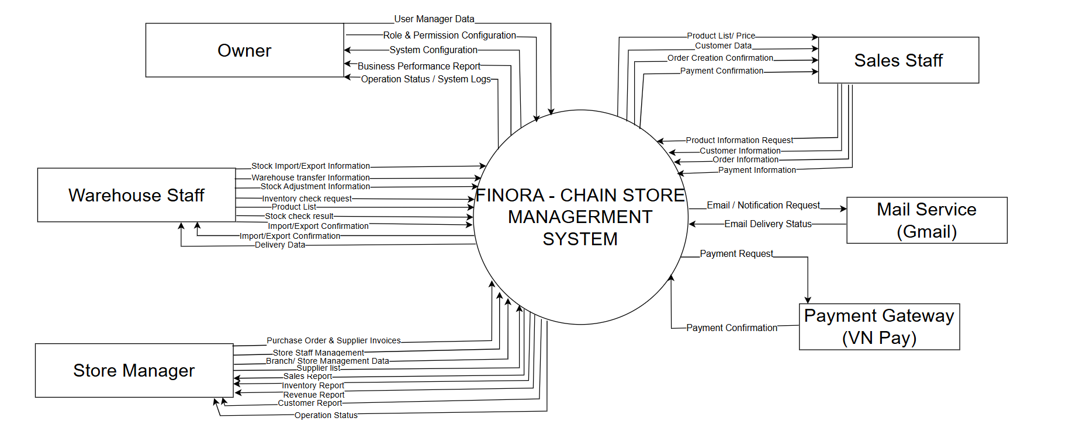
contextdiagram

1.1 Actors
# | Actor | Description
1 | Shop Owner | The business owner with the highest authority. Responsible for managing user accounts, configuring roles/permissions, system settings, and monitoring system audit logs. Monitors overall chain performance, reviews business reports
2 | Store Manager | Manage daily operations, personnel, and inventory at a specific branch. Responsible for approving purchase orders, entering supplier invoices, and analyzing branch sales reports.
3 | Sales Staff | Handles point-of-sale (POS) sales transactions, registers customers, applies promotions/vouchers, and processes retail payments at the counter.
4 | Warehouse Staff | Manages physical warehouse stock, handles goods receipt (entered from delivery notes) and delivery, performs inventory checks, and processes stock transfers.
5 | Payment Gateway (VN Pay) | [External Actor] An external system that processes electronic transactions and returns payment confirmations to the system.
6 | Mail Service (Gmail) | [External Actor] An external service provider used by the system to deliver notifications and emails to users.

1.2 Use Cases

a. Diagram(s)
-Overall Usecase Diagram
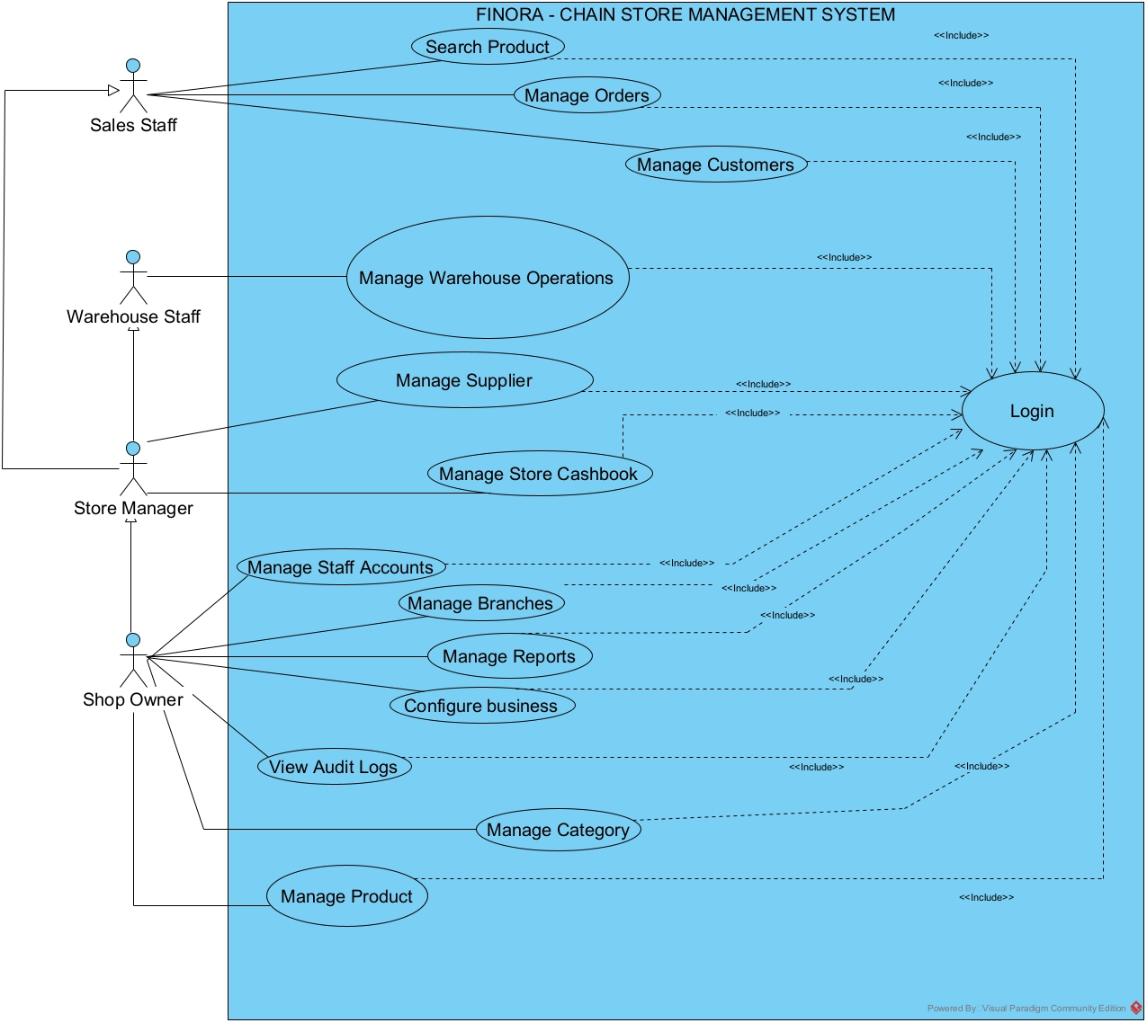

- POS & Customer Subsystem Usecase
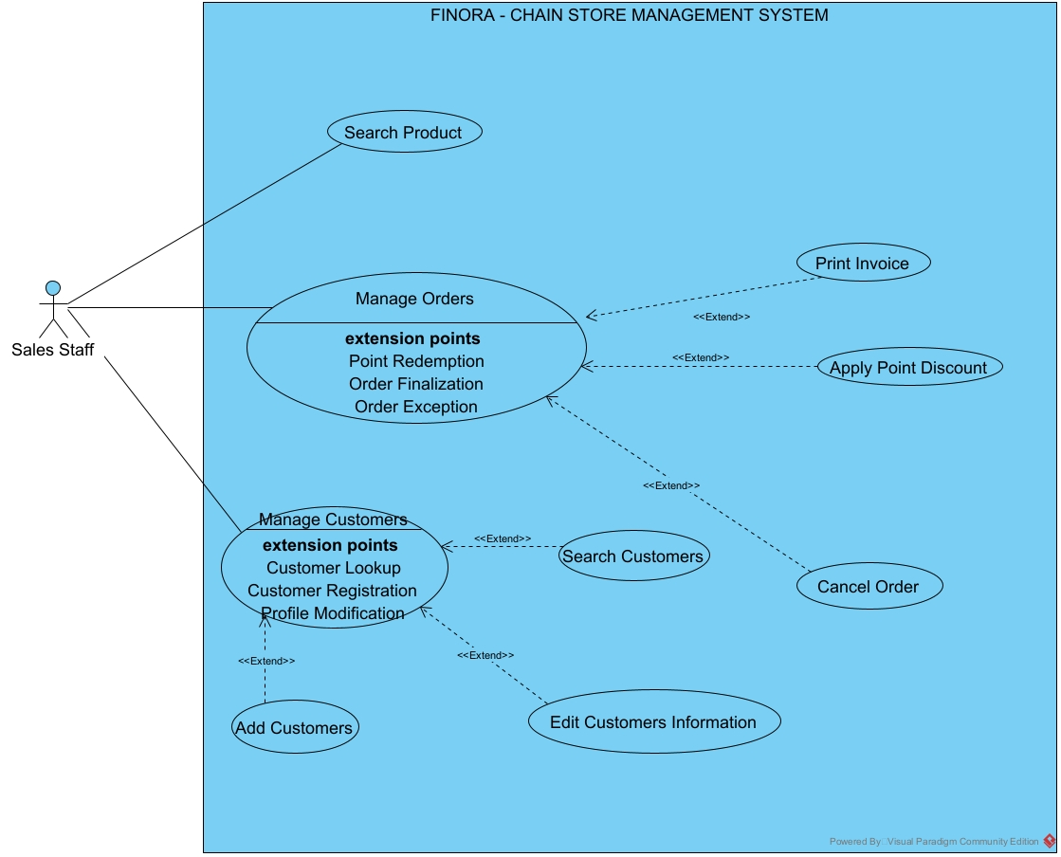

- Warehouse & Supplier Subsystem Usecase
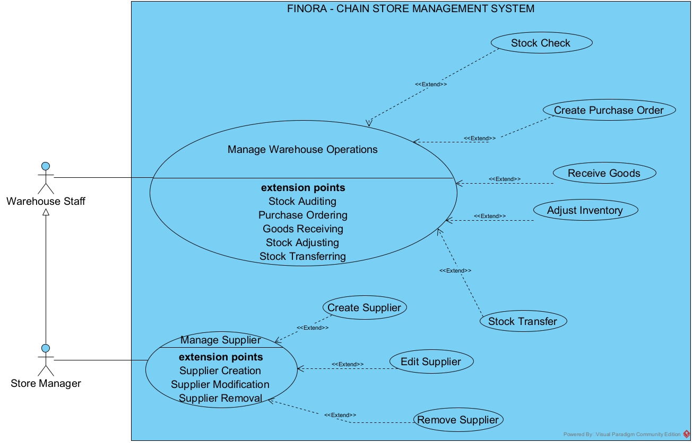

-Product & Category Subsystem Usecase

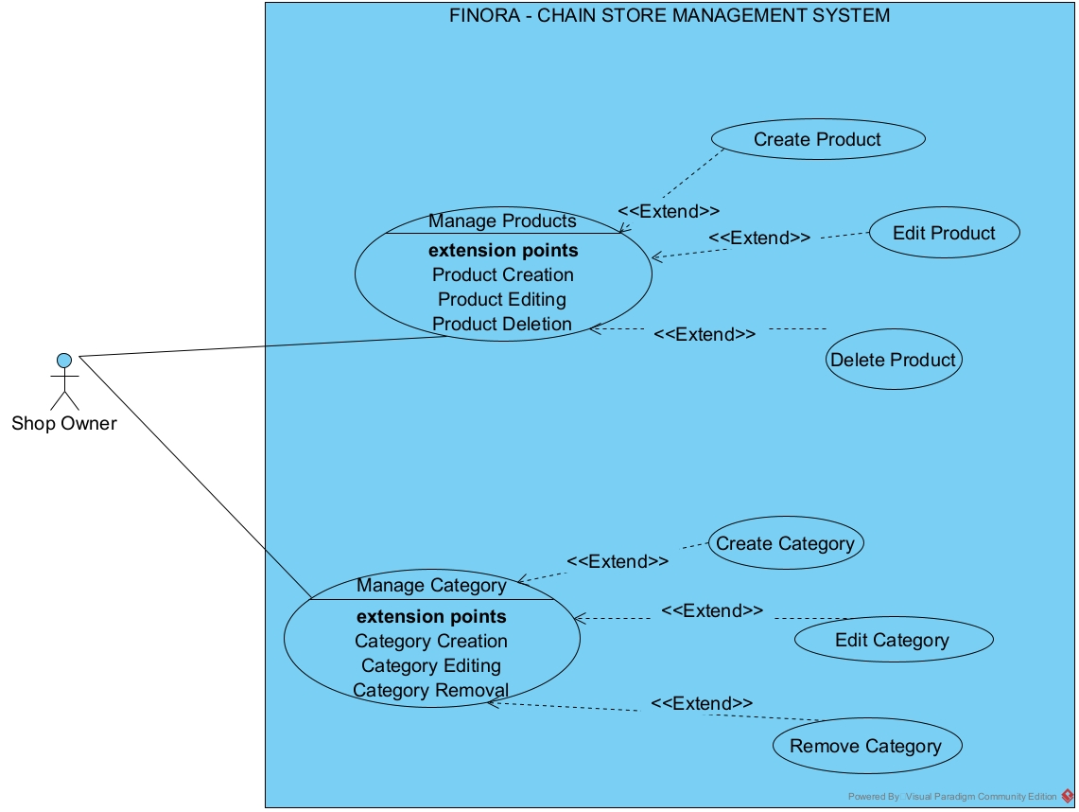

-Financials & Reports Subsystem UseCase
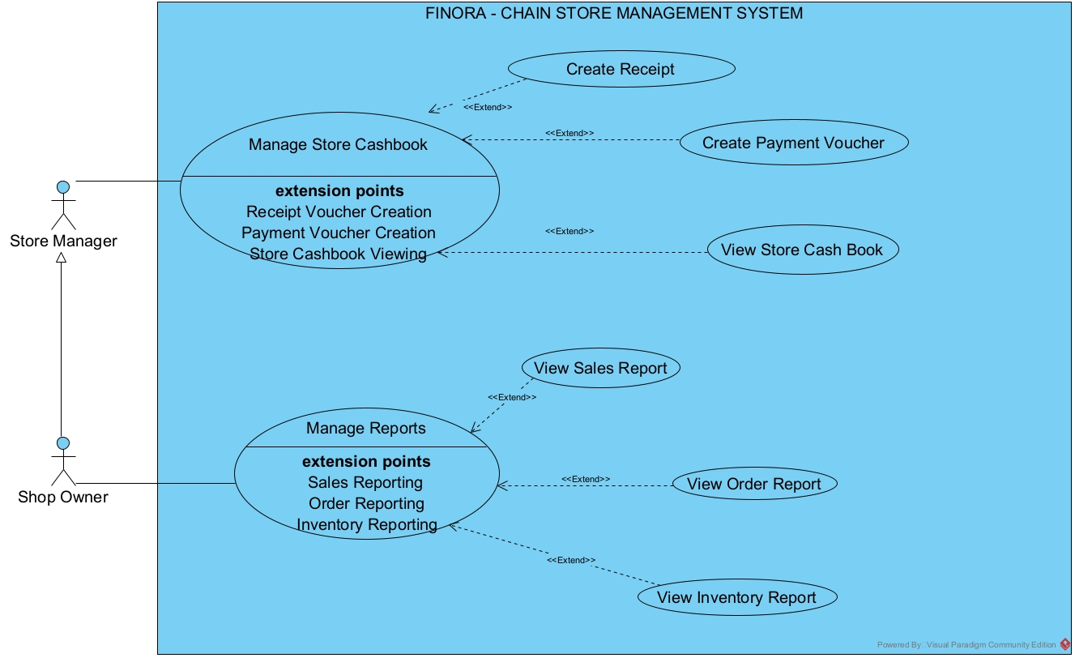

- System & Subsystem Usecase
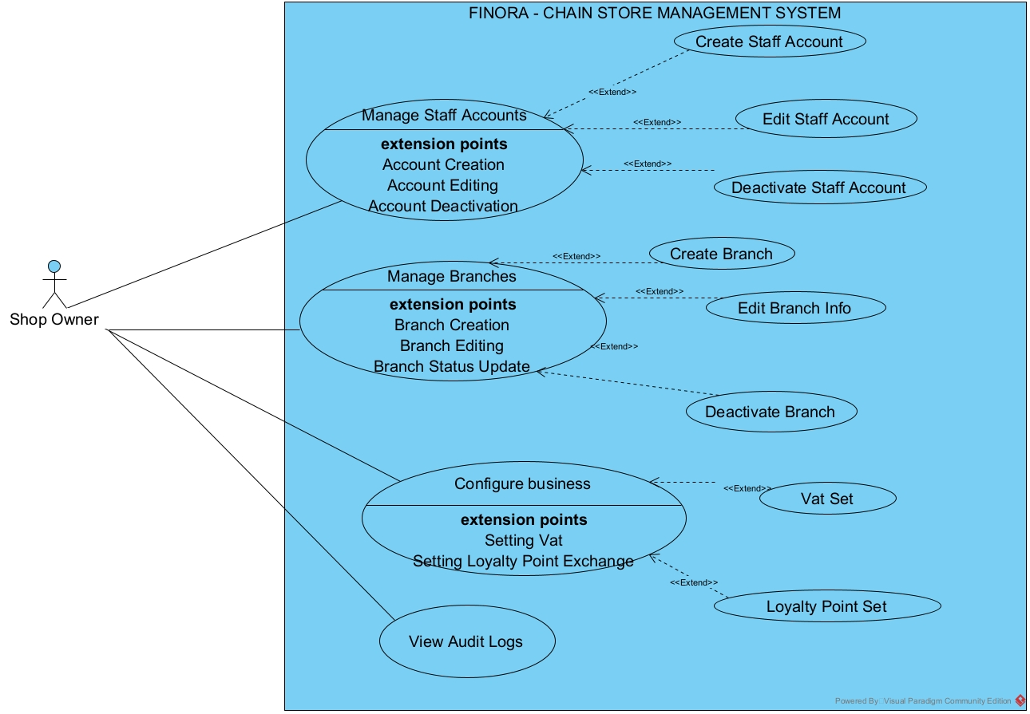

b. Descriptions

ID | Feature | Use Case | Primary Actor | Use Case Description
UC-1.1 | Authentication | Login | All Users | Users log into the system using email/phone and password to access authorized features based on role and branch.
UC-1.2 | Authentication | Logout | All Users | Users securely end their current working session and return to the Login screen.
UC-1.3 | Authentication | Forgot Password | All Users | Users recover account access via an email verification process that sends an auto-generated password.
UC-1.4 | Employee Management | View Employee List | Owner, Store Manager | Owner views all employee accounts across all branches; Store Manager views employees within their assigned branch.
UC-1.5 | Employee Management | Search & Filter Employees | Owner, Store Manager | Users search employees by keyword (name, phone, email) or filter by branch, role, and active status.
UC-1.6 | Employee Management | Create Employee Account | Owner | Owner creates new staff accounts, assigning them to a branch and role, and emails temporary credentials.
UC-1.7 | Employee Management | Edit Employee Account | Owner | Owner updates employee information, assigned role, or assigned branch.
UC-1.8 | Employee Management | Lock / Unlock Employee Account | Owner | Owner toggles employee account status between ACTIVE and INACTIVE.
UC-1.9 | Employee Management | Reset Employee Password | Owner | Owner generates a new random password and emails it to the employee.
UC-1.10 | System Audit | View Activity Log | Owner | Owner views system operation logs recorded for user actions affecting data.
UC-1.11 | System Audit | Search & Filter Activity Logs | Owner | Owner filters activity logs by keyword, date range, action type, or table name.
UC-2.1 | User Profile | View Profile | All Users | Users view their personal profile information, branch/role details, and (for Sales Staff) personal sales metrics.
UC-2.2 | User Profile | Update Profile | All Users | Users update personal details (full name, email, phone).
UC-2.3 | User Profile | Upload Avatar | All Users | Users upload a profile avatar image (JPG, JPEG, PNG, WEBP).
UC-2.4 | User Profile | Change Password | All Users | Users change their current login password after verifying their old password.
UC-3.1 | Branch Management | View Branch List | Owner | Owner views the complete list of store branches across the chain.
UC-3.2 | Branch Management | Search & Filter Branches | Owner | Owner searches branches by code/name or filters by city and active status.
UC-3.3 | Branch Management | Create Branch | Owner | Owner creates a new store branch with code, name, location, operating hours, and manager assignment.
UC-3.4 | Branch Management | Edit Branch | Owner | Owner updates existing branch details, contact info, operating hours, or assigned Store Manager.
UC-3.5 | Branch Management | Delete Branch | Owner | Owner permanently deletes a store branch after confirmation.
UC-3.6 | Branch Management | View Branch Detail & Report | Owner | Owner views detailed profile, assigned employees, and sales revenue for a specific branch.
UC-4.1 | Category Management | View Category List | Owner, Store Manager | Users view the list of product categories along with total linked product counts.
UC-4.2 | Category Management | Search & Filter Categories | Owner, Store Manager | Users search categories by keyword or filter by active status.
UC-4.3 | Category Management | Create Category | Owner, Store Manager | Users create a new product category or sub-category.
UC-4.4 | Category Management | Edit Category | Owner, Store Manager | Users update category details with circular hierarchy dependency checks.
UC-4.5 | Category Management | Delete Category | Owner, Store Manager | Users delete a category if no products or sub-categories are linked to it.
UC-5.1 | Product Management | View Product List | Owner, Store Manager, Warehouse Staff | Users view product catalog details including unit, and selling price.
UC-5.2 | Product Management | Search & Filter Products | Owner, Store Manager, Warehouse Staff | Users search products by name or filter by category, unit, and status.
UC-5.3 | Product Management | Create Product | Owner, Store Manager | Users create new products and initialize starting inventory in the main warehouse.
UC-5.4 | Product Management | Edit Product | Owner, Store Manager | Users update product details, selling price, category, unit, and product image.
UC-5.5 | Product Management | Delete Product | Owner, Store Manager | Users permanently remove a product and its associated stock records.
UC-5.6 | Product Management | View Product Detail | All Users | Users view comprehensive information for a single product.
UC-5.7 | Product Management | Look Up Product (POS) | All Users | Sales/Warehouse staff search products at POS by name/barcode to view price and real-time branch stock.
UC-6.1 | Customer Management | View Customer List | Owner, Store Manager | Users view a paginated list of active registered customers.
UC-6.2 | Customer Management | Search & Filter Customers | Owner, Store Manager, Sales Staff | Users search customers by phone, name, or email with exact phone match prioritization.
UC-6.3 | Customer Management | Create Customer | Owner, Store Manager, Sales Staff | Users register new customers with contact details for point accumulation.
UC-6.4 | Customer Management | Edit Customer | Owner, Store Manager | Users update existing customer contact information.
UC-6.5 | Customer Management | Delete Customer (Soft Delete) | Owner, Store Manager | Users set a customer's status to INACTIVE (soft-delete) to preserve historical data.
UC-6.6 | Customer Management | View Customer Detail | Owner, Store Manager | Users view customer details, point history, and past order history.
UC-6.7 | Customer Management | Loyalty Point Accumulation | Sales Staff | System credits loyalty points (current_points) to customer balance upon order checkout.
UC-6.8 | Customer Management | Redeem Loyalty Points | Sales Staff | Sales Staff redeems customer points to apply a discount on the checkout invoice.
UC-6.9 | Customer Management | Sync Loyalty Points | Owner, Store Manager | Users manually recalculate and synchronize customer points based on completed orders.
UC-7.1 | Sales (POS) | Create Sales Order (POS) | Sales Staff | Sales Staff adds products to cart, selects customer, redeems points, and processes sales orders.
UC-7.2 | Sales (POS) | Cash Payment | Sales Staff | Sales Staff processes cash payments, enters received amount, and calculates change.
UC-7.3 | Sales (POS) | VNPay Payment | Sales Staff | System generates VNPay QR code and verifies payment completion via Webhook/Callback.
UC-7.4 | Sales (POS) | Print Invoice | Sales Staff | Sales Staff previews and prints thermal paper receipts for completed sales orders.
UC-7.5 | Sales (POS) | View Sales History | Sales Staff, Store Manager, Owner | Users view a list of past sales transactions and detailed order summaries.
UC-7.6 | Sales (POS) | Search & Filter Sales History | Sales Staff, Store Manager, Owner | Users search order history by order code/customer name or filter by date range and payment method.
UC-8.1 | Inventory Management | View Inventory Stock | Owner, Store Manager, Warehouse Staff | Users monitor real-time warehouse inventory quantities and low-stock alerts.
UC-8.2 | Inventory Management | Direct Stock Level Adjustment | Store Manager, Warehouse Staff | Authorized staff directly update physical product inventory numbers in stock.
UC-8.3 | Inventory Management | Receive Goods (Stock Import) | Warehouse Staff, Store Manager | Staff receives physical goods from suppliers, enters quantities, and updates stock.
UC-8.4 | Inventory Management | Excel Bulk Stock Intake | Warehouse Staff, Store Manager | Staff uploads an Excel file (.xlsx) to perform bulk inventory restocking.
UC-8.5 | Inventory Management | Create Stock Transfer | Warehouse Staff, Store Manager | Staff creates inter-warehouse stock transfer requests between branches.
UC-8.6 | Inventory Management | Dispatch / Receive Transfer | Warehouse Staff, Store Manager | Staff confirms dispatch from source warehouse and receiving at target warehouse.
UC-8.7 | Inventory Management | Create Inventory Audit Ticket | Warehouse Staff, Store Manager | Staff inputs actual physical counts during stock-takes to calculate variance.
UC-8.8 | Inventory Management | Approval Dashboard | Owner, Store Manager | Managers review, approve, or reject pending stock transfers and audit tickets.
UC-8.9 | Inventory Management | View Inventory Audit Trail | Owner, Store Manager, Warehouse Staff | Users view logs of all stock movements (Import, Export, Transfer, Adjustment, Sale).
UC-9.1 | Supplier Management | View Supplier List | Owner, Store Manager | Users view the list of system suppliers and active status.
UC-9.2 | Supplier Management | Search & Filter Suppliers | Owner, Store Manager | Users search suppliers by name, phone, address, or active status.
UC-9.3 | Supplier Management | Create Supplier | Owner | Users add new supplier profiles to the system.
UC-9.4 | Supplier Management | Edit Supplier | Owner | Users update supplier contact details and address.
UC-9.5 | Supplier Management | Delete Supplier | Owner | Users remove a supplier if no purchase orders are linked to them.
UC-9.6 | Supplier Management | Manage Supplier Products | Owner, Store Manager | Users associate products with suppliers and manage negotiated unit import prices.
UC-9.7 | Supplier Management | Export Supplier Data | Owner, Store Manager | Users export the filtered list of suppliers to an Excel spreadsheet.
UC-10.1 | Cashbook & Finance | View Store Cash Book | Owner, Store Manager | Users view real-time fund balances (cash/bank) and transaction ledgers for assigned branches.
UC-10.2 | Cashbook & Finance | Search & Filter Cashbook | Owner, Store Manager | Users filter financial transactions by date range, transaction type (INCOME/EXPENSE), or payment method.
UC-10.3 | Cashbook & Finance | Create Receipt Voucher | Owner, Store Manager | Store Manager records non-sales cash inflows (e.g., deposits) to increase branch cash balance.
UC-10.4 | Cashbook & Finance | Create Payment Voucher | Owner, Store Manager | Store Manager records cash disbursements for daily branch operational expenses.
UC-10.5 | Cashbook & Finance | View Financial Reports | Owner | Owner views global chain-wide financial performance, total revenue, total expenses, and net profit.
UC-11.1 | Reports & Dashboard | View Dashboard Overview | Owner | Owner views chain-wide KPI summary metrics (today's revenue, order counts, employee counts).
UC-11.2 | Reports & Dashboard | View Order Report (Orders tab) | Owner, Store Manager | View an overview of the order report, total completed revenue, and the list of generated orders.
UC-11.3 | Reports & Dashboard | View Order Report KPIs (KPI Dashboard Tab) | Owner, Store Manager | View order performance metrics, including Total Orders, Total Revenue, Average Order Value (AOV), Completed Orders, Cancelled Orders, and Completion Rate.
UC-11.4 | Reports & Dashboard | Search & Filter Order Reports | Owner, Store Manager | Filter order and KPI reports by time period, specific date, employee, branch, order code, order status, or payment method.
UC-11.5 | Reports & Dashboard | Export Order Report to Excel/PDF | Owner, Store Manager | Export the list of order reports and KPI metrics to an Excel or PDF file.
UC-11.6 | Reports & Dashboard | View Transaction & Revenue Report | Owner, Store Manager | View a transaction overview, total revenue, total expenses, net cash flow, and details of each individual transaction.
UC-11.7 | Reports & Dashboard | Search & Filter Transaction & Revenue Reports | Owner, Store Manager | Filter financial transactions by time period, transaction/order code, order type, voucher type, payment method, branch, staff member, or amount range.
UC-11.8 | Reports & Dashboard | Export Transaction & Revenue Reports to Excel/PDF | Owner, Store Manager | Export the history of income, expense, and revenue reports to an Excel or PDF file.
UC-11.9 | Reports & Dashboard | Xem Báo cáo Hàng tồn kho | Owner, Store Manager, Warehouse Staff | View the total number of products, total stock quantity, total inventory value, and the number of items running low (≤10) or out of stock (0).
UC-11.10 | Reports & Dashboard | Search & Filter Inventory Reports | Owner, Store Manager, Warehouse Staff | Search for inventory items by name or barcode and filter by branch or warehouse.
UC-11.11 | Reports & Dashboard | Export Inventory Report to Excel | Owner, Store Manager, Warehouse Staff | Export detailed branch inventory report data to an Excel file.
UC-11.12 | Reports & Dashboard | View Loyalty Customer Report | Owner, Store Manager | View the total number of customers, total revenue from loyal customers, customer details, and rankings based on spending or accumulated points.
UC-11.13 | Reports & Dashboard | Search & Filter Loyalty Customer Reports | Owner, Store Manager | Search for loyal customers by name, phone number, or email, and filter by time period or purchase branch.
UC-11.14 | Reports & Dashboard | Export Loyalty Customer Report to Excel | Owner, Store Manager | Export the list of loyal customers and their accumulated points to an Excel file.
UC-12.1 | System Configuration | View VAT Setting | Owner | Owner views default VAT rates and category-specific VAT tax rates.
UC-12.2 | System Configuration | Configure VAT Setting | Owner | Owner updates default system VAT percentage or adds category tax overrides.
UC-12.3 | System Configuration | Delete VAT Setting | Owner | Owner removes category-specific VAT rate overrides.
UC-12.4 | System Configuration | View Loyalty Point Setting | Owner | Owner views current point earning rates and redemption exchange values.
UC-12.5 | System Configuration | Configure Loyalty Setting | Owner | Owner updates spending amount per earned point and point-to-currency redemption values.

2. Overall Functionalities

2.1 Screens Flow

2.1.1 Owner Screen Flow
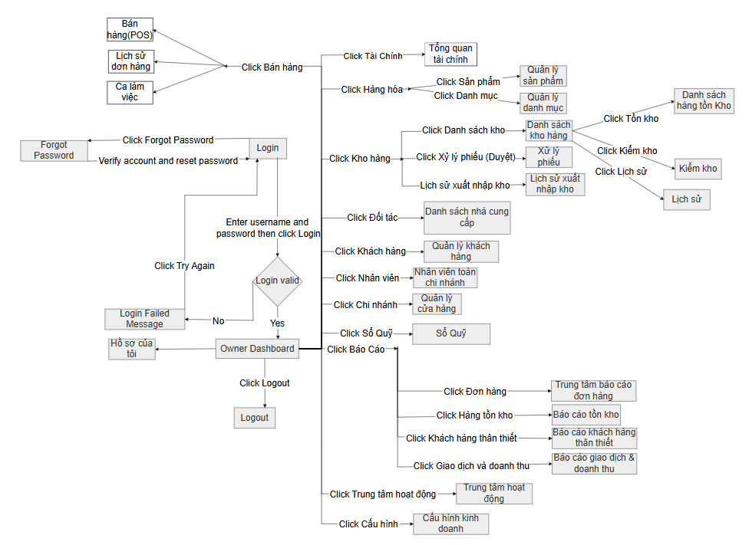

2.1.2 Store Manager Screen Flow

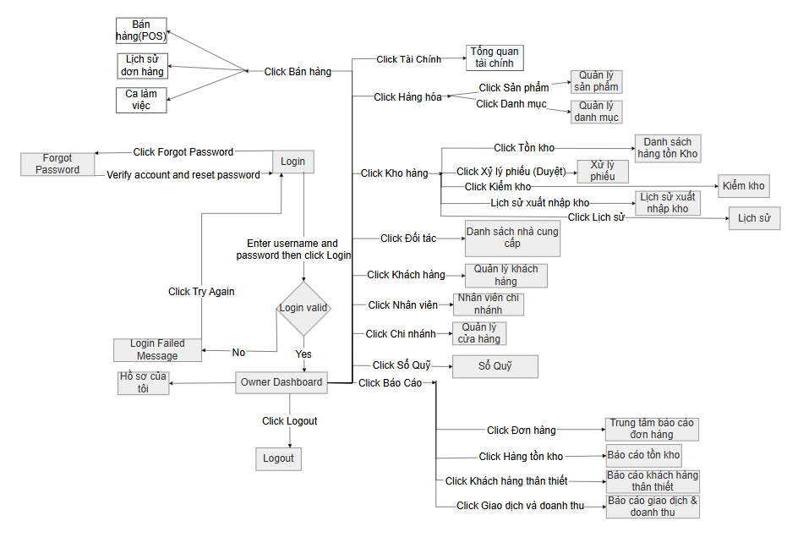

2.1.3 Sales Staff Screen Flow

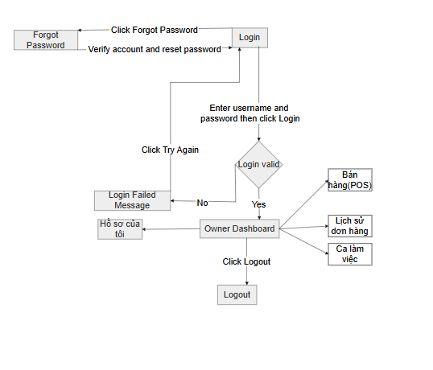

2.1.4 Warehouse Staff Screen Flow
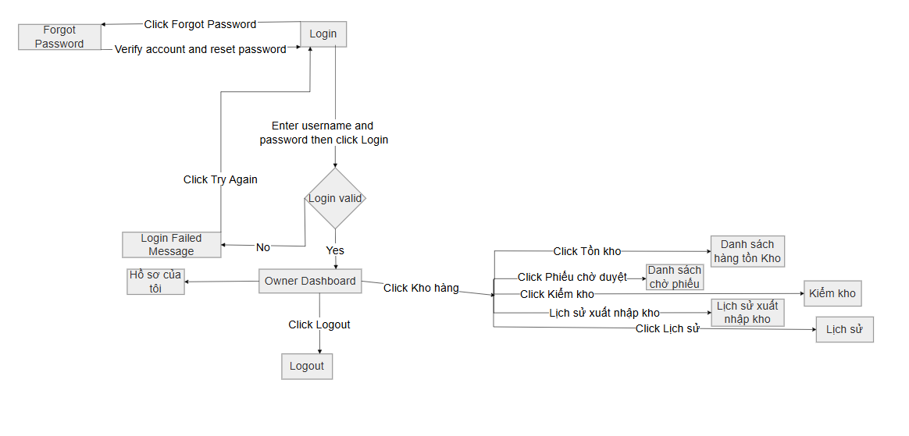

2.1.5 Customer Management Flow
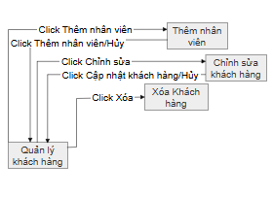

2.1.6 Product and Category Management Flow
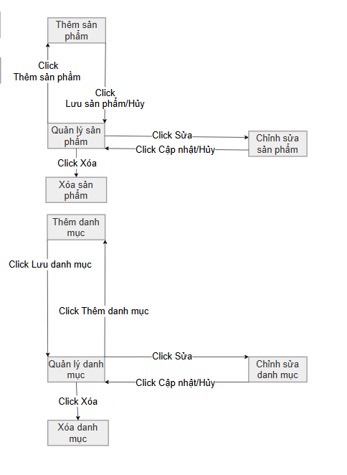

2.1.7 Supplier Management Flow
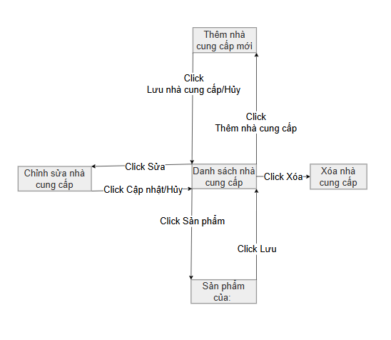

2.1.8 Inventory Management Flow
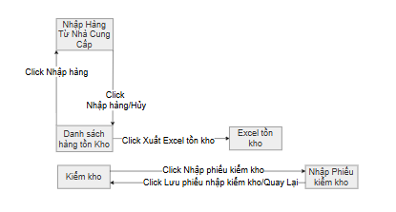

2.1.9 Sales Management Flow
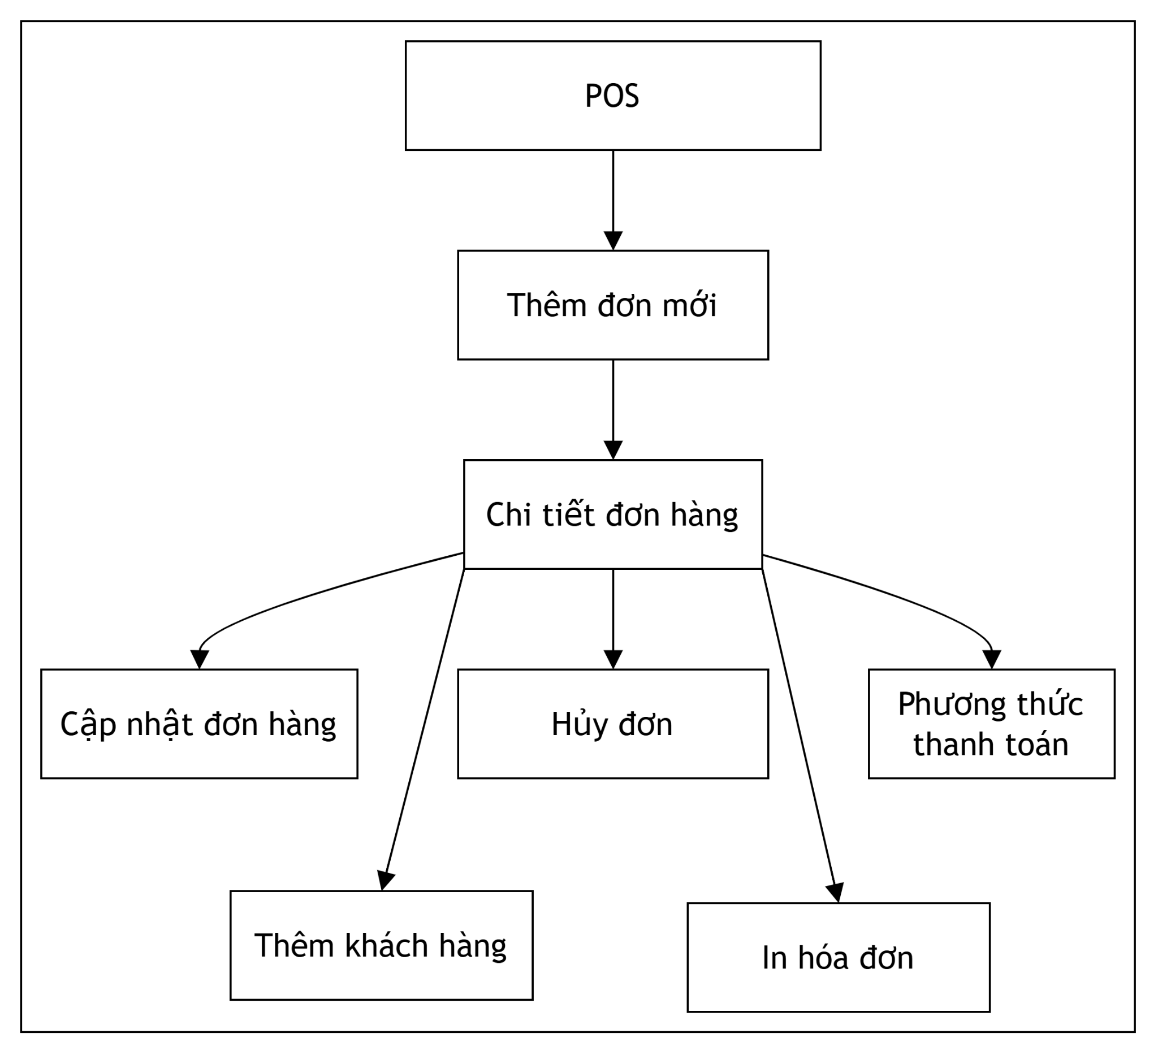

2.1.10 Cash book Flow
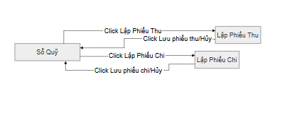

2.1.11 Report System Flow
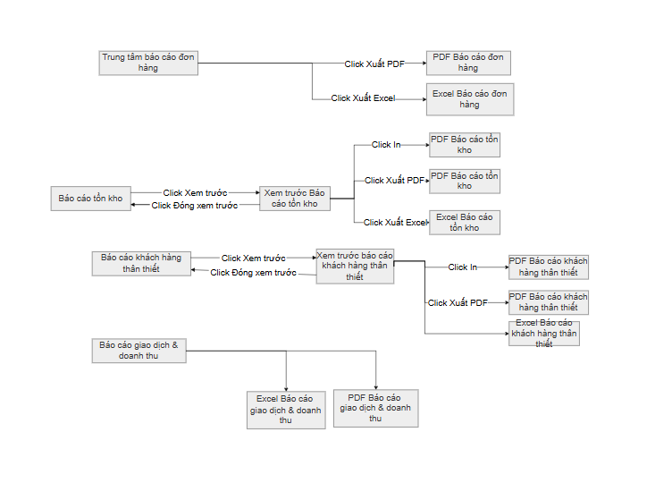

2.1.12 Employee Management Flow
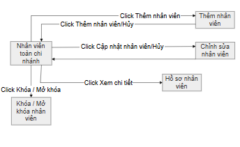

2.1.13 Branch Management Flow
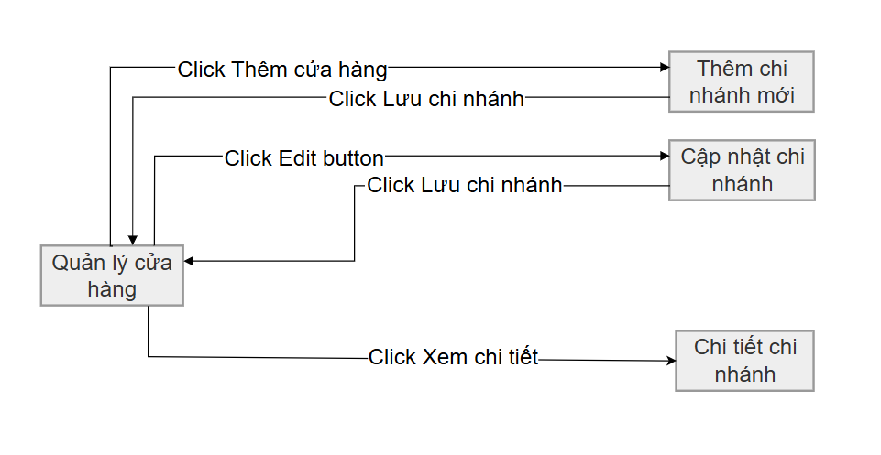

2.2 Screen Descriptions

# | Feature | Screen | Description
1 | Authentication | Login | Users enter username and password to access the system. The system identifies the user's role and assigned store branch (store_id) upon successful login.
2 | Authentication | Forgot Password | Users recover account access via an email verification process that sends a self-generated temporary password
3 | Authentication | Logout | Users securely end their working session. The system records the logout time in the activity log
4 | User Manager | User Manager | Owner views and manages all staff accounts across the entire chain or specific branches
5 | User Manager | Add/Edit User | Owner creates or updates staff accounts, assigning them to a specific branch and gán a single role per account
6 | User Manager | Search User | Allows Owner/Manager to search and filter users by name, email, phone, role, status, or branch.
7 | User Manager | Filter User | The system displays matching results to help manage user accounts efficiently.
8 | User Manager | Lock / Unlock User | Owner disables or enables account access. Locked users are prohibited from logging into the system
9 | User Manager | Redeem consumption points | Sales staff check points and redeem them for customers.
10 | User Manager | Change Password | Users change the password for their newly assigned account for security reasons.
11 | Authorization | Role Management | defines system roles and assigns granular permissions for each module following the RBAC model.
12 | Branch Manager | Store List | Owner views the list of all active branches/stores within the Finora chain
13 | Branch Manager | Add Store | Owner manages branch-specific information including address, contact details, and assigned manager.
14 | Branch Manager | Edit Store | Owner updates branch information such as address and manager.
15 | Branch Manager | Seach Store | Allows Owner to search and filter store by name, email, phone, status, or branch.
16 | Branch Manager | Filter Store | The system displays matching results to help manage store efficiently.
17 | Customer Manager | Customer Manager | Sales staff browse customer transaction history and accumulated spending.
18 | Customer Manager | Add/Edit Customer | Staff registers new customers to track identity for the Loyalty program (point accumulation)
19 | Customer Manager | Search Customer | Allows Sales Staff or Store Manager to search and filter customer by name, email, phone, status.
20 | Customer Manager | Filter Customer | The system displays matching results to help manage customer efficiently.
21 | Customer Manager | Customer Detail | Staff views detailed customer profile and loyalty points.
22 | Product Manager | Product Manager | Users browse all products. Includes quick search by name or barcode and displays real-time stock levels for the current branch.
23 | Product Manager | Product Detail | Users view detailed product information including price and stock quantity.
24 | Product Manager | Add/Edit Product | Store Managers manage product data, including categories and unit conversions
25 | Product Manager | Search Product | Allows user to search and filter product
26 | Product Manager | Filter Product | The system displays matching results to help manage product efficiently.
27 | Category Manager | Category Manager | Users view and manage product groupings (e.g., categories and sub-categories)
28 | Category Manager | Add Category | User creates new product categories.
29 | Category Manager | Edit Category | User updates category information.
30 | Category Manager | Search Category | User search category information.
31 | Category Manager | Filter Category | The system displays matching results to help manage category efficiently.
32 | Supplier Manager | Supplier Manager | Users manage supplier contact information and track accounts payable (debts)
33 | Supplier Management | Add Supplier | Staff adds new suppliers into the system.
34 | Supplier Management | Edit Supplier | Staff updates supplier contact information.
35 | Supplier Management | Search Supplier | User search supplier contact information.
36 | Supplier Management | Filter Supplier | The system displays matching results to help manage supplier efficiently.
37 | Supplier Management | Pagging | Display list of pages
38 | Purchase Manager | Purchase Order | Warehouse staff creates orders for suppliers to replenish stock
39 | Purchase Manager | Purchase Detail | Staff views detailed purchase order information.
40 | Purchase Manager | Import Receipt | Warehouse staff records physical stock intake, automatically updating inventory quantities and supplier debt.
41 | Inventory Manager | Inventory Dashboard | Warehouse staff monitors stock quantity and inventory status.
42 | Inventory Manager | Stock Adjustment | Store Manager approves physical inventory audit results to synchronize system stock with actual counts, recording mandatory reasons.
43 | Inventory Manager | Inventory Transfer | Staff transfers products between branches or warehouses.
44 | Sales Manager | Create Order | Sales staff creates customer sales orders for purchasing products.
45 | Sales Manager | Order Detail | Staff views detailed information of customer orders.
46 | Sales Manager | Edit Order | Staff changes product quantity or updates order information.
47 | Sales Manager | Cancel Order | Staff cancels invalid or unpaid customer orders.
48 | Sales Manager | Payment | Staff processes customer payment using cash or online payment methods.
49 | Sales Manager | Invoice Management | Staff generates and prints invoices after successful payment.
50 | Financial Manager | Income List | views all income transactions from sales activities.
51 | Financial Manager | Expense List | views all business expense transactions.
52 | Financial Manager | Add Expense | Staff records new expense transactions into the system.
53 | Financial Manager | Financial Dashboard | monitors revenue, expenses, and profit statistics.
54 | Report System | Sales Report by Store | views revenue reports of all branches by selected period.
55 | Report System | Employee Sales Report | views sales performance reports of employees.
56 | Report System | Inventory Report | and warehouse staff view inventory reports of all warehouses.
57 | Report System | Loyal Customer Report | views loyal customer statistics and ranking reports.
58 | Report System | Export Report | Users export reports to Excel, PDF, or Word files.
59 | Dashboard | Dashboard Overview | Owner views overview statistics including revenue, orders, customers, and inventory.
60 | System Log | Activity Log | tracks user activities such as login, update, delete, and payment actions.
61 | Notification System | Notification Center | The system displays notifications for low stock, new orders, and account activities.

2.3 Screen Authorization

Screen | Owner | Store Manager | Sales Staff | Warehouse Staff
Login | X | X | X | X
Forgot Password | X | X | X | X
Logout | X | X | X | X
User List | X
Add User | X
Edit User | X
Lock / Unlock User | X
Change Password | X | X | X | X
Role Management | X
Store List | X
Add Store | X
Edit Store | X
Delete Store | X
Customer List | X | X | X
Add Customer | X | X | X
Edit Customer | X | X | X
Customer Detail | X | X | X
Product List | X | X | X | X
Product Detail | X | X | X | X
Add Product | X | X |  | X
Edit Product | X | X |  | X
Delete Product | X | X |  | X
Category List | X | X | X | X
Add Category | X | X |  | X
Edit Category | X | X |  | X
Supplier List | X | X |  | X
Add Supplier | X | X
Edit Supplier | X | X
Purchase Order | X | X |  | X
Purchase Detail | X | X |  | X
Import Receipt | X | X |  | X
Inventory Dashboard | X | X |  | X
Stock Adjustment | X | X |  | X
Inventory Transfer | X | X |  | X
Create Order | X | X | X
Order Detail | X | X | X
Update Order | X | X | X
Cancel Order | X | X | X
Payment | X | X | X
Invoice Management | X | X | X
Income List | X | X
Expense List | X | X
Add Expense | X | X
Financial Dashboard | X
Sales Report by Store | X | X
Employee Sales Report | X | X | X
Inventory Report | X | X |  | X
Loyal Customer Report | X | X
Export Report | X | X
Dashboard Overview | X
Activity Log | X
Notification Center | X

2.4 Non-UI Functions
# | Feature | System Function | Description
1 | Forgot Password | Send Email Verify | Send Email verify to user
2 | Point | Automatic upgrade customer ranking | Automatic upgrade when points meet eligibility requirements.
3 | Inventory Management | Automatic Low Stock Alerts | Automatically generate notifications and alerts when product stock level falls below the minimum threshold (min_stock).
4 | Point Management | Auto-calculate Reward Points | Automatically calculate and award loyalty points to the customer account upon successful order completion.
5 | Security / Audit | Auto Activity Logging | Automatically record user actions (e.g., login, updates, deletions, payments) into the system audit log for security tracing.
6 | Supplier Management | Auto Supplier Debt Update | Automatically update accounts payable / outstanding debt to the supplier when a purchase import receipt is approved.
7 | Sales Management | Auto Order Cancellation | Automatically cancel pending/unpaid orders after a pre-defined timeout period (e.g., 24 hours) to release locked stock.
8 | VAT Management | Auto Calculate Order VAT | Automatically apply default VAT tax rates to calculation of order total and details.

3. System High Level Design

3.1 Database Design

a. Database Schema
Database Schema
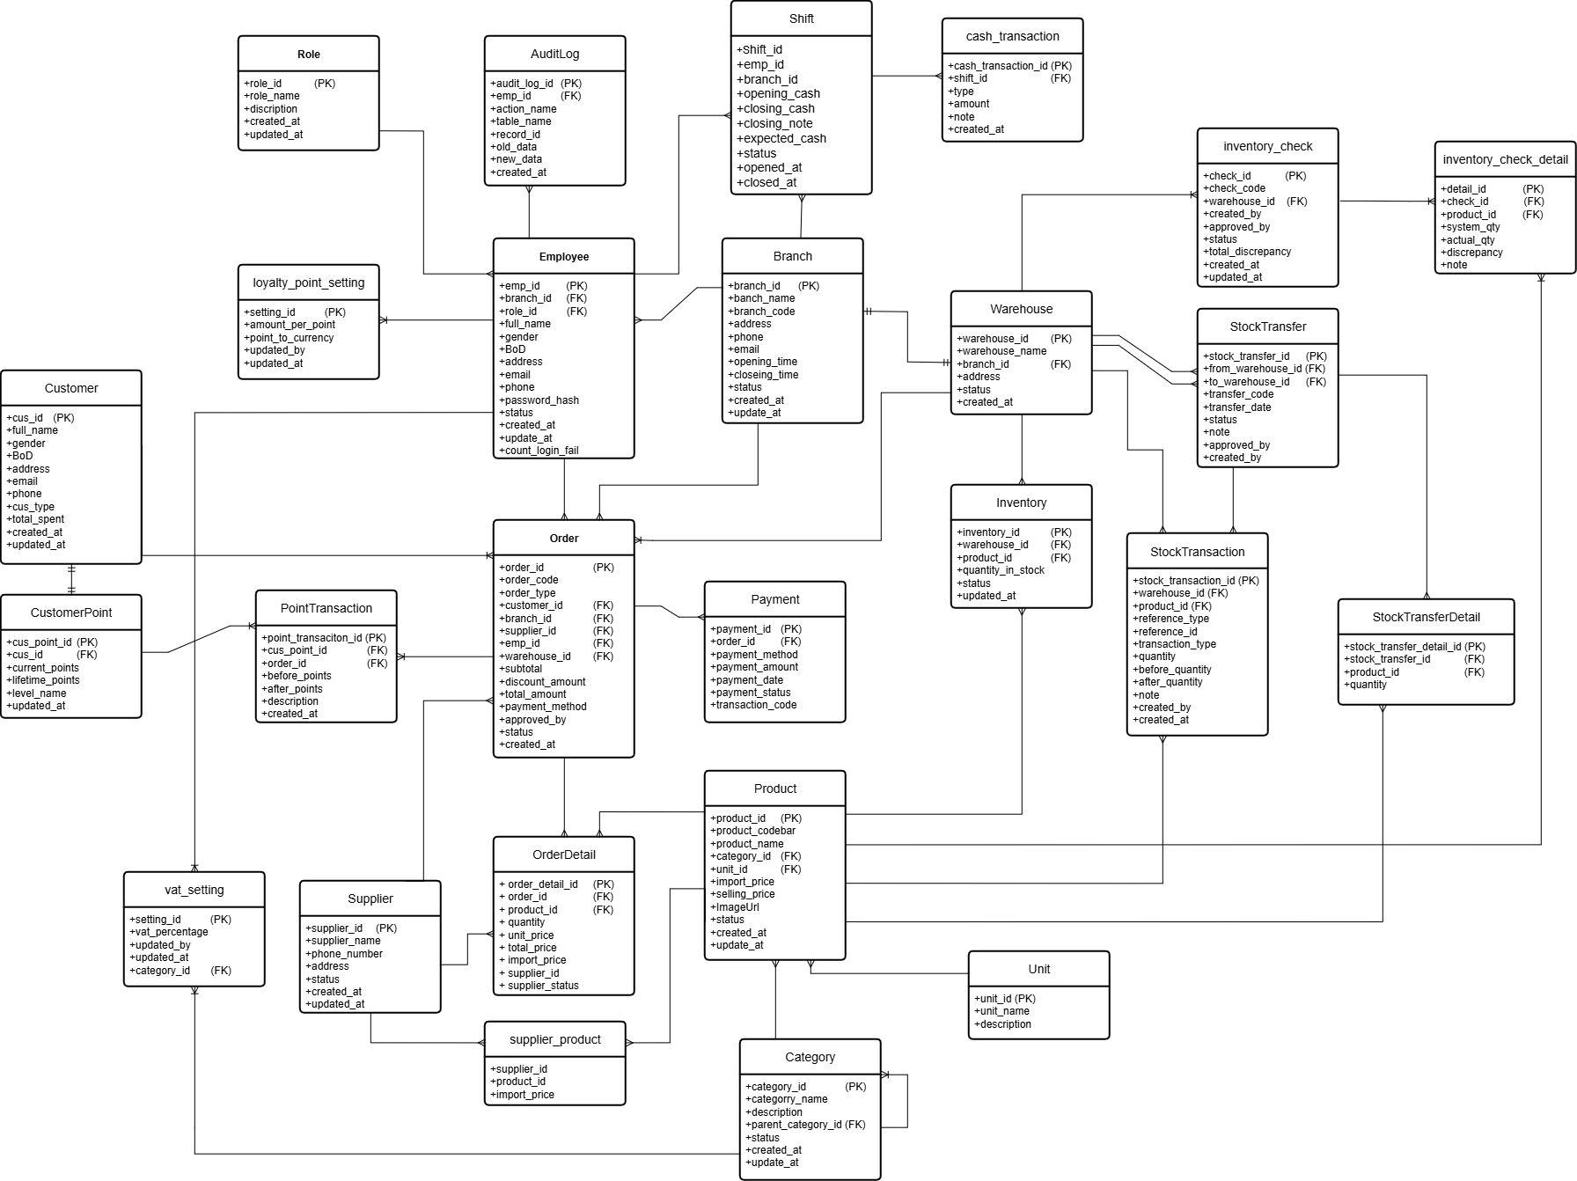

b. Table Descriptions
No | Table | Description
1 | Role | Stores system roles ( Owner, StoreManager, SalesStaff, WarehouseStaff) with names and descriptions.  Primary Key: role_id
2 | Branch | Stores branch information of the business system, including name, address, phone, and status.  Primary Key: branch_id
3 | Employee | Stores employee account information, personal details, contact information, password hash, status, and references their assigned role and branch.  Primary Key: emp_id.  Foreign Keys: branch_id → Branch, role_id → Role
4 | AuditLog | Records audit logs of critical actions in the system (INSERT, UPDATE, DELETE) done by employees, tracking old and new data states for auditing purposes.  Primary Key: audit_log_id.  Foreign Key: emp_id → Employee
5 | CashTransaction | Records cash flow transactions including income and expenses (not directly linked to sales orders) for branch finance management.  Primary Key: cash_transaction_id.  Foreign Keys: branch_id → Branch, created_by → Employee
6 | Category | Stores product categories. Supports hierarchical structures through self-referencing parent categories.  Primary Key: category_id.  Foreign Key: parent_category_id → Category
7 | Unit | Stores units of measure for products (e.g., box, piece, bottle).  Primary Key: unit_id
8 | Product | Stores product details including name, barcode, purchase price, selling price, status, and links to category and unit.  Primary Key: product_id.  Foreign Keys: category_id → Category, unit_id → Unit
9 | Customer | Stores customer details (name, email, phone, gender, type, total_spent).  Primary Key: cus_id
10 | CustomerPoint | Tracks current points and lifetime points accumulated by customers. Each customer has one corresponding point account.  Primary Key: cus_point_id.  Foreign Key: cus_id → Customer
11 | PointTransaction | Tracks point earnings and redemptions related to customer orders.  Primary Key: point_transaction_id.  Foreign Keys: cus_point_id → CustomerPoint, order_id → Order
12 | Supplier | Stores supplier profiles and contact information.  Primary Key: supplier_id
13 | SupplierProduct | Junction table that manages the relationship between suppliers and products, including import prices and product statuses.  Primary Key: supplier_product_id.  Foreign Keys: supplier_id → Supplier, product_id → Product
14 | Warehouse | Stores warehouses belonging to branches where products are stored.  Primary Key: warehouse_id.  Foreign Key: branch_id → Branch
15 | Inventory | Tracks real-time stock levels of products in different warehouses. Represents inventory balance.  Primary Key: inventory_id.  Foreign Keys: warehouse_id → Warehouse, product_id → Product
16 | InventoryCheck | Records inventory check sessions performed to reconcile physical stock with system counts.  Primary Key: inventory_check_id.  Foreign Keys: warehouse_id → Warehouse, created_by → Employee, approved_by → Employee
17 | InventoryCheckDetail | Detailed list of products audited during an inventory check, tracking system quantity and physical count.  Primary Key: inventory_check_detail_id.  Foreign Keys: inventory_check_id → InventoryCheck, product_id → Product
18 | StockTransaction | Logs all stock movements (CHECK_IN, CHECK_OUT, ADJUST, TRANSFER) to track quantity before and after.  Primary Key: stock_transaction_id.  Foreign Keys: warehouse_id → Warehouse, product_id → Product, created_by → Employee
19 | StockTransfer | Records documents transferring stock between warehouses.  Primary Key: stock_transfer_id.  Foreign Keys: from_warehouse_id → Warehouse, to_warehouse_id → Warehouse, created_by → Employee, approved_by → Employee
20 | StockTransferDetail | Specific items and quantities transferred in a stock transfer.  Primary Key: stock_transfer_detail_id.  Foreign Keys: stock_transfer_id → StockTransfer, product_id → Product
21 | Order | Stores order details (SALE or PURCHASE type) containing subtotal, discount, total, payment method, status, branch, warehouse, customer, or supplier.  Primary Key: order_id.  Foreign Keys: customer_id → Customer, branch_id → Branch, supplier_id → Supplier, emp_id → Employee, warehouse_id → Warehouse, approved_by → Employee
22 | OrderDetail | Lists items, quantities, and unit prices inside an order.  Primary Key: order_detail_id.  Foreign Keys: order_id → Order, product_id → Product
23 | Payment | Stores transaction payments (method, amount, reference code, status).  Primary Key: payment_id.  Foreign Key: order_id → Order
24 | Shift | Manages employee working shifts (start time, end time, branch, status).  Primary Key: shift_id.  Foreign Key: branch_id → Branch
25 | LoyaltyPointSetting | Global configurations for point earning and redemption rates (e.g. money spent per point).  Primary Key: setting_id
26 | VatSetting | Stores configurations for default VAT percentage values.  Primary Key: setting_id

3.2 Code Packages

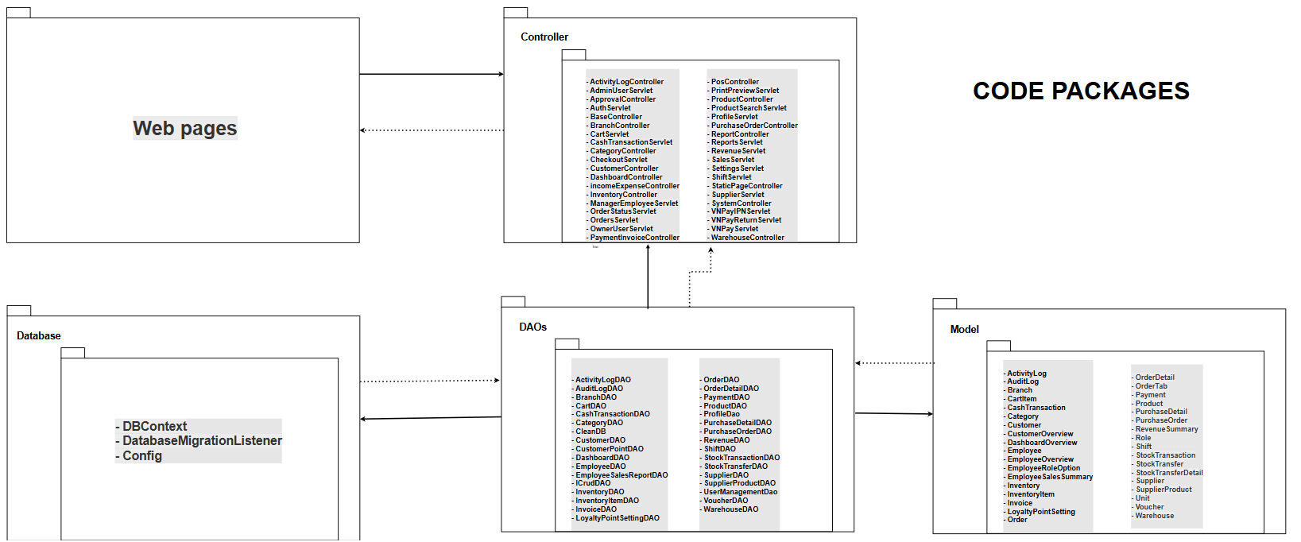
Package descriptions
No | Package | Description
01 | views | Contains user interface (UI) components displayed using JSP, HTML, and CSS pages for a chain store management system.
02 | controllers | Responsible for managing interactions between users, data, and business logic. Includes modular packages such as authentication, branch_management, product_management, order_management, supplier_management, customer_management, and category_management.
03 | DAOs | The Data Access Object class is used to handle data access to the database. It provides basic CRUD methods such as adding, modifying, deleting, and searching for data.
04 | Models / Entities | It contains Model/Entity classes that represent the tables in the database and uses getter/setter functions to manage the data.
05 | Database | The Database/DBContext layer is used to store, configure connections (JDBC), and retrieve data from SQL Server, making data management easier.

II. Requirement Specifications

1. Common Functions

1.1 UC-1.1 Login system

a. Functionalities
UC ID and Name: | UC-1.1 Login system
Created By: | ChiHTH | Date Created: | 22/06/2026
Primary Actor: | All Users (Owner, Store Manager, Sales Staff, Warehouse Staff) | Secondary Actors: | None
Trigger: | User accesses system URL or opens login screen.
Description: | Authenticates users via phone/email and password, assigning appropriate role and branch scope upon success.
Preconditions: | Account exists in the database and status = ACTIVE.
Postconditions: | Active session created; user redirected to role-based dashboard; login event logged in Activity Log.
Normal Flow: | - User enters Email/Phone number and Password, then clicks "Login".  - System validates non-empty credentials.  - System checks password against database hash (BCrypt).  - System verifies account status = ACTIVE.  - System retrieves assigned role_id and branch_id into session.  - System resets count_login_fail to 0 and redirects user to Dashboard.  - System records LOGIN action in Activity Log.
Alternative Flows:
Exceptions: | 1.1.E1 Incorrect Credentials: System increments count_login_fail by 1 and displays "Incorrect username or password". If fail count > 5, account status is set to INACTIVE (BR-22).  1.1.E2 Locked Account: System displays "Your account is locked. Please contact owner/manager" (BR-19).
Priority: | P0 (Must-Have)
Frequency of Use: | Regularly (each time an employee starts their shift)
Business Rules: | BR-02, BR-18, BR-19, BR-20, BR-21, BR-22
Other Information:
Assumptions: | User passwords are stored in encrypted form (BCrypt) in the database.

b. Business Rules
ID | Business Rule | Business Rule Description
BR-02 | RBAC | The system must implement Role-Based Access Control.
BR-18 | Password Encryption | User passwords must be stored and verified using BCrypt standard.
BR-19 | Account Status Check | Users cannot log in if account status is INACTIVE/Locked.
BR-20 | Role Determination | System determines role upon login to render authorized modules.
BR-21 | Branch Scope | Login sessions must be bound to a specific branch_id.
BR-22 | Login Limit | Entering wrong password > 5 consecutive times automatically locks the account.

1.2 UC-1.2 Logout system

a. Functionalities
UC ID and Name: | UC-1.2 Logout system
Created By: | ChiHTH | Date Created: | 22/06/2026
Primary Actor: | All Users | Secondary Actors: | None
Trigger: | User clicks "Logout" button.
Description: | Ends current user session securely and clears authentication tokens.
Preconditions: | User is logged in.
Postconditions: | Session invalidated; user redirected to Login page.
Normal Flow: | - The user clicks "Logout".  - System invalidates HTTP session.  - The system redirects users to the Login page.
Alternative Flows: | None
Exceptions:
Priority: | P0 (Must-Have)
Frequency of Use: | Regularly (at the end of each shift or when leaving the workstation).
Business Rules: | BR-03
Other Information: | Clears client-side session storage and resets active POS cart tabs upon successful logout execution.
Assumptions: | The user's browser allows the deletion of session cookies after logging out.

b. Business Rules
ID | Business Rule | Business Rule Description
BR-23 | Cancel Access | Post-logout, direct URL requests to internal pages are blocked and redirected to Login.
BR-24 | POS Security | Sales staff must log out at shift end to prevent misattributing order sales revenue.

1.3 UC-1.3 Forgot Password

a. Functionalities
UC ID and Name: | UC-1.6 Forgot password
Created By: | ChiHTH | Date Created: | 22/06/2026
Primary Actor: | All Users | Secondary Actors: | Mail Provider (Gmail/SMTP)
Trigger: | The user clicks "Forgot Password?" link on Login page.
Description: | Generates a temporary random password and sends it via email upon successful user verification.
Preconditions: | The account exists with a valid email address.
Postconditions: | New temporary password saved (BCrypt) and emailed to user; activity logged.
Normal Flow: | - User inputs Full Name and Email address.  - The system verifies the exact match of Name and Email in the Employee table.  - The system generates random temporary passwords.  - The system sends an email containing a temporary password via SMTP.  - System hashes new password with BCrypt and updates passwordHash in DB.  - The system displays a success alert and redirects to Login.
Alternative Flows: | None
Exceptions: | 1.3.E1 User Not Found: System displays "Email or Username does not exist".  1.3.E2 Mail Service Failure: System aborts password update and displays "Unable to send email" (BR-29).
Priority: | P0 (Must-Have)
Frequency of Use: | Occasionally (when users forget their password).
Business Rules: | BR-03, BR-18, BR-29
Other Information: | Sent password reset emails utilize pre-configured HTML templates containing company branding and security notices.
Assumptions: | The system has been correctly configured with the Mail Provider's SMTP server to send emails.

b. Business Rules
ID | Business Rule | Business Rule Description
BR-03 | Activity Logging | All user operations affecting data/security must be logged.
BR-18 | BCrypt Encryption | Passwords must be encrypted using BCrypt standard.
BR-29 | Password Delivery | Password reset is aborted if email delivery fails.

1.4 UC-1.4 Manage Staff Accounts

a. Functionalities
UC ID and Name: | UC-1.4 Manage Staff Accounts
Created By: | DungLD | Date Created: | 30/Jun/2026
Primary Actor: | Owner, Store Manager | Secondary Actors: | Email Provider
Trigger: | User opens Staff Management menu.
Description: | Owner creates, updates, locks/unlocks, and resets passwords for employees chain-wide. Store Managers have read-only access to staff within their branch (BR-31).
Preconditions: | Authenticated user with Owner or Store Manager role.
Postconditions: | Employee records created/updated; temporary credentials emailed if applicable; audit log written.
Normal Flow: | - The user accesses the Staff Management screen.  - System checks user role: Owner sees all employees; Store Manager sees branch employees only (BR-31).  - User performs action:  a) Search/Filter: Filter by keyword (Name/Email/Phone), branch, role, or status.  b) Create Staff (Owner): Enter Name, Email, Phone, Role, Branch. System verifies uniqueness (BR-28), emails generated password (BR-29), hashes via BCrypt (BR-30), and inserts record.  c) Edit Staff (Owner): Update details; system persists changes.  d) Lock/Unlock (Owner): Toggle status between ACTIVE and INACTIVE (BR-32).  e) Reset Password (Owner): Generates new password and sends via email.  - System records activity log.
Alternative Flows: | AF-1.3.1 Read-Only view for Store Managers, Owner  At step 4, if the logged-in user is a Store Manager,Owner the UI renders the employee list without the Add, Edit, Lock, Unlock, and Reset Password action options.  AF-1.3.2 Cancel Action  At any action flow, if the user decides to click 'Cancel' or the back button, the system discards all entered inputs and redirects the user to the default employee list view.
Exceptions: | 1.4.E1 Access Denied: Store Manager attempting edit/lock actions is blocked (BR-34).  1.4.E2 Duplicate Credentials: Entered email or phone already exists (BR-28).
Priority: | P0 (Must-Have)
Frequency of Use: | High
Business Rules: | BR-02, BR-05, BR-28, BR-29, BR-30, BR-31, BR-32
Other Information: | Store Manager access is strictly scoped via branch_id session filter; system logs all staff status modifications for audit review.
Assumptions: | The mail provider is active and SMTP configuration is correctly mapped.

b. Business Rules
ID | Business Rule | Business Rule Description
BR-02 | RBAC | Role-Based Access Control enforced.
BR-05 | Single Role | Each account can only be assigned exactly one role.
BR-28 | Unique Credentials | Email and phone number must be unique across all employee accounts.
BR-29 | Password Delivery | Account creation/reset aborts if email delivery fails.
BR-30 | BCrypt Hashing | All passwords hashed with BCrypt.
BR-31 | Branch Isolation | Store Managers can only view employees in their assigned branch.
BR-32 | Account Lockout | Status other than ACTIVE prevents login authentication.

1.5 UC-1.5 View Activity Log

a. Functional Description
UC ID and Name: | UC-1.5 View Activity Log
Created By: | HoangND | Date Created: | 15/Jun/2026
Primary Actor: | Owner | Secondary Actors: | None
Trigger: | The owner navigates to the System Activity Log.
Description: | Displays read-only system operation logs for data auditing.
Preconditions: | - Owner is successfully logged into the system.  - Active user session is validated with Owner role (role_id = 1).
Postconditions: | - System retrieves and displays a paginated list of activity log entries.  - Audit data remains strictly read-only with no modification or deletion allowed.
Normal Flow: | - Owner clicks on "Activity Log" in the sidebar.  - System retrieves the latest system logs sorted by creation timestamp descending (created_at DESC).  - System renders the log entries showing: Timestamp, Staff Name, Action Type, Target Module/Table, Record ID, and Data Changes Summary.  - Owner reviews log details or uses pagination controls to view older entries.
Alternative Flows: | AF-1 Search and Filter Activity Logs:  - Owner enters search keywords (Staff name, action description) or selects filters (Date range, Table Name, Action type).  - Owner clicks "Filter" / "Lọc".  - System applies criteria and updates the displayed log list dynamically.  AF-2 View Detailed Log Payload:  - Owner clicks "Xem nội dung" next to a log record.  - System displays a modal with full JSON payload showing old_data and new_data.
Exceptions: | 1.5.E1 No Log Data Found: System finds no activity entries matching the filter criteria. System displays: "Không tìm thấy nhật ký hoạt động phù hợp."  1.5.E2 Access Denied: Non-Owner user attempts to open Activity Log via direct URL. System blocks request and returns HTTP 403 Forbidden.
Priority: | P1 (Should-Have)
Frequency of Use: | Periodically
Business Rules: | BR-03, BR-06
Other Information: | Audit logs cannot be updated or deleted by any user, including the Owner.
Assumptions: | Backend automatically writes log records whenever data mutations occur.

b. Business Rule
ID | Business Rule | Business Rule Description
BR-03 | Auto Logging | All operations modifying data must write an audit log.
BR-06 | Owner Privilege | Owner has unrestricted access to view audit data across all branches.

1.6 UC-2.1 View & Update Profile

a. Functionalities
UC ID and Name: | UC-2.1 View & Update Profile
Created By: | DungLD | Date Created: | 30/Jun/2026
Primary Actor: | All Users | Secondary Actors: | None
Trigger: | User clicks "Profile" in menu.
Description: | Allows user to view profile details, sales metrics (if Sales Staff), update info, and upload avatar.
Preconditions: | User is logged in.
Postconditions: | User profile information and role-specific sales metrics are rendered on screen.
Normal Flow: | - User navigates to /profile.  - System retrieves user account details using session emp_id.  - System checks user's assigned role.  - If user role is Sales Staff (role_id = 4), system computes personal metrics (Total Orders Processed, Total Revenue Generated, Average Order Value) and fetches order history.  - System sets readOnlyProfile = false and renders personal profile view.
Alternative Flows: | AF-1 Management View Other Employee Profile:  - Owner or Store Manager clicks "Detail" on a staff member in the Employee List.  - System loads target employee's profile and sets readOnlyProfile = true.  - Input fields are disabled; "Back" button is shown instead of update options
Exceptions: | 1.6.E1 Session Expired: User session has timed out. System redirects request to Login page.  1.6.E2 Cross-Branch Access Error: Store Manager attempts to view profile of staff from another branch. System blocks request with HTTP 403 Forbidden.
Priority: | P(0) Must Have
Frequency of Use: | High
Business Rules: | BR-33, BR-34, BR-35, BR-36
Other Information: | None
Assumptions: | Session contains valid authenticated user context.

b. Business Rules
ID | Business Rule | Business Rule Description
BR-33 | Self Edit | Viewing own profile enables editing permissions.
BR-34 | Read-Only Profile | Viewing another staff's profile is strictly read-only.
BR-35 | Sales Metrics | Personal order sales history rendered for Sales Staff only.
BR-36 | Avatar Format | Avatar image must be JPG, JPEG, PNG, or WEBP

1.7 UC-2.4 Change Password

a. Functionalities
UC ID and Name: | UC-2.4 Change Password
Created By: | DungLD | Date Created: | 30/Jun/2026
Primary Actor: | All Users | Secondary Actors: | None
Trigger: | User submits Change Password form in Profile page.
Description: | Updates login password after verifying old password.
Preconditions: | Active user session.
Postconditions: | - Updated details and avatar URL are persisted in Employee table.  - Active session user details are refreshed.  - Activity is recorded in system log.
Normal Flow: | - User edits fields (Full Name, Email, Phone) in "Cập nhật hồ sơ" section.  - User clicks "Choose File" to upload an avatar image (Optional).  - User clicks "Cập nhật hồ sơ" (Save Changes).  - System validates mandatory fields (Name, Email).  - System validates uniqueness of Email and Phone against other existing active accounts.  - If image is uploaded, system checks image format (JPG, JPEG, PNG, WEBP) and file size (<= 5MB), then stores image.  - System updates database record in Employee table.  - System refreshes current HTTP session data and displays success alert: "Cập nhật hồ sơ thành công."
Alternative Flows: | AF-1 Cancel Edits: User clicks "Hủy" / resets page. Changes are discarded.
Exceptions: | 1.7.E1 Required Field Missing: User leaves Full Name or Email blank. System displays: "Vui lòng điền đầy đủ họ tên và email."  1.7.E2 Duplicate Email/Phone: Entered Email or Phone belongs to another user. System displays: "Email hoặc số điện thoại đã tồn tại."  1.7.E3 Invalid File Type or Size: Uploaded file is not JPG/PNG/WEBP or exceeds 5MB. System blocks upload and displays: "Ảnh đại diện phải là JPG, PNG, WEBP"
Priority: | P(0) Must Have
Frequency of Use: | High
Business Rules: | BR-25, BR-26, BR-27
Other Information: | None
Assumptions:. | User has write permission for their own profile.

b. Business Rules
ID | Business Rule | Business Rule Description
BR-25 | Auth Requirement | Password change strictly allowed for authenticated sessions only.
BR-26 | Old Password Verify | Old password input must match DB hash.
BR-27 | BCrypt Standard | New password must be hashed using BCrypt (work factor 12).

1.8 UC-3.1 Manage Branch Chain

a. Functionalities
UC ID and Name: | UC-3.1 Manage Branch Chain
Created By: | PhucNH | Date Created: | 15/Jun/2026
Primary Actor: | Owner | Secondary Actors: | None
Trigger: | Owner accesses the Branch Management module.
Description: | Owner views, creates, updates, and deletes store branches.
Preconditions: | - The user has successfully logged into the system with their respective role.  - Product data exists in the system
Postconditions: | - New BCrypt password hash is stored in Employee table (passwordHash).  - Security event is logged in Activity Log.
Normal Flow: | - User accesses "Đổi mật khẩu" panel on Profile page.  - User inputs Old Password, New Password, and Confirm New Password.  - User clicks "Đổi mật khẩu" (Submit).  - System validates all fields are populated.  - System validates New Password matches Confirm New Password.  - System fetches existing passwordHash from DB and verifies Old Password via BCrypt.checkpw().  - System hashes New Password via BCrypt (work factor = 12).  - System updates passwordHash and update_at = CURRENT_TIMESTAMP in database.  - System displays success message: "Đổi mật khẩu thành công."
Alternative Flows: | AF-1 Cancel Password Change: User clears inputs or leaves tab without submitting. Password remains unchanged.
Exceptions: | 1.8.E1 Blank Password Fields: One or more fields are empty. System displays: "Vui lòng nhập đầy đủ các trường mật khẩu."  1.8.E2 Password Mismatch: New Password and Confirm Password do not match. System displays: "Mật khẩu xác nhận không khớp."  1.8.E3 Incorrect Old Password: Entered Old Password fails BCrypt verification. System displays: "Mật khẩu cũ không chính xác."
Priority: | P0 (Must-Have)
Frequency of Use: | High
Business Rules: | BR-06, BR-37, BR-38, BR-39, BR-40, BR-41, BR-42, BR-43, BR-44, BR-45
Other Information: | Recommended minimum password strength guidelines enforced on frontend.

b. Business Rules

ID | Business Rule | Business Rule Description
BR-06 | Owner Authority | The owner can manage all branches without restriction.
BR-37 | Branch Display | Must display Code, Name, Address, City, District, Phone, Email, Hours, Status.
BR-38 | Data Accuracy | System must fetch and render real-time DB branch records.
BR-39 | Code Uniqueness | Each branch code (branch_code) must be unique.
BR-40 | Email Uniqueness | Branch email address must be unique.
BR-41 | Phone Uniqueness | Branch phone numbers must be unique.
BR-42 | Mandatory Fields | Code, Name, Address, City, District, Phone, Email, Hours are required.
BR-43 | Hours Check | Opening time must be earlier than closing time.
BR-44 | Auto Timestamp | updated_at updated automatically on edits.
BR-45 | Record Existence | Edit/Delete allowed on existing records only.

2. Store Operations & POS Features

2.1 UC-4.1 Search & Manage Product Catalog

a. Functionalities
UC ID and Name: | UC-4.1 Search & Manage Product Catalog
Created By: | PhucNH | Date Created: | 30/Jun/2026
Primary Actor: | Owner, Store Manager, Sales Staff, Warehouse Staff | Secondary Actors: | None
Trigger: | Staff enters keywords into search bar at POS or Product Management page.
Description: | Allows looking up products by name, SKU, or barcode. Displays branch inventory stock for staff, and chain-wide stock management options for Owner/Manager.
Preconditions: | User is logged in with authorized role; product database contains records.
Postconditions: | Matching products with price, category, and real-time inventory quantity rendered.
Normal Flow: | - The user enters the keyword (product name) into the search bar.  - System queries Product joined with Inventory filtered by session warehouse_id / store_id.  - System returns matching product list displaying Thumbnail, Name, Selling Price, and Stock Quantity.  - The user selects the product to view details or add to the POS cart.
Alternative Flows: | AF-1 Filter by Category / Status: User selects category or status dropdowns. System filters results accordingly
Exceptions: | 2.1.E1 Product Not Found: System finds no matches. System displays: "Không tìm thấy sản phẩm phù hợp."
Priority: | P(0) Must Have
Frequency of Use: | High
Business Rules: | BR-01, BR-02, BR-06, BR-08
Other Information: | None
Assumptions:. | Searching is performed asynchronously via AJAX.

b. Business Rules
ID | Business Rule | Business Rule Description
BR-01 | Data Association | Stock view must be associated with active store_id / warehouse_id.
BR-06 | Owner Scope | The owner views products and stock across all branches.
BR-08 | Sales Scope | Sales Staff only views product stock of assigned branches.

2.2 UC-6.1 Manage Customers & Lookup

a. Functionalities
UC ID and Name: | UC-6.1 Manage Customers & Lookup
Created By: | DungLD | Date Created: | 30/Jun/2026
Primary Actor: | Owner, Store Manager, Sales Staff | Secondary Actors: | None
Trigger:
Description: | Sales staff look up customers at POS by phone/name/email. Store Managers & Owners manage full customer list, edit profiles, or soft delete records.
Preconditions: | User must be logged in and authorized (Store Manager or Owner, ).
Postconditions: | Selected customer linked to sale order or customer record updated/soft-deleted in DB.
Normal Flow: | - User inputs phone number or name in search bar.  - System queries active customers (status = 'ACTIVE') sorted by phone exact match first.  - System returns JSON payload with Customer ID, Name, Phone, Points, Total Spent.  - Staff selects customer to assign to order.
Alternative Flows: | AF-1 Create New Customer at POS: Customer not found. Staff enters Name and Phone to register customer immediately.  AF-2 Soft Delete Customer (Manager): Manager clicks "Delete" on customer row. System sets status to INACTIVE.
Exceptions: | 2.2.E1 Duplicate Customer Phone: Registration fails if phone number already exists. System displays: "Số điện thoại đã tồn tại."
Priority: | P(0) Must Have
Frequency of Use: | High
Business Rules: | BR-46, BR-47, BR-48, BR-49
Other Information: | Soft deletion preserves order history integrity.
Assumptions:. | Phone numbers serve as primary customer identifier.

b. Business Rules
ID | Business Rule | Business Rule Description
BR-46 | Search Priority | Search lookup orders results by: Exact Phone > Partial Phone > Name > Email.
BR-47 | Active Filter | Only customers with status = ACTIVE can be selected at checkout.
BR-48 | UI Restriction | Customer management UI restricted to Owner/Manager; Sales staff uses POS lookup modal.
BR-49 | Soft Deletion | Deleting a customer sets status to INACTIVE to preserve transaction history.

2.3 UC-7.1 Create Sales Order (POS)

a. Functionalities
UC ID and Name: | UC-7.1 Create Sales Order (POS)
Created By: | PhucNH | Date Created: | 15/Jun/2026
Primary Actor: | Sales Staff | Secondary Actors: | System (Auto-recording)
Trigger: | Sales Staff initiates transaction on POS screen.
Description: | Adds products to cart, selects customers, redeems points/discounts, selects payment method, deducts inventory, and completes order.
Preconditions: | Sales Staff logged in; active store and warehouse assigned; inventory available.
Postconditions: | Order created with COMPLETED status; inventory deducted; points added/deducted; receipt generated.
Normal Flow: | - Staff scans barcodes or adds items to POS cart.  - Staff searches and assigns customer (Optional).  - Staff applies discount or redeems loyalty points (Optional).  - System computes: Total = Subtotal - Discount + VAT.  - Staff selects payment method (Cash / VNPay) and clicks "Thanh toán" (Checkout).  - System verifies stock availability in warehouse.  - System executes atomic transaction: Creates Order, OrderDetail, Payment, deducts Inventory, updates CustomerPoint, and logs StockTransaction.  - System displays checkout success message and clears cart.
Alternative Flows: | AF-1 Hold / Draft Order: Staff saves active cart tab as draft to process another customer.
Exceptions: | 2.3.E1 Insufficient Stock: Requested quantity exceeds warehouse inventory. System blocks checkout and displays: "Không đủ hàng trong kho."  2.3.E2 Payment Deficit: Cash given < Total amount. System blocks payment.
Priority: | P0 (Must-Have)
Frequency of Use: | Very High
Business Rules: | BR-01, BR-08, BR-09, BR-10, BR-16, BR-55, BR-56, BR-57, BR-58, BR-59, BR-60
Other Information: | Logs must guarantee data integrity (Read-Only). No user, including the Owner, is allowed to manually edit or delete log entries through the interface.

b. Business Rules

ID | Business Rule | Business Rule Description
BR-01 | Data Association | Order strictly tied to staff's branch_id.
BR-08 | Sales Scope | Sales Staff operates within the assigned store only.
BR-09 | Inventory Limit | Sales quantity cannot exceed physical stock in DB.
BR-10 | Revenue Integrity | Sales Staff cannot edit financial total after order finalization.
BR-16 | Order Formula | Total Invoice = (Unit Price x Qty) - Point Discount + VAT.
BR-55 | Product Check | Products must exist in system before checkout.
BR-56 | Order Code | System auto-generates unique order code.
BR-57 | Auto VAT | VAT calculated automatically based on configuration.
BR-58 | Cash Check | Received cash must be >= total invoice amount.
BR-59 | Immediate Deduct | Inventory deducted immediately upon completed checkout.
BR-60 | Atomicity | Order submission executed in an atomic DB transaction.

2.4 UC-7.3 VNPay Online Payment Gateway

a. Functional Description
UC ID and Name: | UC-7.3 VNPay Online Payment Gateway
Created By: | HoangND | Date Created: | 15/Jun/2026
Primary Actor: | Sales Staff | Secondary Actors: | VNPay Gateway
Trigger: | Sales Staff selects "VNPay" payment method during POS checkout.
Description: | Generates VNPay QR code; verifies payment result via Callback/IPN before finalizing order.
Preconditions: | - Sales Staff is logged into the POS system.  - The cart contains products with a total payable amount > 0.  - VNPay API configurations (TmnCode, HashSecret, PayUrl) are active and valid.
Postconditions: | - Order status is updated to COMPLETED.  - Payment record is created in payment table with status PAID and VNPay transaction code.  - Product quantities are deducted from physical inventory.  - Customer loyalty points are credited to customer account.
Normal Flow: | - Sales Staff builds POS order cart and selects "VNPay" payment method.  - Sales Staff clicks "Thanh toán VNPay" (Checkout).  - System creates order with status PENDING and requests payment URL from VNPay API with HMAC-SHA512 signature.  - System displays VNPay QR code modal on POS screen.  - Customer scans QR code and completes payment inside banking application.  - VNPay server sends asynchronous Callback/IPN with response code '00' to system.  - System verifies digital signature (HMAC-SHA512), updates order status to COMPLETED, records payment record (PAID), deducts inventory in database, and awards loyalty points.  - POS screen updates status automatically and displays payment success message.
Alternative Flows: | AF-1 Manual Status Check / Retry: Sales Staff clicks "Kiểm tra trạng thái" (Check Status) on POS screen while waiting. System queries VNPay API to pull transaction status.
Exceptions: | 2.4.E1 Payment Failed / Cancelled: Customer cancels payment or timeout occurs. VNPay returns non-zero error code. System updates payment status to FAILED, leaves inventory undeducted, and allows Sales Staff to change payment method or retry.  2.4.E2 Invalid Signature: Callback HMAC signature verification fails. System rejects transaction update, logs security alert, and returns error code to VNPay.
Priority: | P0 (Must-Have)
Frequency of Use: | High
Business Rules: | BR-11
Other Information: | Supports testing via local sandbox environment before production deployment.
Assumptions: | Internet connection remains stable during gateway handshake.

b. Business Rules
ID | Business Rule | Business Rule Description
BR-01 | Data Association | Orders and payments must be associated with active store identifier (store_id).
BR-09 | Sales Scope | Sales Staff operates within assigned branch scope only.
BR-10 | Physical Inventory Limit | Sales cannot exceed system recorded physical stock.
BR-11 | Callback Verification | VNPay order confirmed completed ONLY upon receiving valid response code ('00') from gateway.

2.5 UC-7.4 Print Invoice

a. Functional Description
UC ID and Name: | UC-7.4 Print Invoice
Created By: | PhucNH | Date Created: | 15/Jun/2026
Primary Actor: | Sales Staff | Secondary Actors: | None
Trigger: | Sales Staff selects the Print Invoice function after completing a sales transaction.
Description: | Formats and prints thermal paper receipt for completed sales orders.
Preconditions: | - Sales Staff is logged in with POS access.  - Selected sales order exists in database and is in COMPLETED status.  - Printer device or thermal print preview service is connected.
Postconditions: | - Invoice preview window is rendered and sent to thermal printer.  - Order transaction and sales data remain unaltered in database.
Normal Flow: | - Sales Staff completes sales transaction at POS counter.  - Sales Staff clicks "In hóa đơn".  - System queries completed order info, order details, VAT settings, customer info, and employee details.  - System formats receipt layout (Store header, Order code, Date, Itemized table, Subtotal, Discount, VAT, Total, Thank-you footer).  - System triggers browser print dialogue / receipt printer pipeline.  - Receipt is printed; system returns to active POS screen.
Alternative Flows: | AF-1 Reprint Historical Invoice: Staff opens Sales History, selects past completed order, and clicks "In lại hóa đơn" (Reprint). System generates invoice preview again without creating duplicate records.
Exceptions: | 2.5.E1 Non-Completed Order Error: Order is in PENDING or CANCELLED status. System blocks printing and displays: "Chỉ có thể in hóa đơn cho đơn hàng đã hoàn thành."  2.5.E2 Printer Service Unavailable: Thermal printer is offline. System displays notification allowing user to retry or export print preview.
Priority: | P0 (Must-Have)
Frequency of Use: | Many times per day
Business Rules: | BR-65, BR-66, BR-67, BR-68
Other Information: | Printing is a strictly read-only DB operation.
Assumptions: | Receipt printer utilizes standard 80mm roll paper.

b. Business Rules
ID | Business Rule | Business Rule Description
BR-65 | Order Status | Only orders with status COMPLETED can be printed as invoice.
BR-66 | Invoice Accuracy | Printed receipt must accurately reflect DB order data.
BR-67 | Read-Only Print | Printing an invoice does not modify any order data.
BR-68 | Reprint Allowed | Multiple reprints allowed without duplicating order records.

2.6 UC-7.5 View Sales History & Cancel Order

a. Functional Description
UC ID and Name: | UC-7.5 View Sales History & Cancel Order
Created By: | PhucNH | Date Created: | 15/Jun/2026
Primary Actor: | Sales Staff, Store Manager, Owner | Secondary Actors: | None
Trigger: | User opens "Lịch sử đơn hàng" (Sales History) tab or initiates order cancellation.
Description: | Views past sales orders. Cancels COMPLETED order to restore stock and adjust points.
Preconditions: | - User is authenticated with valid role access.  - For order cancellation: target order exists in COMPLETED status.
Postconditions: | - Sales order list/details displayed on screen.  - If cancelled: order status changed to CANCELLED, inventory quantities restored in inventory table, customer points deducted/adjusted in customer_point, refund logged in stock_transaction and audit_log.
Normal Flow: | View History  - User navigates to Sales History module.  - System retrieves paginated order list filtered by user branch scope.  - User applies search filters (Order code, Customer phone, Date range, Status).  - System updates order list.  - User clicks "Xem chi tiết" (View Detail) to view full itemized list, prices, VAT, and discounts.  Cancel Order:  - User locates target order in Sales History and clicks "Hủy đơn" (Cancel Order).  - System prompts modal dialog requesting cancellation reason confirmation.  - User enters reason and confirms cancellation.  - System executes atomic transaction: updates order status to CANCELLED, restores product quantities to inventory, creates REFUND record in stock_transaction, reverses loyalty points earned, and writes audit_log entry.  - System displays success message and refreshes history view.
Alternative Flows: | AF-1 Cancel Cancellation: User closes confirmation dialog. Order status remains unchanged.
Exceptions: | 2.6.E1 Order Already Cancelled: Selected order status is already CANCELLED. System disables cancel button and displays error alert.  2.6.E2 Stock Restoration Failure: DB deadlock or error during inventory increment. System rolls back entire transaction and alerts user
Priority: | P0 (Must-Have)
Frequency of Use: | Many times per day
Business Rules: | BR-04, BR-61, BR-62, BR-63, BR-64
Other Information: | All refund/cancellation steps execute atomically.
Assumptions: | Historical transactions are retained permanently for auditing.

b. Business Rules
ID | Business Rule | Business Rule Description
BR-04 | Data Integrity | Completed transaction records cannot be hard deleted.
BR-61 | Real-time Data | History displays latest database order entries.
BR-62 | History Search | Supports searching by Order Code or Customer info.
BR-63 | Detailed Order | Detail view shows items, tax, discount, payment method, totals.
BR-64 | Read-Only | Viewing order history does not alter DB records.

2.7 UC-6.7 & UC-6.8 Loyalty Point Accumulation & Redemption

a. Functional Description
UC ID and Name: | UC-6.7 & UC-6.8 Loyalty Point Accumulation & Redemption
Created By: | DungLD | Date Created: | 15/Jun/2026
Primary Actor: | Sales Staff | Secondary Actors: | None
Trigger: | Sales Staff attaches customer to POS order and enters points to redeem or completes order checkout.
Description: | Automatically calculates and awards loyalty points to customer balances upon order checkout based on system spending ratios (amount_per_point). Allows redeeming available loyalty points for cash discounts on active cart invoices (point_to_currency).
Preconditions: | - Valid customer profile selected on POS screen (customer_id > 0).  - For point redemption: customer has positive available current_points balance.
Postconditions: | - Point accumulation: current_points and lifetime_points incremented; entry logged in point_transaction.  - Point redemption: current_points decremented; order discount applied; entry logged in point_transaction.
Normal Flow: | Point Accumulation:  - Sales Staff processes order checkout with an assigned customer.  - System fetches point configuration settings from loyalty_point_setting.  - System calculates points earned: Earned = floor(Total Order Amount / amount_per_point).  - If Earned > 0, system increments current_points and lifetime_points in customer_point.  - System inserts transaction audit entry in point_transaction linked to order_id.  Point Redemption:  - Sales Staff enters number of points customer wishes to redeem (redeemPoints) in POS panel.  - System validates redeemPoints <= customer.current_points.  - System computes discount amount: Discount = redeemPoints * point_to_currency.  - System applies discount to cart total and deducts current_points upon checkout completion.
Alternative Flows: | AF-1 Manual Point Sync (Manager): Owner or Store Manager triggers "Đồng bộ điểm" (Sync Points) on customer profile. System aggregates all paid orders and recalculates points balance.
Exceptions: | 2.7.E1 Anonymous Order: No customer selected at checkout. System skips point calculation and redemption.  2.7.E2 Insufficient Point Balance: Staff attempts to redeem points exceeding customer's current_points. System blocks redemption and displays: "Số điểm đổi vượt quá số điểm hiện có."
Priority: | Must Have
Frequency of Use: | Many times per day
Business Rules: | BR-17, BR-50, BR-51, BR-52, BR-53, BR-54
Other Information: | Point redemptions deduct from current_points only, leaving lifetime_points intact.
Assumptions: | Point exchange configuration settings are active in database.

b. Business Rules
ID | Business Rule | Business Rule Description
BR-17 | Point Rate | Points earned based on actual final payment value.
BR-50 | Calculation Formula | Earned Points = floor(Total Amount / Amount Per Point Setting).
BR-51 | Current Points | Point earning increments current_points balance.
BR-52 | Redemption Limit | Redemption points must be > 0 and <= customer's available current_points.
BR-53 | Balance Deduction | Point redemption deducts directly from current_points.
BR-54 | Sync Paid Orders | Manual point sync only calculates points from orders with status PAID/COMPLETED.

3. Warehouse & Supplier Operations

3.1 UC-8.3 Receive Goods

a. Functional Description
ID and Name: | UC-8.3 Receive Goods
Created By: | ThangLV | Date Created: | 10/4/13
Primary Actor: | Warehouse Staff (Creator), Store Manager/Owner (Approver) | Secondary Actors: | None
Description: | Creates stock intake ticket from supplier. Stock increases and payment expense logged upon approval.
Trigger: | Supplier delivers physical inventory to warehouse.
Preconditions: | Active receiving warehouse and supplier exist in system.
Postconditions: | Purchase order completed; warehouse stock incremented; stock movement logged; financial expense logged.
Normal Flow: | - Warehouse Staff selects receiving warehouse and opens "Import Goods" screen.  - Staff selects Supplier and adds products with quantities and import prices.  - Staff submits import ticket (Status: PENDING).  - Store Manager/Owner reviews ticket in Approval Dashboard and clicks "Approve".  - System sets ticket status to COMPLETED, increases product stock in Inventory, logs StockTransaction (IMPORT), and generates Payment voucher in cashbook.
Alternative Flows: | AF-1 Manager Direct Intake: Store Manager/Owner creates ticket directly. System sets status to COMPLETED immediately without separate approval step.  AF-2 Rejection: Manager clicks "Reject". Status set to REJECTED; no stock or financial changes occur.
Exceptions: | 3.1.E1 Unlinked Supplier Product: Product not linked to supplier. System prompts manager to link supplier first.
Priority: | P0 (Must-Have)
Frequency of Use: | High
Business Rules: | BR-01, BR-04, BR-12
Other Information: | Approved import receipts cannot be edited or deleted.
Assumptions: | Physical goods delivery note is verified against system entry.

b. Business Rules

ID | Business Rule | Business Rule Description
BR-01 | Data Scope | Intake voucher must be linked to a valid branch_id and warehouse_id.
BR-04 | Data Integrity | Approved/Completed import receipts cannot be deleted.
BR-12 | Supplier Check | Warehouse intake vouchers must select an active existing supplier.

3.2 UC-8.5 Warehouse Transfer

a. Functional Description
ID and Name: | UC-8.5 Warehouse Transfer
Created By: | Thắng | Date Created: | 10/4/13
Primary Actor: | Warehouse Staff, Store Manager, Owner | Secondary Actors:
Description: | Transfers products between branch warehouses with multi-stage approval (Dispatch -> Receive).
Trigger: | Stock rebalancing required between store warehouses.
Preconditions: | At least 2 active warehouses exist; sufficient stock at source warehouse.
Postconditions: | Stock transferred; source stock decremented; destination stock incremented; transfer logs generated.
Normal Flow: | - Staff creates Stock Transfer slip selecting target warehouse and item quantities.  - Approver approves ticket.  - Source Warehouse Staff confirms "Dispatch (Export)". System checks available stock, deducts source inventory, and updates status to IN_TRANSIT.  - Destination Warehouse Staff inspects shipment and confirms "Receive (Import)".  - System increases destination warehouse inventory, logs StockTransaction (TRANSFER_IN), and sets status to COMPLETED.
Alternative Flows: | AF-1 Reject Dispatch / Receive: Source or destination staff rejects transfer due to stock discrepancy or damage. Status updated to REJECTED.
Exceptions: | 3.2.E1 Stock Deficit at Dispatch: Source inventory is less than transfer quantity. System blocks dispatch: "Số lượng tồn kho không đủ để xuất chuyển."
Priority: | P1 (Should-Have)
Frequency of Use: | Medium
Business Rules: | BR-01, BR-13
Other Information: | Generates two stock transaction logs (TRANSFER_OUT at source, TRANSFER_IN at target).
Assumptions: | Goods transport between warehouses is secure.

b. Business Rules

ID | Business Rule | Business Rule Description
BR-01 | Data Scope | Transfer tickets bound to source and target warehouse_id.
BR-13 | Transfer Stock Check | Source warehouse stock must be >= requested transfer quantity at dispatch.

3.3 UC-8.7 Check & Adjust Inventory

a. Functional Description
UC ID and Name: | UC-8.7 Check & Adjust Inventory
Created By: | ThangLV | Date Created: | 30/Jun/2026
Primary Actor: | Warehouse Staff (Auditor), Store Manager/Owner (Approver) | Secondary Actors: | None
Trigger: | Warehouse Staff performs periodic physical stock-count and opens "Kiểm kho" (Inventory Check) screen.
Description: | Allows staff to input actual physical stock counts for products in a target warehouse. The system calculates variance (actual_qty - system_qty). Upon Store Manager or Owner approval, system stock is updated to match physical count, and stock adjustment transaction records are logged.
Preconditions: | - Target warehouse exists and is active.  - User is logged in with Warehouse Staff, Store Manager, or Owner role.
Postconditions: | - Inventory check ticket saved (inventory_check and inventory_check_detail).  - Upon approval: inventory.quantity_in_stock updated to match actual counted quantity; variance transaction logged in stock_transaction (Type: ADJUSTMENT).
Normal Flow: | - Warehouse Staff opens "Tạo phiếu kiểm kho" screen and selects target warehouse.  - Staff enters physical "Actual Quantity" counted and notes/reasons for discrepancies for each item.  - System calculates discrepancy (discrepancy = actual_qty - system_qty).  - Staff clicks "Lưu phiếu kiểm kho" (Submit Ticket). Ticket saved with status PENDING.  - Store Manager / Owner reviews discrepancy details in Approval Dashboard and clicks "Duyệt" (Approve).  - System updates inventory quantities to match physical counts, logs stock_transaction entries (CHECK_IN for surplus, CHECK_OUT for shortage), and updates ticket status to APPROVED.
Alternative Flows: | AF-1 Direct Approval by Owner/Manager: Owner or Store Manager creates check ticket directly. System sets status to APPROVED and balances inventory immediately.  AF-2 Rejection / Cancellation: Approver clicks "Từ chối" (Reject) or Creator clicks "Hủy". Ticket status updated to REJECTED/CANCELLED; system stock remains unchanged.
Exceptions: | 3.3.E1 Invalid Count Input: Staff inputs negative physical quantity (< 0). System blocks submission and displays: "Số lượng thực tế phải là số nguyên không âm (>= 0)."
Priority: | P1 (Should-Have)
Frequency of Use: | Medium
Business Rules: | BR-01, BR-14, BR-15
Other Information: | All discrepancy reasons and timestamps are permanently archived for stock auditing.
Assumptions:. | Physical counting is conducted accurately by warehouse staff.

b. Business Rules
ID | Business Rule | Business Rule Description
BR-01 | Data Scope | Stock audit ticket bound to branch_id and warehouse_id.
BR-14 | Audit Approval | Stock updates take effect ONLY after approval by Store Manager or Owner.
BR-15 | Adjustment Audit | Stock adjustments must record specific reason, performer ID, and timestamp.

4. Financials & Cashbook

4.1 UC-10.1 View Store Cashbook

a. Functional Description
UC ID and Name: | UC-10.1 View Store Cashbook
Created By: | ChiHTH | Date Created: | 30/Jun/2026
Primary Actor: | Owner, Store Manager | Secondary Actors: | None
Trigger: | User accesses "Sổ quỹ" (Cashbook) module from navigation menu.
Description: | Tracks real-time cash inflows/outflows and fund balance. Store Managers view assigned branch only (BR-07).
Preconditions: | User logged in as Owner or Store Manager.
Postconditions: | Financial transaction ledgers and calculated fund balances rendered.
Normal Flow: | - User accesses Cashbook page (/cashbook).  - System checks user scope: Owner views all branches or filters by branch; Store Manager auto-locked to session branch_id.  - System retrieves all completed financial transactions (Sales revenue, income vouchers, expense vouchers).  - System computes current balance: Current Balance = Total Inflows - Total Outflows.  - System displays summary dashboard cards and transaction data table.
Alternative Flows: | AF-1 Filter Transactions: User filters ledger by Date Range, Payment Method (Cash / Bank), or Transaction Type (Income / Expense).
Exceptions: | 4.1.E1 Unauthorized Cross-Branch View: Store Manager attempts to access financial data of another branch. System blocks access with HTTP 403 Forbidden.
Priority: | P(0) Must Have
Frequency of Use: | High
Business Rules: | BR-06, BR-07, BR-69, BR-70
Other Information: | None
Assumptions:. | Financial records in database are synchronized.

b. Business Rules
ID | Business Rule | Business Rule Description
BR-06 | Owner View | The owner views financial cashbooks across all branches.
BR-07 | Current Balance Impact Only | Store Managers are restricted to viewing cashbook of their assigned branch only.
BR-69 | Data Scope | All receipt/payment transactions must be associated with a store_id.
BR-70 | Real-time Balance | Ledger balance updates instantly upon order payment or voucher creation.

4.2 UC-10.3 & UC-10.4 Create Receipt / Payment Voucher

a. Functional Description.
ID and Name: | UC-10.3 & UC-10.4 Create Receipt / Payment Voucher
Created By: | ChiHTH | Date Created: | 10/6/2026
Primary Actor: | Store Manager, Owner | Secondary Actors: | None
Description: | Creates internal non-sales receipt vouchers or operational expense payment vouchers.
Trigger: | Store Manager needs to record non-sales revenue (e.g., deposits) or operational branch expenses (e.g., utilities, repairs, stationery).
Preconditions: | - Store Manager or Owner is logged in with active session.  - Assigned branch is active.
Postconditions: | - Auxiliary order record (order_type = 'OTHER', status = 'COMPLETED') created to maintain foreign key integrity.  - Financial transaction record created in payment table with status PAID.  - Branch cashbook balance recalculated in real time.  - Activity logged in audit_log.
Normal Flow: | Create Receipt Voucher  - User selects "Lập phiếu thu" (Create Receipt) in Cashbook module.  - User inputs Amount (VND), Payment Method (Cash / Bank Transfer), and Reason/Description.  - User clicks "Lưu phiếu thu" (Save).  - System validates amount (> 0) and required fields.  - System generates supplementary order (order_type = 'OTHER') and inserts payment record (PaymentType = 'INCOME', payment_status = 'PAID').  - System updates store cash balance dynamically, writes audit_log entry, and displays success alert.  Create Payment Voucher:  - User selects "Lập phiếu chi" (Create Payment Voucher) in Cashbook module.  - User inputs Amount (VND), Payment Method, and Expense Category/Description.  - User clicks "Lưu phiếu chi" (Save).  - System validates amount (> 0).  - System creates supplementary order and inserts payment record (PaymentType = 'EXPENSE', payment_status = 'PAID').  - System deducts amount from branch cash balance, writes audit_log, and displays success notification.
Alternative Flows: | AF-1 Cancel Voucher Creation: User clicks "Hủy" / closes modal. Voucher creation is aborted; financial ledger remains unchanged.
Exceptions: | 4.2.E1 Invalid Amount: User enters amount <= 0. System blocks submission and displays: "Số tiền thu/chi phải lớn hơn 0."  4.2.E2 Exceeding Spending Limit: Manager attempts expense payment exceeding authorized branch limit without Owner approval (BR-08). System blocks voucher creation and prompts for Owner approval.
Priority: | P0 (Must-Have)
Frequency of Use: | Daily / As needed
Business Rules: | BR-01, BR-03, BR-69, BR-70
Other Information: | Receipts and payment vouchers update real-time cashbook balance dashboard widgets instantly.
Assumptions: | Branch cashbook is enabled for active store location.

b. Business Rules
ID | Business Rule | Business Rule Description
BR-01 | Data Scope | Voucher bound to active store_id.
BR-03 | Activity Log | Financial voucher creation recorded in system audit log.
BR-69 | Financial Link | Transaction stored with valid category and payment method.
BR-70 | Balance Update | Fund balance recalculated immediately upon voucher saving.

5. System Configurations

5.1 UC-12.1 & UC-12.2 & UC-12.3 VAT Settings Configuration

a. Functional Description
ID and Name: | UC-12.1 & UC-12.2 & UC-12.3 VAT Settings Configuration
Created By: | DungLD | Date Created: | 10/7/2026
Primary Actor: | Owner | Secondary Actors: | None
Description: | Allows the Chain Owner to view, configure, and manage system-wide Value Added Tax (VAT) percentage rates. Supports configuring a global default VAT rate as well as defining specific category-level VAT tax overrides.
Trigger: | The owner accesses the "Cấu hình" (Business Configuration) module and selects the VAT Setting tab.
Preconditions: | - The user is authenticated with the Owner role (role_id = 1).  - Active session is validated.
Postconditions: | - Updated VAT percentages are persisted in the vat_setting database table.  - Configuration modifications are recorded in the System Activity Log (audit_log).  - Subsequent sales order calculations automatically apply the updated VAT percentages.
Normal Flow: | - The owner accesses the System Configurations screen (/settings?tab=vat).  - System retrieves and displays the current global default VAT rate and any category-specific VAT overrides from vat_setting.  - The owner updates the default system VAT percentage field (e.g., 8% or 10%).  - Owner clicks "Lưu VAT mặc định" (Save Default VAT).  - The system validates that the input value is a valid non-negative number between 0 and 100.  - System executes an UPSERT operation on table vat_setting where category_id IS NULL.  - System displays a success alert message: "Cập nhật cấu hình VAT thành công."  - System logs the action in audit_log.
Alternative Flows: | AF-1 Add/Update Category VAT Override:  - Owner locates a specific product category in the "VAT theo ngành hàng" table.  - Owner inputs a custom VAT percentage for that category and clicks "Thêm" / "Cập nhật".  - System validates and saves the category-specific VAT override (category_id = ?) in vat_setting.  AF-2 Delete Category VAT Override (UC-12.3):  - The owner clicks "Xóa" next to a category tax override.  - System prompts confirmation: "Xóa cấu hình VAT riêng cho ngành hàng này?"  - Upon confirmation, the system deletes the record from vat_setting. Products in this category revert to using the default VAT rate.
Exceptions: | 5.1.E1 Access Denied: Non-Owner user attempts to access VAT configuration URL. System blocks access and returns HTTP 403 Forbidden.  5.1.E2 Invalid Percentage Value: Owner enters negative numbers or values > 100%. System displays error: "Tỷ lệ thuế VAT phải từ 0% đến 100%."
Priority: | P1 (Should-Have)
Frequency of Use: | Low
Business Rules: | BR-03, BR-06, BR-50, BR-57
Other Information: | Category-specific VAT rates take precedence over the global default VAT rate during order total calculation.
Assumptions: | VAT settings take effect immediately for all newly created orders without requiring application server restart.

b. Business Rules
ID | Business Rule | Business Rule Description
BR-03 | Audit Trail | Configuration updates must write an entry to Activity Log.
BR-06 | Owner Only | Global system configurations restricted to Chain Owner role only.
BR-50 | Loyalty Config | Point earning rate affects BR-50 order calculations.
BR-57 | VAT Config | Updated VAT rates apply to subsequent sales order calculations.

5.2 UC-12.5 Configure Loyalty Point Settings

a. Functional Description
ID and Name: | UC-12.5 Configure Loyalty Point Settings
Created By: | HoangND | Date Created: | 10/7/2026
Primary Actor: | Owner | Secondary Actors:
Description: | Configures the parameters for customer loyalty point earning and redemption rules chain-wide. Defines the spending threshold required to earn 1 loyalty point (amount_per_point) and the currency conversion rate when redeeming 1 point for invoice discounts (point_to_currency).
Trigger: | Owner opens System Configuration and selects the Loyalty Point Setting section.
Preconditions: | User is logged in with Owner role privileges.
Postconditions: | - Updated earning and redemption thresholds saved in loyalty_point_setting.  - System Activity Log updated.  - POS checkout automatically uses updated rates for point calculation and redemption discounts.
Normal Flow: | - The owner accesses the Business Configuration screen (/settings?tab=loyalty).  - System loads and displays current active parameters from loyalty_point_setting:  - Spending per point (amount_per_point, Default: 100,000 VND).  - Value per point (point_to_currency, Default: 10,000 VND / point).  - The owner modifies spending per point value (e.g., updates to 50,000 VND) or point conversion value.  - Owner clicks "Lưu cài đặt" (Save Loyalty Settings).  - System validates that entered values are positive numeric values (> 0).  - System updates or inserts active configuration record in loyalty_point_setting.  - System displays success notification: "Cập nhật cấu hình điểm tích lũy thành công.”  - System logs operation details into audit_log.
Alternative Flows: | AF-1 Reset to Default Settings: Owner selects "Khôi phục mặc định" (Reset Defaults). System resets parameters to 100,000 VND/point earning and 10,000 VND/point redemption.
Exceptions: | 5.2.E1 Non-Positive Value Error: Owner inputs a value <= 0. System blocks submission and displays: "Số tiền quy đổi điểm phải lớn hơn 0."
Priority: | P1 (Should-Have)
Frequency of Use: | Low
Business Rules: | BR-03, BR-06, BR-50, BR-52
Other Information: | Changes to point configuration affect order transactions created after the update timestamp. Past historical orders and accumulated points remain unchanged.
Assumptions: | Currency unit for configuration values is Vietnam Dong (VND).

b. Business Rules
ID | Business Rule | Business Rule Description
BR-03 | System Activity Logging | Configuration updates write an audit trail record in audit_log.
BR-06 | Owner Authority | Point ratio configurations restricted exclusively to Chain Owner.
BR-50 | Point Formula | Earning formula: Earned Points = floor(Total Order Amount / amount_per_point).
BR-52 | Redemption Formula | Redemption discount formula: Discount Amount = Redeemed Points * point_to_currency.

III. Design Specifications

1. Authentication

1.1 Login

a. User Login
This screen allows users to use the system's login function.
Related use cases: UC-1.1

UI Design
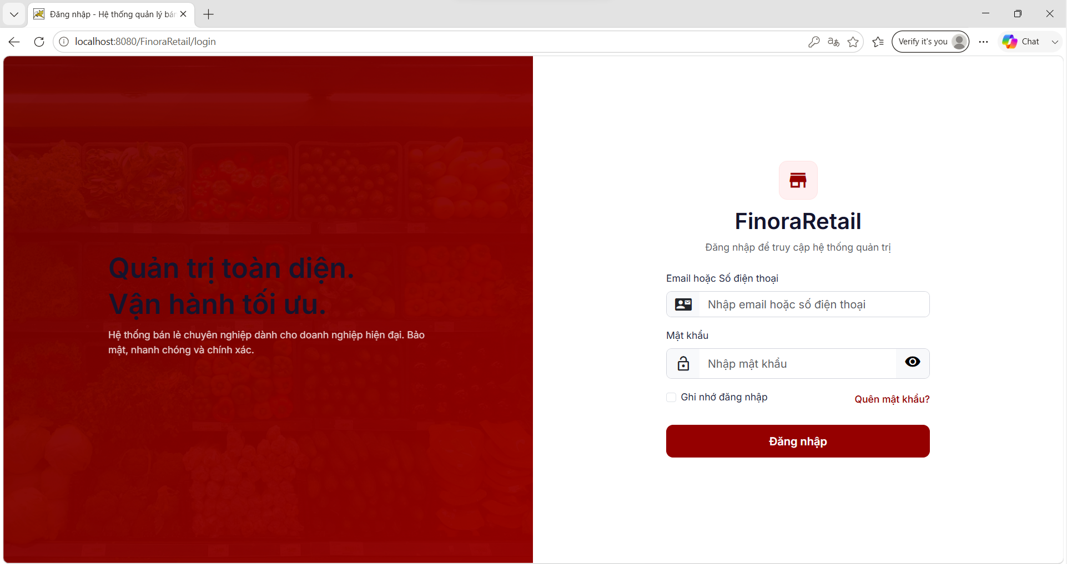
Field Name | Field Type | Description
Form Inputs
Username | Textbox | Enter your registered email or phone number.
Password | Password Textbox | Enter password
Actions
Login button | Button | Perform login authentication
Forgot Password | Link | Redirect to the "Forgot Password" screen.

Database Access
Table | CRUD | Description
Employee | R | Search for employee information by email or phone number to verify the password.
Employee | U | Update the failed login count (count_login_fail) or lock the account (status = 'INACTIVE') when the number of failed login attempts exceeds the specified limit.
Role | R | Perform a join with the roles table to retrieve the employee's role name (role_name) after a successful login.
Branch | R | Join to retrieve information about the store branch to which the employee is assigned.

SQL Commands:
1/ Find an employee by email or phone number.
SELECT
e.emp_id AS EmployeeID,
e.role_id AS RoleID,
e.branch_id AS BranchID,
e.fullName AS FullName,
e.email AS Email,
e.phone AS Phone,
e.passwordHash AS PasswordHash,
e.status AS Status,
e.count_login_fail AS CountLoginFail,
r.role_name AS RoleName,
b.branch_name AS BranchName
FROM Employee e
JOIN Role r ON e.role_id = r.role_id
LEFT JOIN Branch b ON e.branch_id = b.branch_id
WHERE e.email = ? OR e.phone = ?;
2/Update the count of failed login attempts upon entering an incorrect password.
UPDATE Employee SET count_login_fail = count_login_fail + 1,
update_at = CURRENT_TIMESTAMP
WHERE emp_id = ?
3/ Deactivate the employee account (change status to INACTIVE).
UPDATE employee
SET status = 'INACTIVE',
update_at = CURRENT_TIMESTAMP
WHERE emp_id = ?;

4/ Reset số lần đăng nhập sai về 0 khi đăng nhập thành công
UPDATE employee
SET count_login_fail = 0,
update_at = CURRENT_TIMESTAMP
WHERE emp_id = ?;

1.2 Forgot Password

a. Forgot Password
This screen allows users to authenticate their accounts in order to reset their system login passwords.
Related use cases:
UC-1.6 Forgot password

UI Design
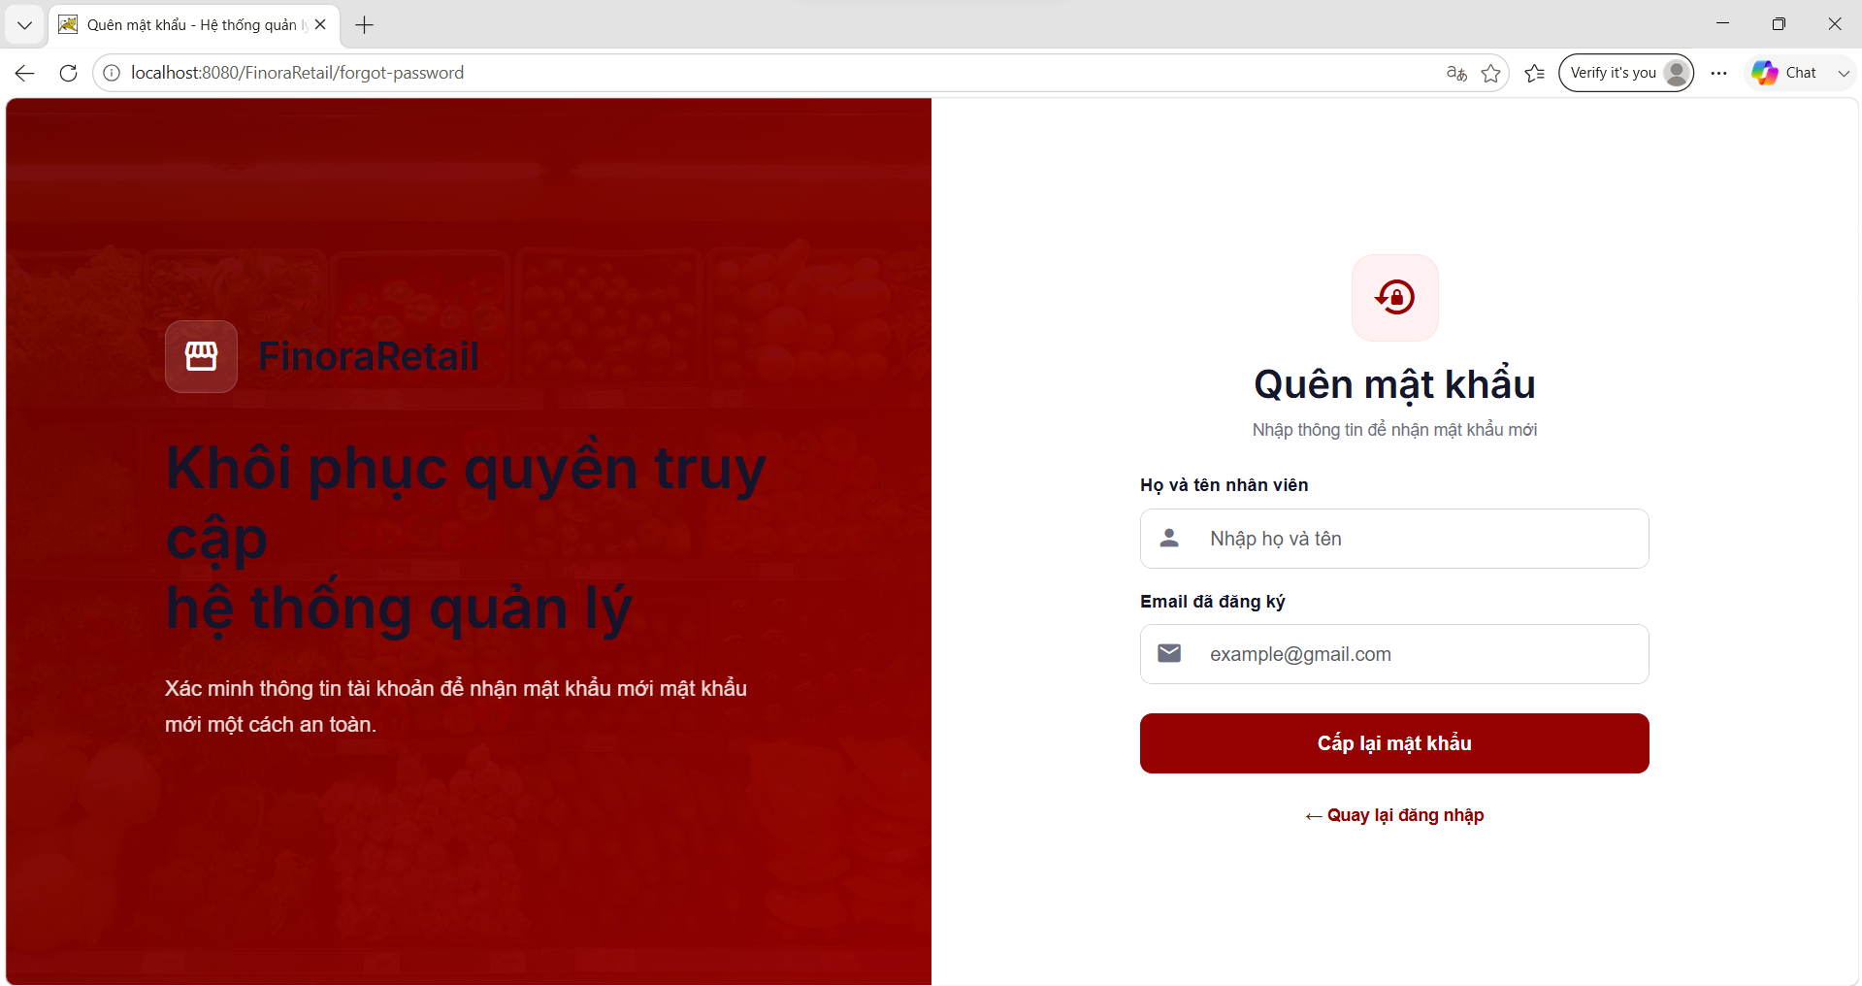
Field Name | Field Type | Description
Form Inputs
Full Name | Textbox | Enter your full name for security verification.
Email | Textbox | Enter the email address to receive the recovery link / OTP.
Actions
Send Request | Button | Submit a password recovery request
Back to Login | Link | Redirecting back to the login screen

Database Access
Table | CRUD | Description
Employee | R | Verify the match between the full name and email address in the system.
Employee | U | Update the new encrypted password string (passwordHash) after successful authentication.

SQL Commands
1/ Verify the existence and match between the full name and email.
SELECT COUNT(*)
FROM employee
WHERE LOWER(fullName) = LOWER(?) AND LOWER(email) = LOWER(?);

2/ Update new password (the new password has been Bcrypt-encrypted on the server)
UPDATE employee
SET passwordHash = ?,
update_at = CURRENT_TIMESTAMP
WHERE LOWER(email) = LOWER(?);

2. Customer Management

2.1 Customer List

a. Customer List
Displays a paginated list of active customers with search, filter, and quick-action controls.
Related use case(s):
- UC-4.12 – View Customer List

UI Design
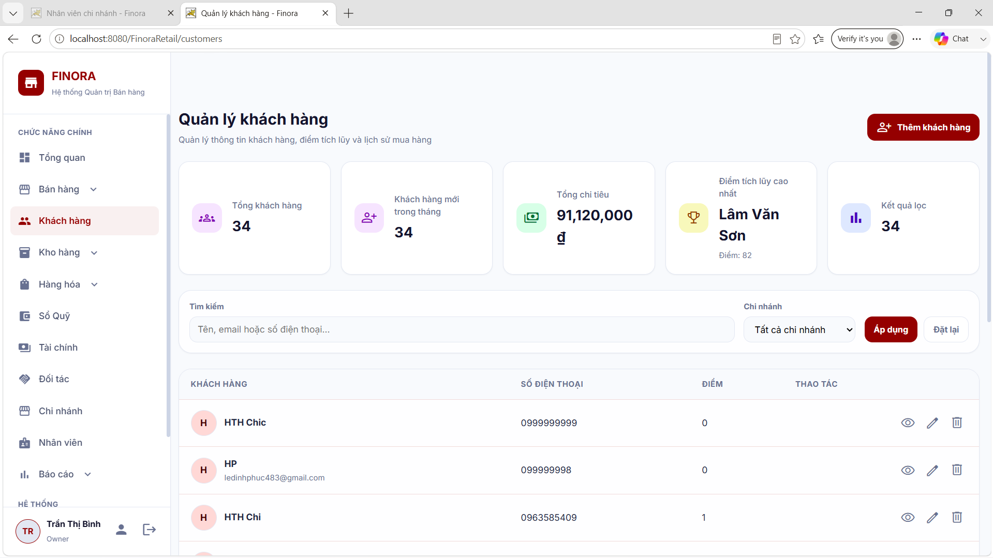

Field Name | Field Type | Description
Search & Filter
Keyword | Textbox | Search by name, phone, or email
Branch | Dropdown | Filter customers by branch (based on order branch)
Data Table Columns
Customer Name | Display | Full name of the customer
Phone | Display | Unique phone number
Email | Display | Email address
Gender | Display | Gender (Nam/Nữ)
Date of Birth | Display | Customer date of birth
Total Spent | Display (Currency) | Total amount spent (VND)
Loyalty Points | Display (Number) | Current loyalty points
Lifetime Points | Display (Number) | Lifetime accumulated points
Status | Badge | ACTIVE / INACTIVE
Actions
Actions | Button Group | View, Edit, Delete icons
Add Customer | Button | Opens the Create Customer form (StoreManager only)

Database Access
Table | CRUD | Description
customer | R | Load the customer list with pagination, keyword search, and branch filter
customer_point | R | Join to get current_points and lifetime_points
[order] | R | Filter customers by branch via an EXISTS subquery

SQL Commands
1/ Get customers (paginated, with search and branch filter)
SELECT c.cus_id, c.full_name, c.gender, c.bod, c.address, c.email, c.phone, c.total_spent, c.created_at, c.updated_at, c.status, cp.current_points, cp.lifetime_points
FROM customer c
LEFT
JOIN customer_point cp ON cp.cus_id = c.cus_id
WHERE c.status = 'ACTIVE'
AND (? IS NULL OR c.phone LIKE ? OR c.full_name LIKE ? OR c.email LIKE ?)
AND (? IS NULL OR EXISTS (SELECT 1
FROM [order] o
WHERE o.customer_id = c.cus_id
AND o.branch_id = ?))
ORDER BY CASE WHEN c.phone = ? THEN 1 WHEN c.phone LIKE ? THEN 2 WHEN c.full_name LIKE ? THEN 3 WHEN c.email LIKE ? THEN 4 ELSE 5 END, c.created_at DESC
OFFSET ? ROWS FETCH NEXT ? ROWS ONLY

2.2 Create Customer

a. Create Customer
Allows a StoreManager to create a new customer record.
Related use case(s):
- UC-4.8 – Create Customer

UI Design
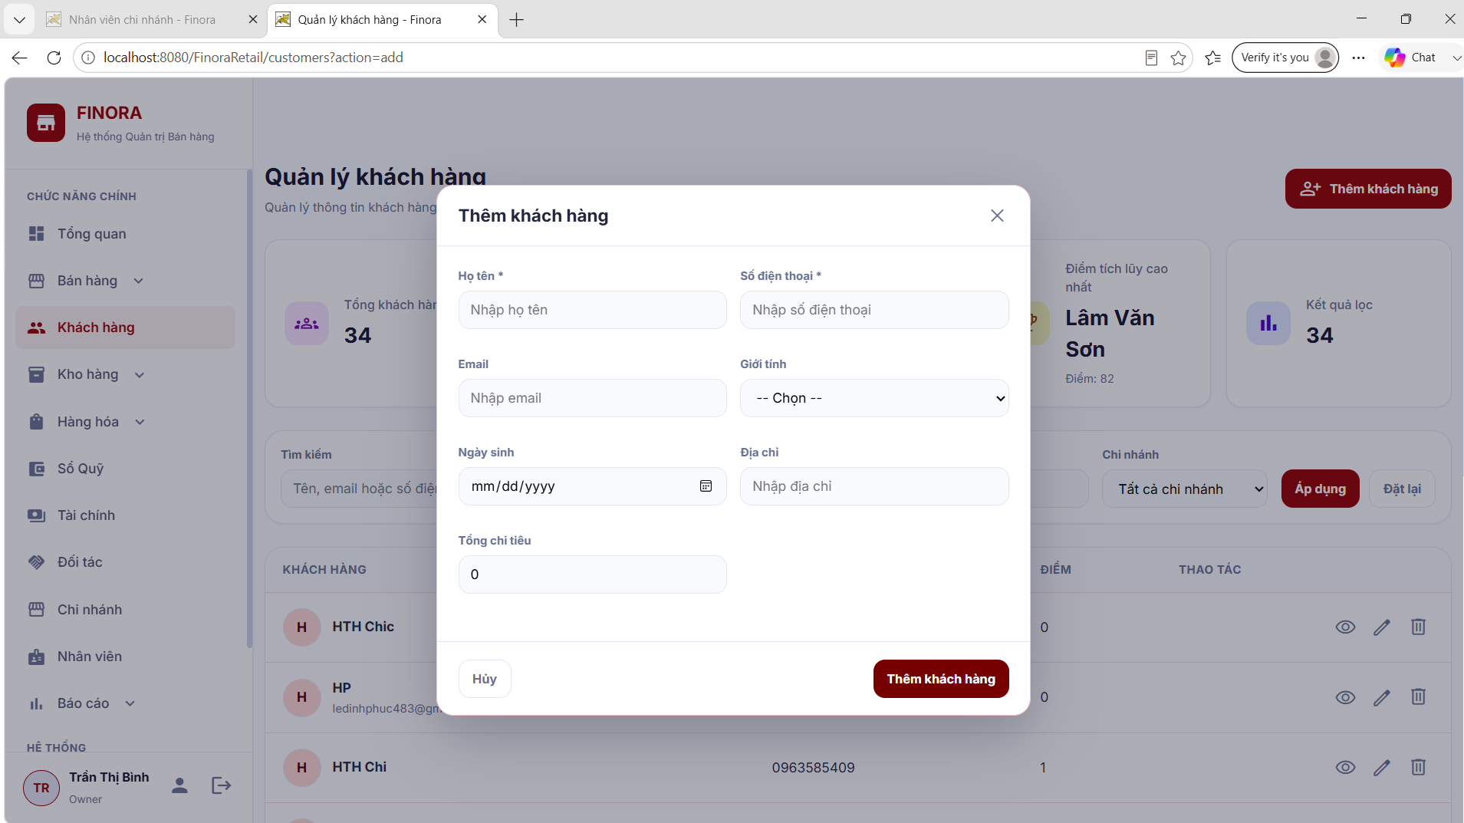
Field Name | Field Type | Description
Customer Information
Full Name | Textbox | Required
Phone | Textbox | Required, must be unique
Email | Textbox | Optional, unique if provided
Gender | Dropdown | Optional
Date of Birth | Date | Optional, must be a valid date
Address | Textbox | Optional
Actions
Save | Button | Submits the form and creates the customer
Cancel | Button | Discards the form

Database Access
Table | CRUD | Description
customer | C | Insert the new customer record
customer_point | C | Insert a default point record (0 points) for the new customer

SQL Commands
1/ Insert customer record
INSERT INTO customer (full_name, gender, bod, address, email, phone, total_spent, status, created_at, updated_at)
VALUES (?, ?, ?, ?, ?, ?, ?, 'ACTIVE', GETDATE(), GETDATE())

2/ Insert default point record
INSERT INTO customer_point (cus_id, current_points, lifetime_points, updated_at)
VALUES (?, 0, 0, GETDATE())

2.3 Edit Customer

a. Edit Customer
Updates the details of an existing customer.
Related use case(s):
- UC-4.11 – Manage Customer

UI Design
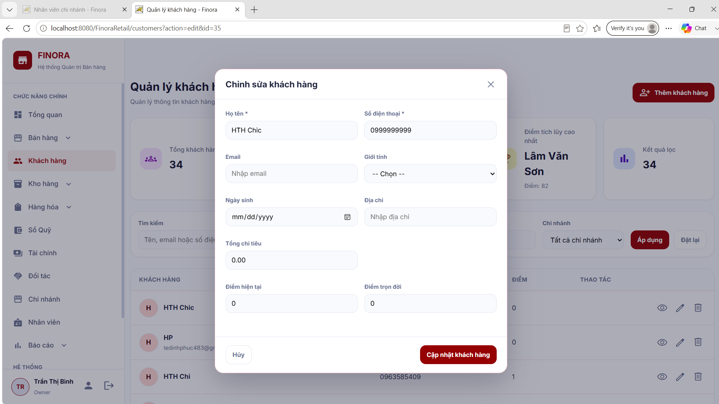
Field Name | Field Type | Description
Customer Information
Full Name | Textbox | Editable
Phone | Textbox | Editable; uniqueness check excludes the current record
Email | Textbox | Editable; uniqueness check excludes the current record
Gender | Dropdown | Editable
Date of Birth | Date | Editable
Address | Textbox | Editable
Total Spent | Currency | Editable

Database Access
Table | CRUD | Description
customer | U | Update customer details
customer_point | U | Update current/lifetime points ( only)

SQL Commands
1/ Update customer
UPDATE customer
SET full_name = ?, gender = ?, bod = ?, address = ?, email = ?, phone = ?, total_spent = ?, updated_at = GETDATE()
WHERE cus_id = ?

2.4 Delete Customer (Soft Delete)

a. Delete Customer
Soft-deletes a customer by setting their status to INACTIVE; the record is retained but hidden from active lists.
Related use case(s):
- UC-4.11 – Manage Customer

UI Design
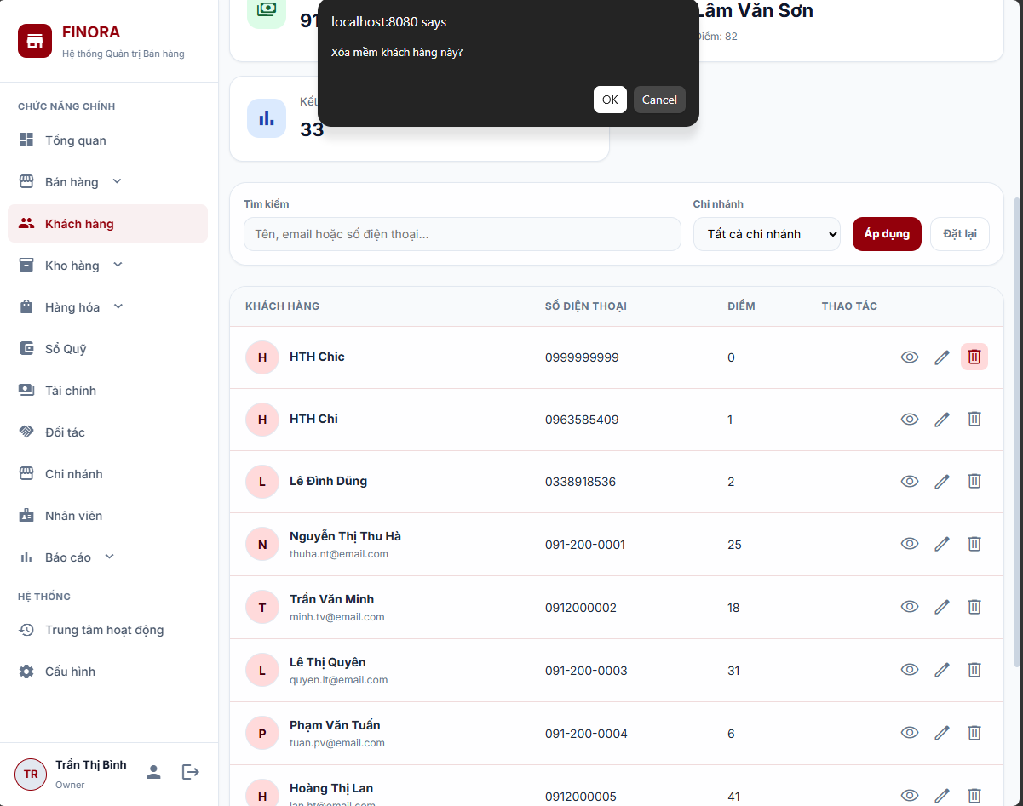
Field Name | Field Type | Description
Actions
Confirm Delete | Button | User confirms the soft-delete action
Cancel | Button | Cancels the action

Database Access
Table | CRUD | Description
customer | U | Set status = INACTIVE

SQL Commands
1/ Soft-delete customer
UPDATE customer
SET status = 'INACTIVE', updated_at = GETDATE()
WHERE cus_id = ?

2.5 Customer Detail

a. Customer Detail
Displays the full customer profile, including point-transaction history and order history.
- UC-4.11 – Manage Customer

UI Design
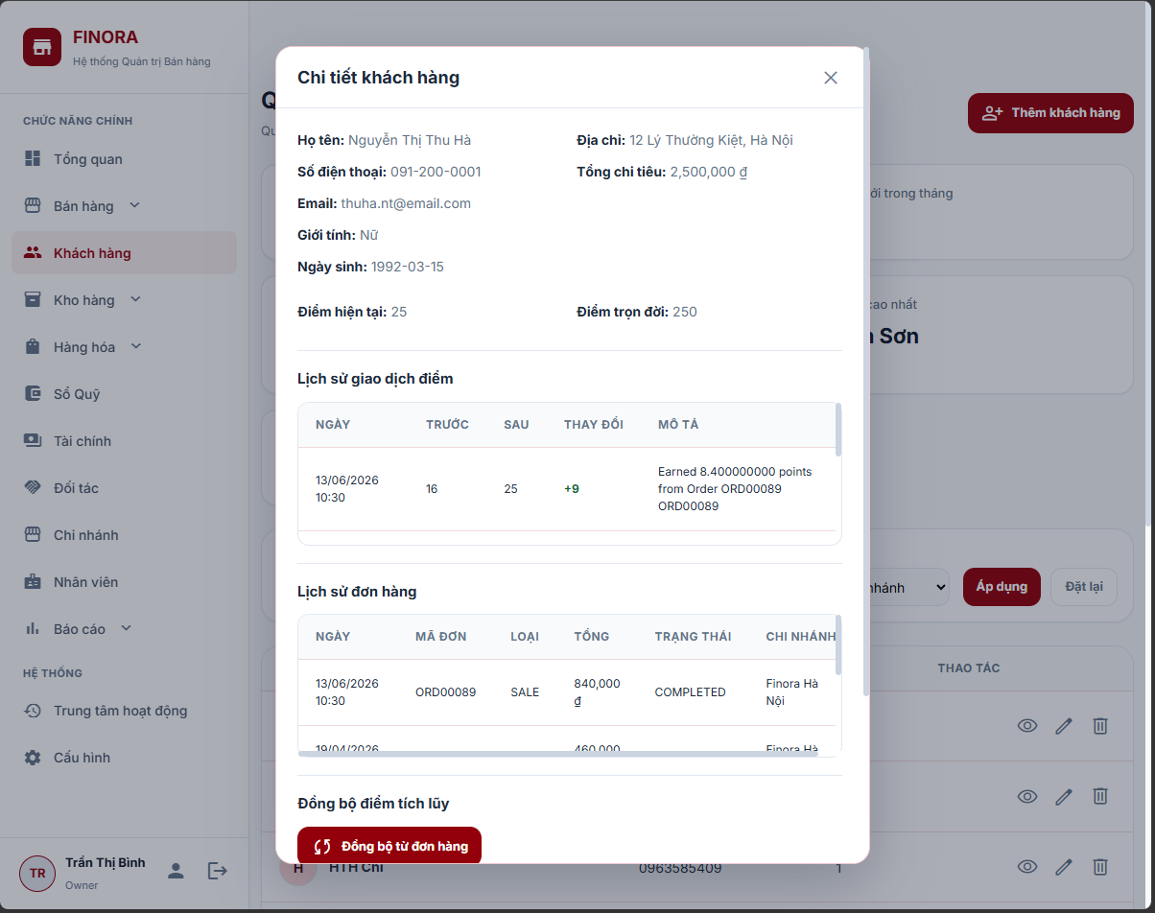
Field Name | Field Type | Description
Customer Information
Full Name / Phone / Email / Gender / DOB / Address | Display | Customer's stored personal information
Total Spent / Loyalty Points | Display | Customer's spending and points summary
Point Transaction History
Before Points | Display | Points balance before the transaction
After Points | Display | Points balance after the transaction
Description | Display | Reason for the point change
Date | Display | Transaction date
Order Code | Display | Related order (if any)
Order History
Order Code / Type / Amount / Status / Branch / Date | Display | Customer's past orders

Database Access
Table | CRUD | Description
point_transaction | R | Retrieve the points-transaction history for the customer
customer_point | R | Join to filter transactions by customer
[order] | R | Retrieve the order history for the customer

SQL Commands
1/ Get point transactions
SELECT pt.point_transaction_id, pt.before_points, pt.after_points, pt.description, pt.created_at, o.order_code
FROM point_transaction pt
JOIN customer_point cp ON pt.cus_point_id = cp.cus_point_id
LEFT
JOIN [order] o ON pt.order_id = o.order_id
WHERE cp.cus_id = ?
ORDER BY pt.created_at DESC

2/ Get order history
SELECT o.order_id, o.order_code, o.order_type, o.total_amount, o.status, o.created_at, b.branch_name
FROM [order] o
LEFT
JOIN branch b ON o.branch_id = b.branch_id
WHERE o.customer_id = ?
ORDER BY o.created_at DESC

2.6 Loyalty Points Management

a. Sync Loyalty
Recalculates a customer's total_spent from paid orders and updates their loyalty points via a MERGE statement.
Related use case(s):
- UC-4.9 – Accumulate Loyalty Points

UI Design
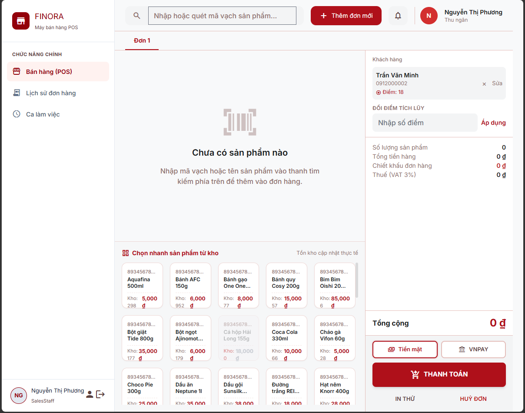
Field Name | Field Type | Description
Actions
Sync Loyalty | Button | Recalculates and updates the customer's points

Database Access
Table | CRUD | Description
[order] | R | Calculate total spent from paid orders
customer_point | C/U | Insert or update the points record (MERGE)

SQL Commands
1/ Calculate spent from paid orders
SELECT COALESCE(SUM(total_amount), 0) AS spent
FROM [order] o
WHERE o.customer_id = ?
AND (LOWER(o.status) = 'paid' OR EXISTS (SELECT 1
FROM payment p
WHERE p.order_id = o.order_id
AND LOWER(p.payment_status) = 'paid'))

2/ Update points via MERGE
MERGE customer_point AS target USING (SELECT ? AS cus_id) AS source ON target.cus_id = source.cus_id
WHEN MATCHED THEN
UPDATE
SET current_points = ?, lifetime_points = ?, updated_at = GETDATE()
WHEN NOT MATCHED THEN INSERT (cus_id, current_points, lifetime_points, updated_at)
VALUES (?, ?, ?, GETDATE());

b. Redeem Points
Deducts loyalty points from a customer's balance and logs the redemption as a point transaction.
Related use case(s):
- UC-4.10 – Redeem Points

UI Design
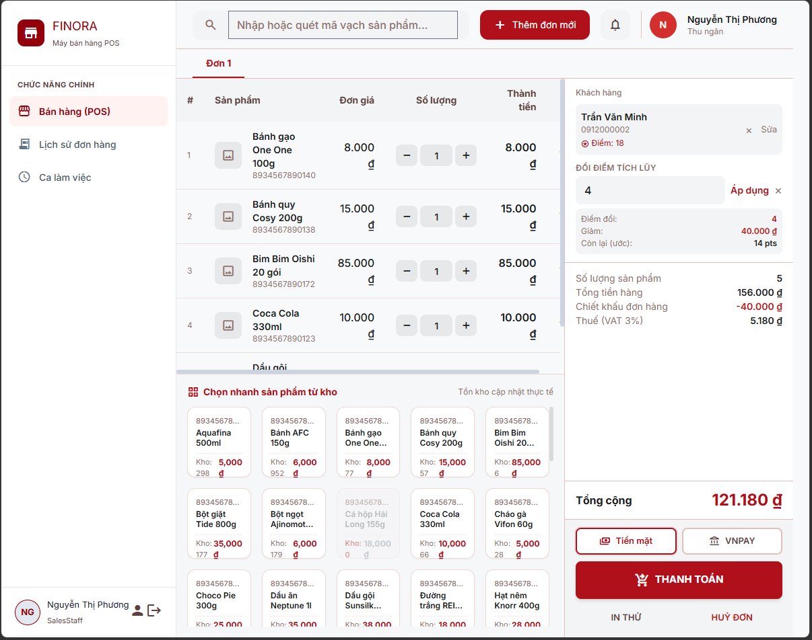
Field Name | Field Type | Description
Actions
Redeem Points | Number (input) | Number of points to redeem
Confirm | Button | Submits the redemption

Database Access
Table | CRUD | Description
customer_point | R, U | Check and deduct the current points
point_transaction | C | Log the redemption transaction

SQL Commands
1/ Check current points
SELECT cus_point_id, current_points
FROM customer_point
WHERE cus_id = ?

2/ Deduct points and log the transaction
UPDATE customer_point
SET current_points = ?, updated_at = GETDATE()
WHERE cus_point_id = ?;
INSERT INTO point_transaction (cus_point_id, order_id, before_points, after_points, description, created_at)
VALUES (?, NULL, ?, ?, ?, GETDATE())

2.7 POS API (AJAX)

a. POS Customer API
Exposes JSON API endpoints, consumed by the POS module, for searching, quick-creating, and quick-updating customers during checkout.
Related use case(s):
- UC-4.7 – Look Up Customer

UI Design
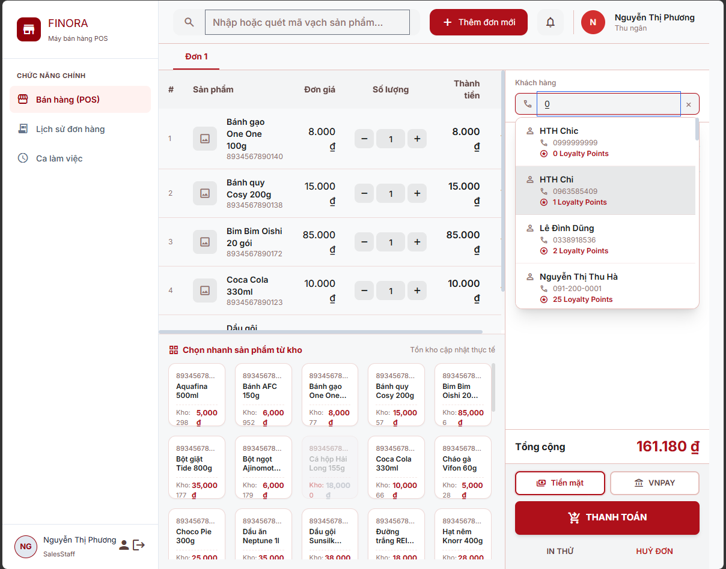
Field Name | Field Type | Description
POS Search / Quick Form
Keyword | Textbox | Search by name, phone, or email (POS autocomplete)
Full Name / Phone / Email | Textbox | Quick create/update fields

Database Access
Table | CRUD | Description
customer | R | Search customers for POS
customer | C | Quick create a customer from POS
customer | U | Quick update phone/email from POS

SQL Commands
Reuses the same SELECT / INSERT / UPDATE statements as Customer List (1.1), Create Customer (1.2), and Edit Customer (1.3) above, with the update case scoped to the phone/email fields only.

3. Employee Management

3.1 Employee List

a. Employee List
Allows to view and manage all employee accounts across the system.
Related use case(s):
- UC-1.3 – Manage Staff Accounts

UI Design
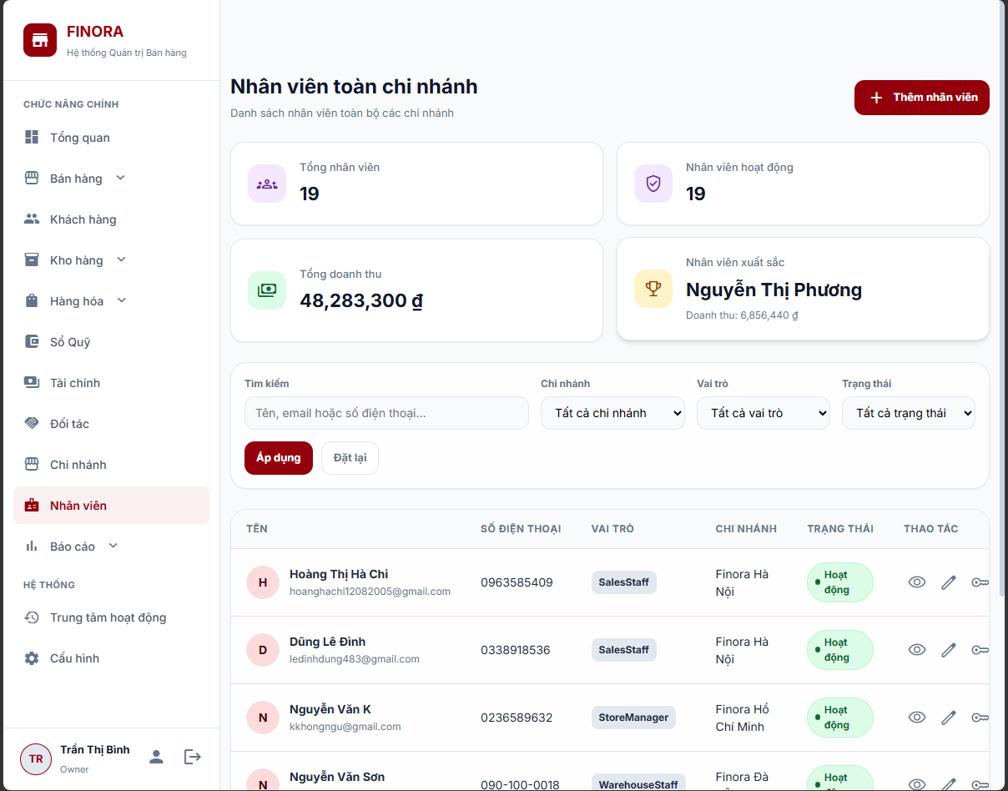
Field Name | Field Type | Description
Search & Filter
Keyword | Textbox | Search by name, email, or phone
Branch | Dropdown | Filter by branch
Role | Dropdown | Filter by role
Status | Dropdown | Filter by ACTIVE/INACTIVE
Data Table Columns
Full Name | Display | Employee full name
Email | Display | Email address
Phone | Display | Phone number
Role | Display | Role name from the Role table
Branch | Display | Branch name from the Branch table
Status | Badge | ACTIVE / INACTIVE
Created At | Display | Account creation date
Actions
Actions | Button Group | Edit, Lock/Unlock, Reset Password, View Profile
Add Employee | Button | Opens the Create Employee form

Database Access
Table | CRUD | Description
Employee | R | Load the employee list with JOIN to Role and Branch
Role | R | Get role name
Branch | R | Get branch name
[order] | R | Calculate overview metrics

SQL Commands
1/ Get all employees ( paginated)
SELECT DISTINCT e.emp_id AS EmployeeID, e.role_id AS RoleID, e.branch_id AS BranchID, e.fullName AS FullName, e.email AS Email, e.phone AS Phone, e.status AS Status, e.created_at AS CreatedAt, e.image_URL AS AvatarUrl, r.role_name AS RoleName, b.branch_name AS BranchName
FROM Employee e
LEFT
JOIN Role r ON e.role_id = r.role_id
LEFT
JOIN Branch b ON e.branch_id = b.branch_id
WHERE (? IS NULL OR e.fullName LIKE ? OR e.email LIKE ? OR e.phone LIKE ?)
AND (? IS NULL OR e.branch_id = ?)
AND (? IS NULL OR e.role_id = ?)
AND (? IS NULL OR e.status = ?)
ORDER BY e.emp_id DESC
OFFSET ? ROWS FETCH NEXT ? ROWS ONLY

3.2 Create Employee (Owner)

a. Create Employee
creates a new employee account.
Related use case(s):
- UC-1.3 – Manage Staff Accounts

UI Design
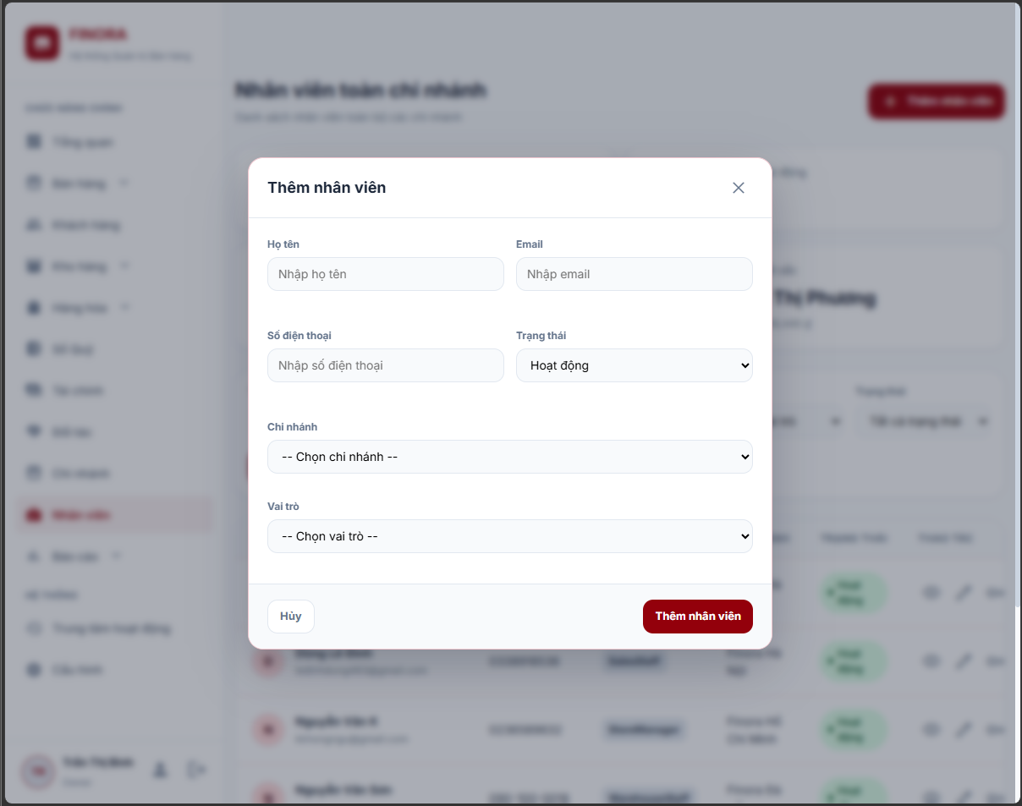
Field Name | Field Type | Description
Employee Information
Role | Dropdown | Required
Branch | Dropdown | Required
Full Name | Textbox | Required
Email | Textbox | Required, unique
Phone | Textbox | Required, unique
Status | Display | Defaults to ACTIVE

Database Access
Table | CRUD | Description
Employee | C | Insert the new employee record

SQL Commands
1/ Insert employee
INSERT INTO Employee (role_id, branch_id, fullName, email, phone, passwordHash, status, created_at, update_at)
VALUES (?, ?, ?, ?, ?, ?, ?, GETDATE(), GETDATE())

3.3 Edit Employee (Owner)

a. Edit Employee
updates employee details (role, branch, name, email, phone, status).
Related use case(s):
- UC-1.3 – Manage Staff Accounts

UI Design
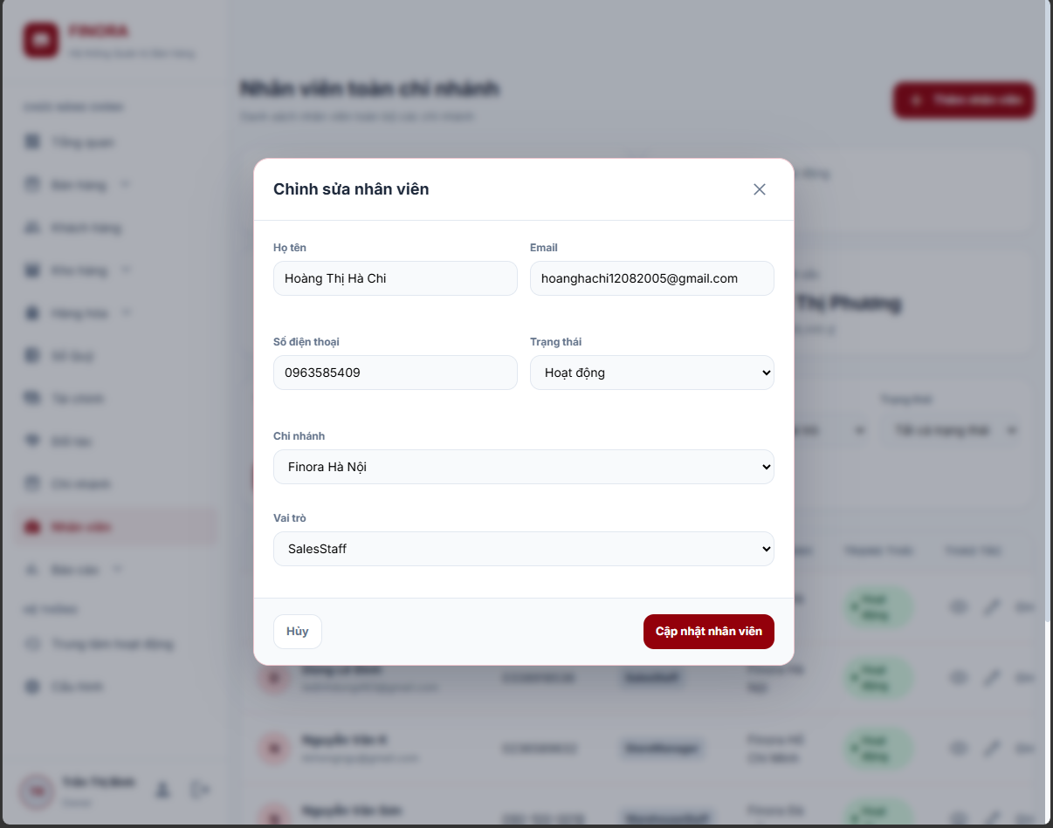
Field Name | Field Type | Description
Employee Information
Role | Dropdown | Editable
Branch | Dropdown | Editable
Full Name | Textbox | Editable
Email | Textbox | Editable
Phone | Textbox | Editable
Status | Dropdown | Editable

Database Access
Table | CRUD | Description
Employee | U | Update the employee record

SQL Commands
1/ Update employee
UPDATE Employee
SET role_id = ?, branch_id = ?, fullName = ?, email = ?, phone = ?, status = ?, update_at = GETDATE()
WHERE emp_id = ?

3.4 Lock/Unlock Employee ( )

a. Lock/Unlock Employee
locks (sets INACTIVE) or unlocks (sets ACTIVE) an employee account.

UI Design
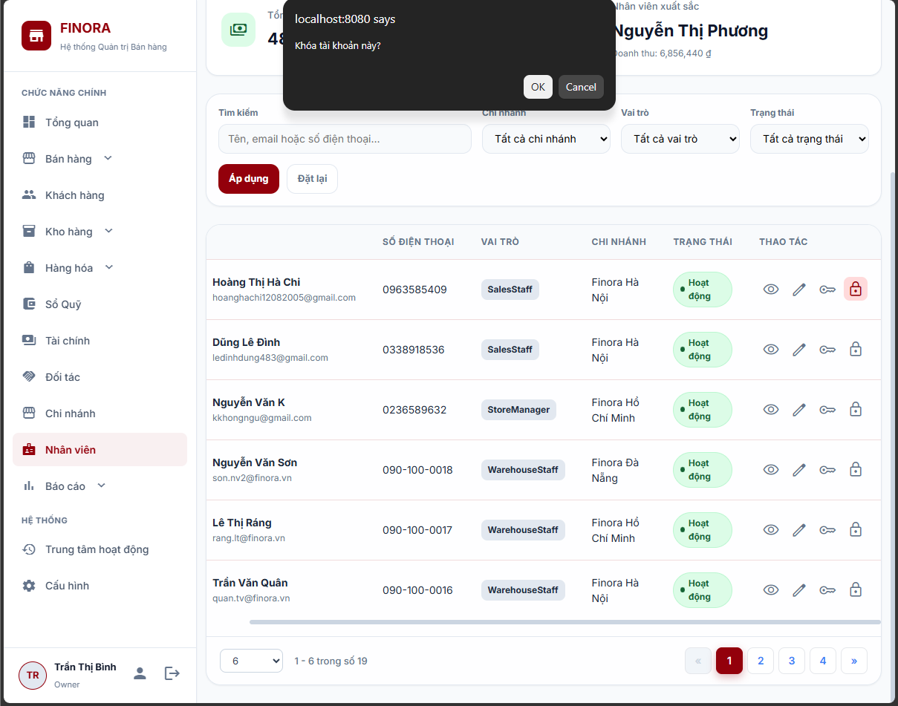
Field Name | Field Type | Description
Actions
Status Toggle | Button | Locks or unlocks the account

Database Access
Table | CRUD | Description
Employee | U | Update status

SQL Commands
1/ Update employee status
UPDATE Employee
SET status = ?, update_at = GETDATE()
WHERE emp_id = ?

3.5 Employee List (StoreManager)

a. Employee List (StoreManager)
StoreManager views employee accounts within their assigned branch only, read-only.
Related use case(s):
- UC-1.3 – Manage Staff Accounts

UI Design
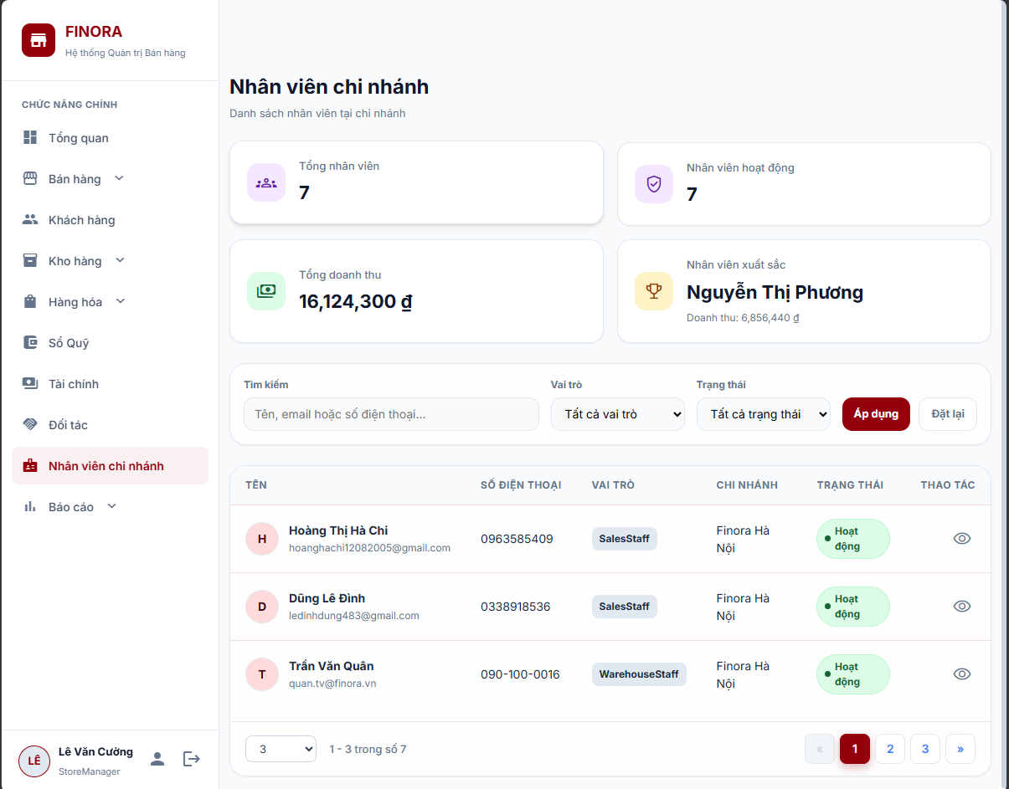
Field Name | Field Type | Description
Data Table Columns
Full Name / Email / Phone / Role / Status | Display | Same as Employee List ( )

Database Access
Table | CRUD | Description
Employee | R | Load employee list filtered by branch_id

SQL Commands
1/ Additional WHERE clause appended to the base query
WHERE e.branch_id = ?
AND (r.role_name IS NULL OR r.role_name NOT IN (' ', 'Owner'))

3.6 Employee View Profile

a. Employee View Profile
Owner/Manager views a detailed, read-only employee profile including sales-performance data.
Related use case(s):
- UC-1.7 – View Profile

UI Design
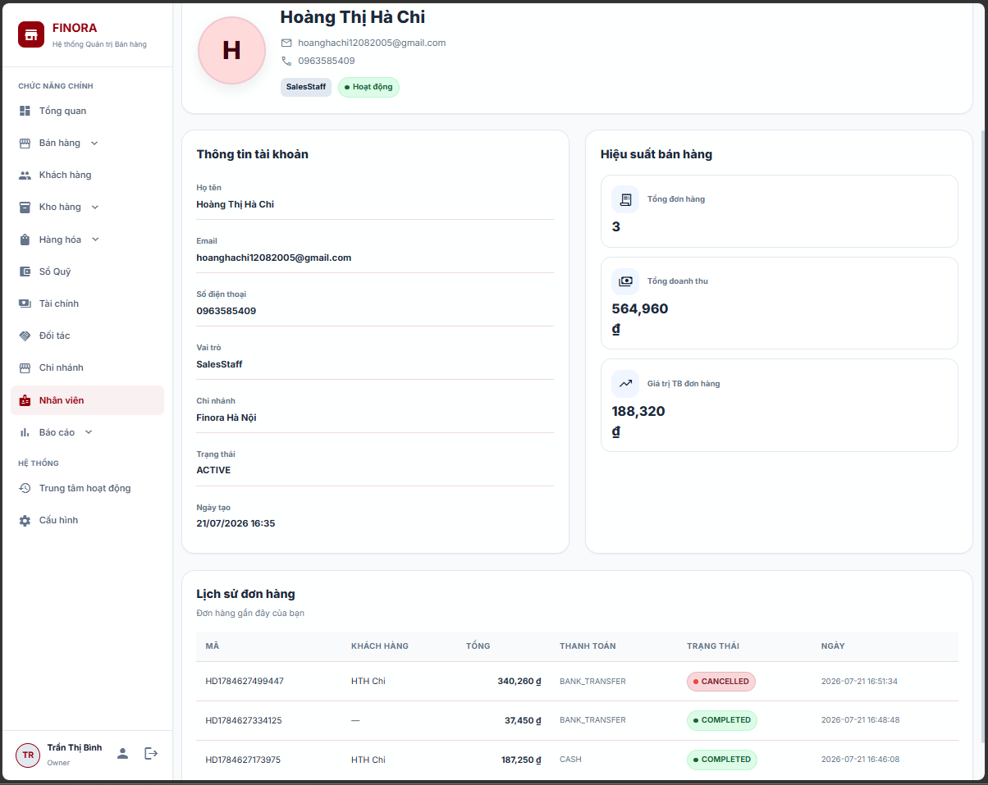
Field Name | Field Type | Description
Profile & Sales Summary
Full Name / Email / Phone / Role / Branch / Status | Display | Employee's stored information
Total Orders / Total Revenue / Avg Order Value | Display | Sales performance summary

Database Access
Table | CRUD | Description
Employee | R | Get profile by ID with JOIN to Role and Branch
[Order] | R | Get sales summary (total orders, revenue, average)

SQL Commands
Reuses the Get Profile and Get Employee Sales Summary queries from User Profile (3.1).

4. User Profile

4.1 View Profile

a. View Profile
Displays the logged-in user's personal information and, for sales staff, a sales-performance summary.

UI Design
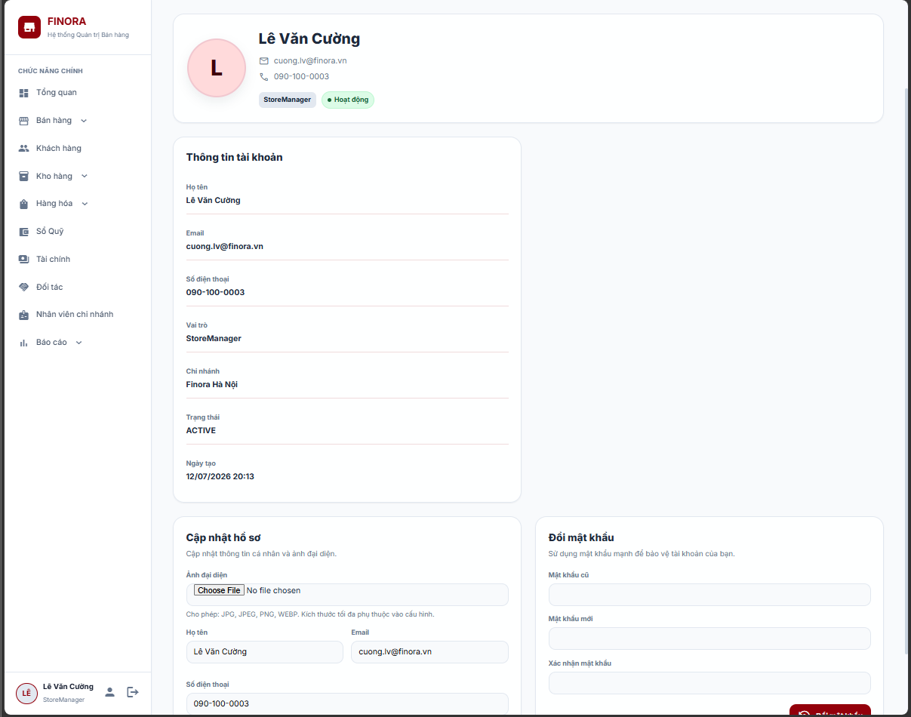
Field Name | Field Type | Description
Personal Information
Avatar | Image | Upload | Employee photo (JPG/PNG/WEBP, max 5MB)
Full Name | Textbox | Employee full name
Email | Textbox | Unique email, checked for duplicates
Phone | Textbox | Phone number
Role | Display | Role name from DB
Branch | Display | Assigned branch name
Status | Badge | ACTIVE / INACTIVE
Sales Summary (SalesStaff only)
Total Orders | Number (display) | Total orders processed
Total Revenue | Currency (display) | Sum of order amounts
Avg Order Value | Currency (display) | Average order value

Database Access
Table | CRUD | Description
Employee | R | Get profile by ID with JOIN to Role and Branch
[Order] | R | Get sales summary (total orders, revenue, average)

SQL Commands
1/ Get profile
SELECT DISTINCT e.emp_id AS EmployeeID, e.role_id AS RoleID, e.branch_id AS BranchID, e.FullName, e.Email, e.Phone, e.image_URL AS AvatarUrl, e.Status, e.created_at AS CreatedAt, b.branch_name AS BranchName, r.role_name AS RoleNames
FROM Employee e
LEFT
JOIN Branch b ON e.branch_id = b.branch_id
LEFT
JOIN Role r ON e.role_id = r.role_id
WHERE e.emp_id = ?
2/ Get employee sales summary
SELECT e.emp_id AS EmployeeID, e.FullName, b.branch_name AS BranchName, COUNT(o.order_id) AS TotalOrders, COALESCE(SUM(o.total_amount), 0) AS TotalRevenue, COALESCE(AVG(o.total_amount), 0) AS AverageOrderValue
FROM Employee e
LEFT
JOIN Branch b ON e.branch_id = b.branch_id
LEFT
JOIN [Order] o ON e.emp_id = o.emp_id
WHERE e.emp_id = ?
GROUP BY e.emp_id, e.FullName, b.branch_name

4.2 Update Profile

a. Update Profile
Updates personal information (name, email, phone, avatar).
Related use case(s):
- UC-1.9 – Update Profile

UI Design

Field Name | Field Type | Description
Editable Fields
Full Name | Textbox | Required
Email | Textbox | Required, unique (excluding current user)
Phone | Textbox | Optional
Avatar | Image | Upload | JPG/JPEG/PNG/WEBP, max 5MB

Database Access
Table | CRUD | Description
Employee | U | Update profile (name, email, phone, avatar)

SQL Commands
1/ Update employee profile
UPDATE Employee
SET FullName = ?, Email = ?, Phone = ?, image_URL = ?, update_at = GETDATE()
WHERE emp_id = ?

4.3 Change Password

a. Change Password
Changes the account password.
Related use case(s):
- UC-1.8 – Change Password

UI Design

Field Name | Field Type | Description
Password Fields
Old Password | Password Box | Required, must match current hash
New Password | Password Box | Required
Confirm Password | Password Box | Required, must match New Password

Database Access
Table | CRUD | Description
Employee | R | Get current password hash
Employee | U | Update password hash

SQL Commands
1/ Get current hash
SELECT PasswordHash
FROM Employee
WHERE emp_id = ?

2/ Update password
UPDATE Employee
SET PasswordHash = ?, update_at = GETDATE()
WHERE emp_id = ?

4.4 Avatar Upload

a. Avatar Upload
Uploads and updates the profile avatar image.

UI Design

Field Name | Field Type | Description
Upload
Avatar File | Image | Upload | JPG/JPEG/PNG/WEBP, max 5MB

Database Access
Table | CRUD | Description
Employee | U | Update image_URL

SQL Commands
Reuses the Update Profile query (3.2), updating only the image_URL column.

5. Employee Sales Report

5.1 Employee Sales Report Screen
Owner/StoreManager view employee sales-performance metrics with filtering, preview, and PDF export.

UI Design
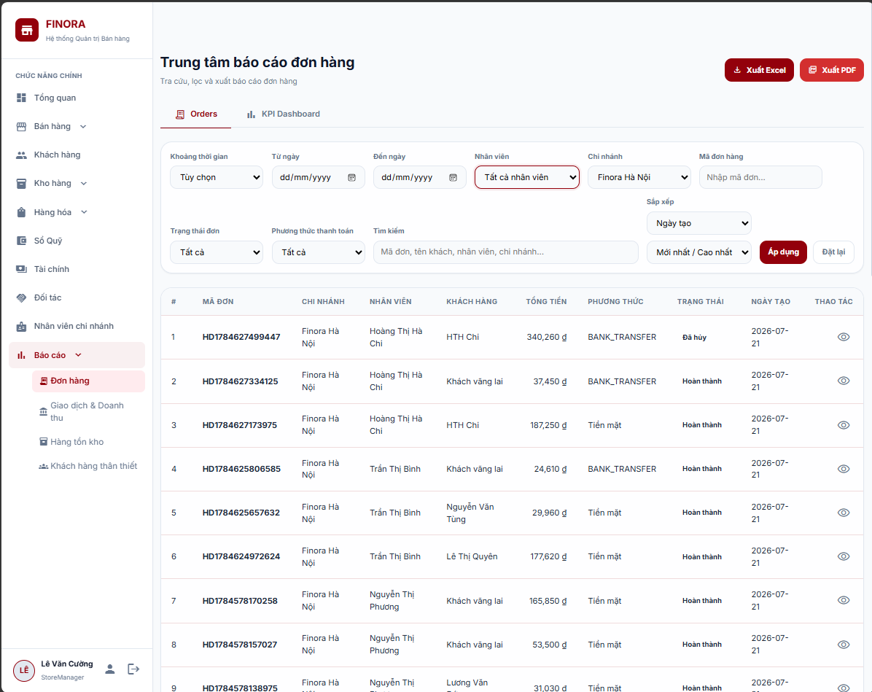
Field Name | Field Type | Description
Filters
Keyword | Textbox | Search by employee name, email, or phone
Branch | Dropdown | Filter by branch (auto-filtered for StoreManager)
Date From | Datepicker | Filter orders from this date (inclusive)
Date To | Datepicker | Filter orders to this date (inclusive)
Overview Cards
Total Employees / Active Employees | Display | Employee counts
Total Orders / Total Revenue | Display | Aggregated order metrics
Top Employee / Lowest Employee | Display | Name + revenue
Avg Revenue Per Employee | Display | Total revenue divided by total employees
Data Table Columns
Employee Name / Branch / Role | Display | Employee identification
Total Orders / Completed Orders / Cancelled Orders | Number | Order counts by status
Total Revenue / Average Order Value | Currency | Revenue metrics
Actions
Preview Full Report | Button | Opens the preview page with all records
Export PDF | Button | Generates and downloads the PDF report

Database Access
Table | CRUD | Description
Employee | R | List employees (excludes Owner)
Role | R | Get role name
Branch | R | Get branch name
[Order] | R | Count orders, sum revenue, calculate averages

SQL Commands
1/ Get employee sales report (paginated)
SELECT e.emp_id, e.fullName, b.branch_name AS BranchName, r.role_name AS RoleName, COUNT(o.order_id) AS TotalOrders, COALESCE(SUM(o.total_amount), 0) AS TotalRevenue, COALESCE(AVG(o.total_amount), 0) AS AverageOrderValue, COUNT(CASE WHEN o.status = 'COMPLETED' THEN 1 END) AS CompletedOrders, COUNT(CASE WHEN o.status = 'CANCELLED' THEN 1 END) AS CancelledOrders
FROM Employee e
LEFT
JOIN [Role] r ON e.role_id = r.role_id
LEFT
JOIN Branch b ON e.branch_id = b.branch_id
LEFT
JOIN [Order] o ON e.emp_id = o.emp_id
AND (? IS NULL OR CAST(o.created_at AS DATE) >= ?)
AND (? IS NULL OR CAST(o.created_at AS DATE) <= ?)
WHERE (r.role_name IS NULL OR r.role_name NOT IN (' ', 'Owner'))
AND (? IS NULL OR e.fullName LIKE ? OR e.email LIKE ? OR e.phone LIKE ?)
AND (? IS NULL OR e.branch_id = ?)
GROUP BY e.emp_id, e.fullName, b.branch_name, r.role_name
ORDER BY TotalRevenue DESC, fullName ASC
OFFSET ? ROWS FETCH NEXT ? ROWS ONLY

2/ Get report overview
SELECT COUNT(DISTINCT e.emp_id) AS TotalEmployees, COUNT(DISTINCT CASE WHEN LOWER(e.status) = 'active' THEN e.emp_id END) AS ActiveEmployees
FROM Employee e
LEFT
JOIN [Role] r ON e.role_id = r.role_id
WHERE (r.role_name IS NULL OR r.role_name NOT IN (' ', 'Owner'))
AND (? IS NULL OR e.fullName LIKE ? OR e.email LIKE ? OR e.phone LIKE ?)
AND (? IS NULL OR e.branch_id = ?);
SELECT COUNT(o.order_id) AS TotalOrders, COALESCE(SUM(o.total_amount), 0) AS TotalRevenue
FROM [Order] o
JOIN Employee e ON o.emp_id = e.emp_id
LEFT
JOIN [Role] r ON e.role_id = r.role_id
WHERE (r.role_name IS NULL OR r.role_name NOT IN (' ', 'Owner'))
AND (? IS NULL OR e.fullName LIKE ? OR e.email LIKE ? OR e.phone LIKE ?)
AND (? IS NULL OR e.branch_id = ?)
AND (? IS NULL OR CAST(o.created_at AS DATE) >= ?)
AND (? IS NULL OR CAST(o.created_at AS DATE) <= ?)

3/ Get top / lowest employee
SELECT TOP 1 e.fullName, COALESCE(SUM(o.total_amount), 0) AS EmployeeRevenue
FROM Employee e
LEFT
JOIN [Role] r ON e.role_id = r.role_id
LEFT
JOIN Branch b ON e.branch_id = b.branch_id
LEFT
JOIN [Order] o ON e.emp_id = o.emp_id
AND (? IS NULL OR CAST(o.created_at AS DATE) >= ?)
AND (? IS NULL OR CAST(o.created_at AS DATE) <= ?)
WHERE (r.role_name IS NULL OR r.role_name NOT IN (' ', 'Owner'))
AND (? IS NULL OR e.fullName LIKE ? OR e.email LIKE ? OR e.phone LIKE ?)
AND (? IS NULL OR e.branch_id = ?)
GROUP BY e.emp_id, e.fullName
ORDER BY EmployeeRevenue DESC, e.fullName ASC; -- Lowest employee uses the same query with
ORDER BY EmployeeRevenue ASC, e.fullName ASC
AND HAVING COALESCE(SUM(o.total_amount), 0) > 0

5.2 PDF Export

a. PDF Export
Exports the employee sales report to a PDF file.

UI Design
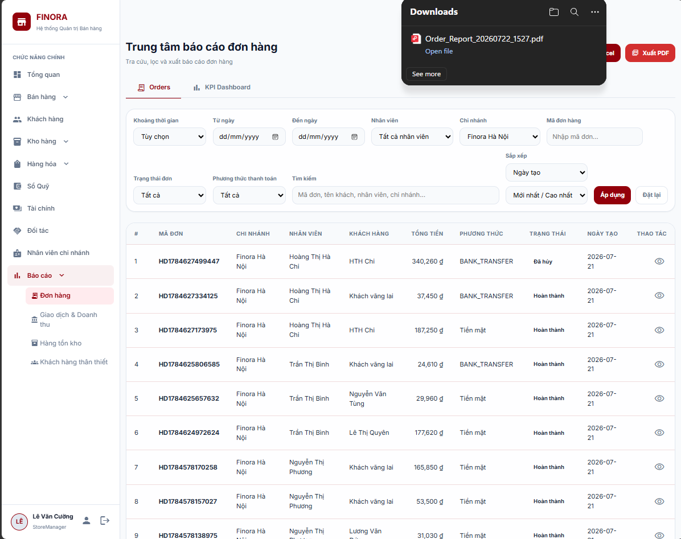
Field Name | Field Type | Description
Actions
Export PDF | Button | Triggers PDF generation and download

Database Access
Table | CRUD | Description
Employee | R | Same data source as Full Report Preview (4.2)
Role | R | Get role name
Branch | R | Get branch name
[Order] | R | Count orders, sum revenue, calculate averages

SQL Commands
Reuses the same queries as the Report Screen (4.1) and Full Report Preview (4.2) to build the report data used for PDF rendering.

6. Category Management

6.1 Category List

a. Category List
Displays a paginated list of product categories with multi-criteria search (by category name, description, parent category name, linked product name), status filtering (active/inactive)
Related use case(s):
UC-4.1 – Manage Product Categories

UI Design
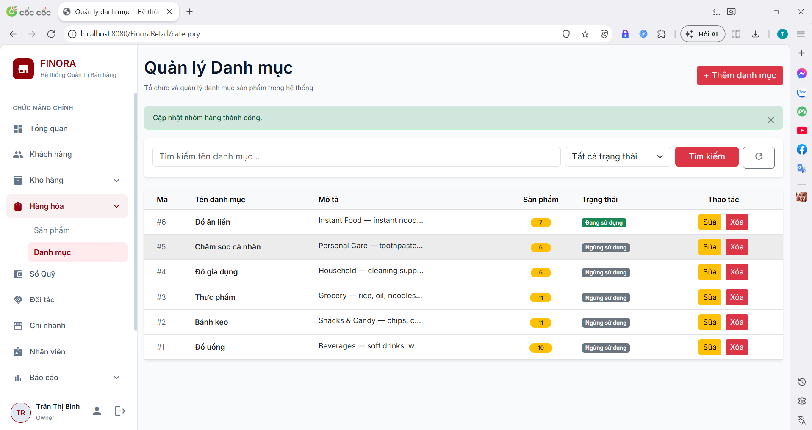

Field Name | Field Type | Description
Keyword | Textbox | Search by category name, description, parent category, or linked product name.
Status | Dropdown | Filter by status: Active (active) or Inactive (inactive).
Linked Products | Stat Card (Display) | Displays total count of products associated with categories.
CategoryID | Table Cell | Unique primary key identifier for the category.
Category Name | Table Cell | Name of the product category (CategoryName).
Description | Table Cell | Detailed description of the category.
Product Count | Table Cell | Number of products linked to this category.
Status | Badge | Status badge: active (green) or inactive (red).
+ Add Category | Button | Opens modal dialog to create a new category.
Actions (Edit / Delete) | Action Buttons | Pencil icon button to edit, trash icon button to delete category.

Database Access
Table | CRUD | Description
category | R | Queries category list, performs self-join to retrieve parent category names and summary statistics.
product | R | Counts linked products per category (COUNT(product_id)).

SQL Commands
1/ Get category statistics & summary metrics (using CTE CategoryStats):
WITH CategoryStats AS (
SELECT c.category_id, c.parent_category_id AS ParentCategoryID, c.status, c.category_name, c.description, p.category_name AS ParentName,
COUNT(pr.product_id) AS ProductCount
FROM category c
LEFT JOIN category p ON c.parent_category_id = p.category_id
LEFT JOIN product pr ON c.category_id = pr.category_id
WHERE 1=1
AND (LOWER(c.category_name) LIKE ? OR LOWER(c.description) LIKE ? OR LOWER(p.category_name) LIKE ? OR EXISTS (SELECT 1 FROM product pr2 WHERE pr2.category_id = c.category_id AND LOWER(pr2.product_name) LIKE ?))
AND c.status = ?
GROUP BY c.category_id, c.parent_category_id, c.status, c.category_name, c.description, p.category_name
)
SELECT
COUNT(*) AS TotalItems,
SUM(CASE WHEN ParentCategoryID IS NULL THEN 1 ELSE 0 END) AS TotalRootCategories,
SUM(ProductCount) AS TotalLinkedProducts
FROM CategoryStats;
2/ Get paginated categories with search & filter (OFFSET / FETCH NEXT):
SELECT c.category_id AS CategoryID, c.category_name AS Name, c.description AS Description,
c.parent_category_id AS ParentCategoryID, c.status AS Status,
p.category_name AS ParentName, COUNT(pr.product_id) AS ProductCount
FROM category c
LEFT JOIN category p ON c.parent_category_id = p.category_id
LEFT JOIN product pr ON c.category_id = pr.category_id
WHERE 1=1
AND (LOWER(c.category_name) LIKE ? OR LOWER(c.description) LIKE ? OR LOWER(p.category_name) LIKE ? OR EXISTS (SELECT 1 FROM product pr2 WHERE pr2.category_id = c.category_id AND LOWER(pr2.product_name) LIKE ?))
AND c.status = ?
GROUP BY c.category_id, c.category_name, c.description, c.parent_category_id, c.status, p.category_name
ORDER BY c.category_id DESC
OFFSET ? ROWS FETCH NEXT ? ROWS ONLY;

6.2 Create Category

a. Create Category
Opens a modal dialog allowing users to create a new category by entering name, description and setting active/inactive status. Performs validation to prevent duplicate category names.
Related use case(s):
UC-4.1 – Manage Product Categories

UI Design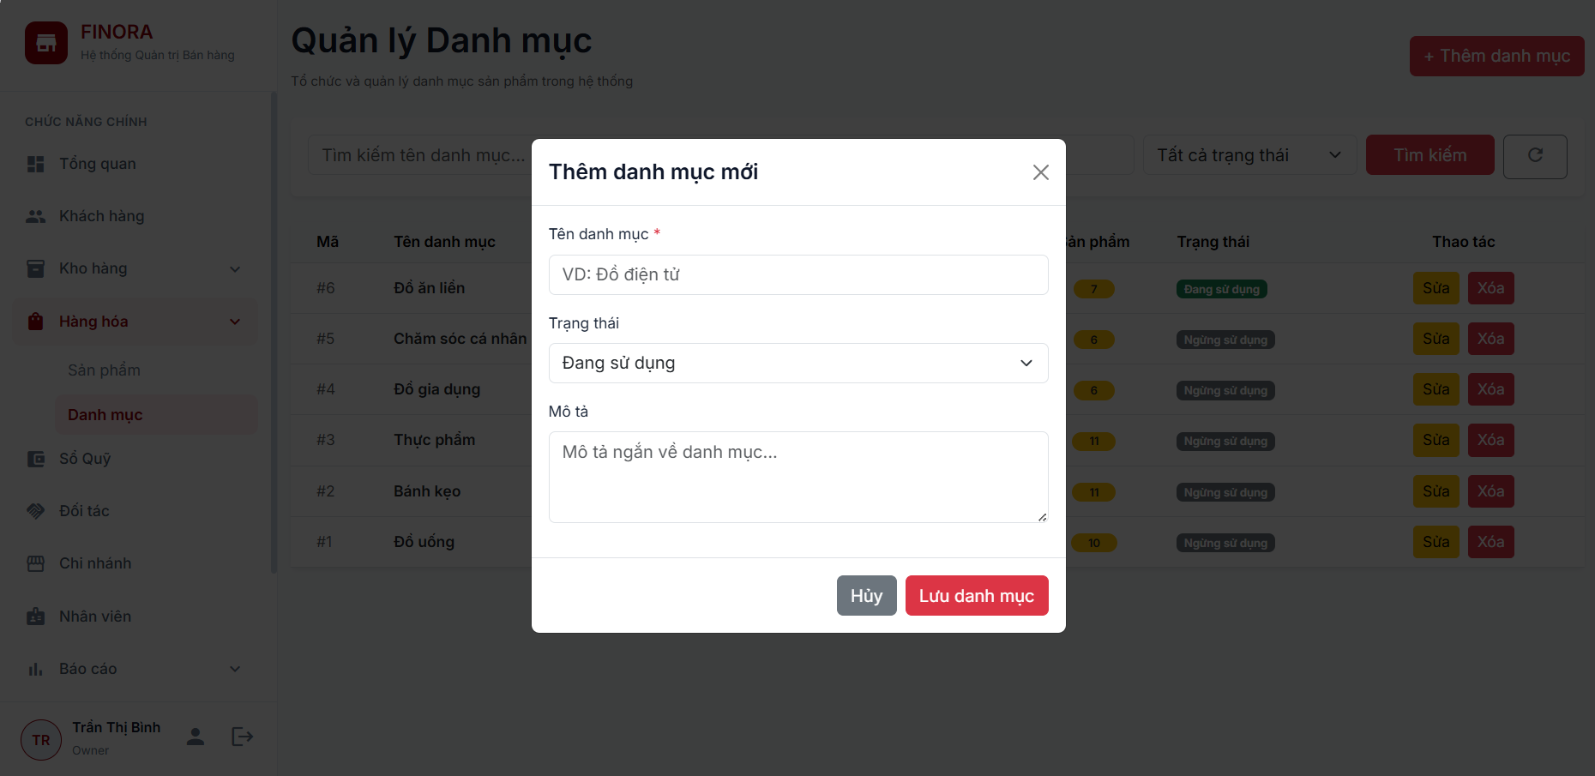
Field Name | Field Type | Description
Category Name | Textbox | Required. Name of the new category (CategoryName). Checked for duplicate name.
Description | Textarea | Detailed notes or description for the category.
Status | Radio / Select | Select 'active' or 'inactive'.
Cancel | Button | Closes modal without saving data.
Save | Button | Submits POST request to insert new category record.

Database Access
Table | CRUD | Description
category | C, R | Checks for duplicate category name, resolves parent category ID, and inserts (INSERT) new record.

SQL Commands
1/ Check for duplicate category name (case-insensitive and trimmed):
SELECT category_id FROM category WHERE LOWER(LTRIM(RTRIM(category_name))) = LOWER(LTRIM(RTRIM(?)));
2/ Get parent CategoryID by parent name:
SELECT category_id AS CategoryID FROM category WHERE LOWER(LTRIM(RTRIM(category_name))) = LOWER(LTRIM(RTRIM(?)));
3/ Insert new category record:
INSERT INTO category (category_name, description, parent_category_id, status)
VALUES (?, ?, ?, ?);

6.3 Edit Category

a. Edit Category
Updates details of an existing category. Incorporates recursive CTE cycle detection to prevent setting a category's parent to itself or to any of its subcategories (preventing circular hierarchical loops).
Related use case(s):
UC-4.1 – Manage Product Categories

UI Design
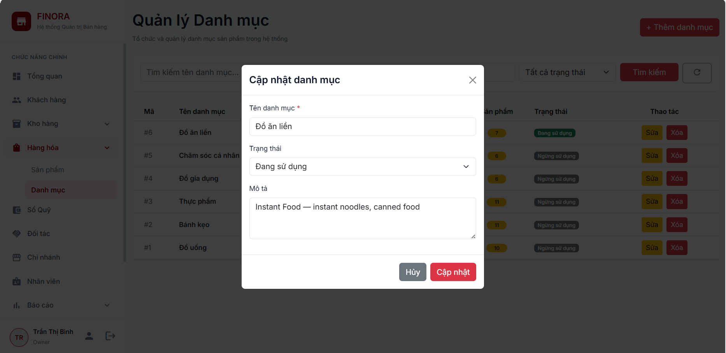

Field Name | Field Type | Description
CategoryID | Hidden Input | ID of the category being edited.
Category Name | Textbox | Updated category name (validated against duplicates).
Description | Textarea | Updated description.
Status | Dropdown | Update status (active / inactive).
Update | Button | Submits updated category information.

Database Access
Table | CRUD | Description
category | U, R | Fetches category details, executes recursive CTE to check circular dependency, and updates (UPDATE) record.

SQL Commands
1/ Check duplicate name excluding current category ID:
SELECT category_id FROM category WHERE LOWER(LTRIM(RTRIM(category_name))) = LOWER(LTRIM(RTRIM(?))) AND category_id <> ?;
2/ Check circular hierarchy using recursive CTE (CategoryTree):
WITH CategoryTree AS (
SELECT category_id, parent_category_id FROM category WHERE parent_category_id = ?
UNION ALL
SELECT c.category_id, c.parent_category_id FROM category c
INNER JOIN CategoryTree ct ON c.parent_category_id = ct.category_id
)
SELECT category_id FROM CategoryTree WHERE category_id = ?;
3/ Update category record:
UPDATE category
SET category_name = ?, description = ?, parent_category_id = ?, status = ?, update_at = GETDATE()
WHERE category_id = ?;

6.4 Delete Category

a. Delete Category
Deletes a category from the database. If the category has linked products or dependent subcategories, deletion is safely blocked by database foreign key constraints and error alerts.
Related use case(s):
UC-4.1 – Manage Product Categories

UI Design
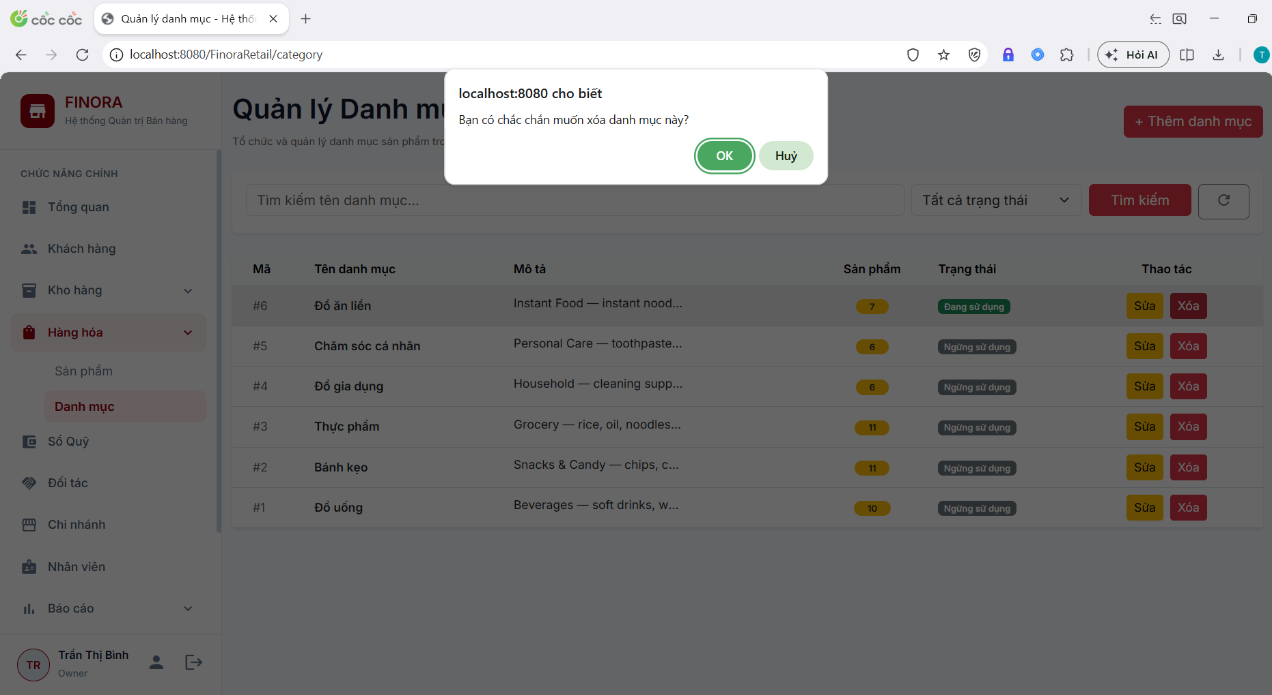

Field Name | Field Type | Description
Confirm Alert Window | Browser Popup | Displays dialog: 'Are you sure you want to delete this category?'
Message Alert Banner | Notification Banner | Displays green success alert or red danger alert if deletion is blocked by FK constraints.

Database Access
Table | CRUD | Description
category | D | Executes DELETE statement to remove category record.
product | R | Foreign key constraint reference from product table.

SQL Commands
1/ Delete category record by ID:
DELETE FROM category WHERE category_id = ?;

7. Inventory Management

7.1 Stock Management & Low Stock Alert

a. Stock Management & Low Stock Alert
Manages product inventory levels per store/warehouse, displays key performance metric cards (Total Products, Total Categories, Low Stock Count), and provides direct stock level adjustment capabilities for authorized staff.
Related use case(s):
UC-5.1 – View Inventory & Stock Alerts
UC-5.6 – Check Inventory

UI Design
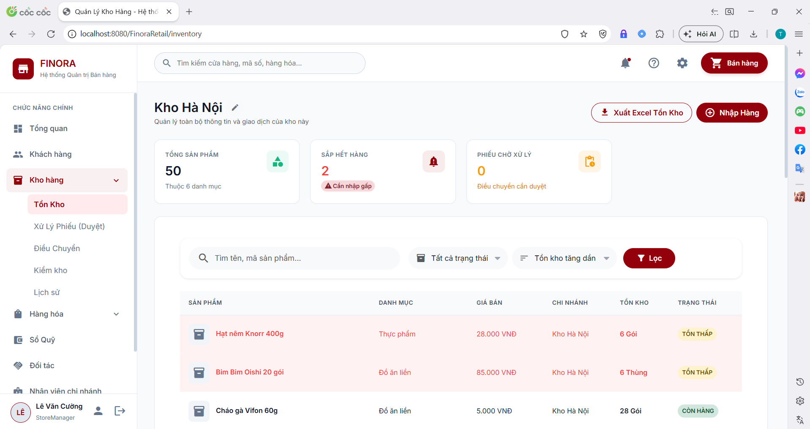

Field Name | Field Type | Description
Warehouse Selector | Dropdown | Select warehouse location (Owner can view all warehouses, staff views assigned warehouse).
Total Products KPI | Stat Card (Display) | Displays total number of products stocked in the selected warehouse.
Total Categories KPI | Stat Card (Display) | Displays count of distinct product categories in stock.
Low Stock Count KPI | Stat Card (Display) | Displays count of items with quantity <= 10 (highlighted in orange/red).
Keyword Search | Textbox | Filter stock list by Product Name or SKU.
Category Filter | Dropdown | Filter stock list by product category.
Product / SKU Column | Table Cell | Displays product thumbnail image, product name, and SKU code.
Warehouse Column | Table Cell | Name of the managing warehouse.
Quantity in Stock | Badge | Current physical inventory count.
Stock Status | Badge | Status badge: In Stock (green), Low Stock (orange), Out of Stock (red).
Update Stock | Button | Opens modal to directly update stock quantity.

Database Access
Table | CRUD | Description
inventory | R, U | Queries inventory records, calculates KPI stats, and updates stock quantities.
product | R | Retrieves product name, SKU, image URL, and category ID.
warehouse | R | Retrieves warehouse name and authorized warehouse list.
category | R | Retrieves category name for filtering.

SQL Commands
1/ Calculate KPI metrics (Total Products & Total Categories):
SELECT COUNT(DISTINCT i.product_id) AS totalProducts, COUNT(DISTINCT p.category_id) AS totalCategories
FROM inventory i
JOIN product p ON i.product_id = p.product_id
WHERE i.warehouse_id = ?;
2/ Count low stock items (quantity > 0 and <= 10):
SELECT COUNT(i.inventory_id)
FROM inventory i
WHERE i.warehouse_id = ? AND i.quantity_in_stock > 0 AND i.quantity_in_stock <= 10;
3/ Get paginated stock inventory list with search and filters:
SELECT i.inventory_id, p.product_id, p.product_name, p.sku, p.image_url, c.category_name,
w.warehouse_name, i.quantity_in_stock, i.status
FROM inventory i
JOIN product p ON i.product_id = p.product_id
JOIN warehouse w ON i.warehouse_id = w.warehouse_id
LEFT JOIN category c ON p.category_id = c.category_id
WHERE i.warehouse_id = ?
AND (LOWER(p.product_name) LIKE ? OR LOWER(p.sku) LIKE ?)
AND (? IS NULL OR c.category_id = ?)
ORDER BY i.inventory_id DESC
OFFSET ? ROWS FETCH NEXT ? ROWS ONLY;
4/ Direct stock update (Direct Stock Update):
UPDATE inventory
SET quantity_in_stock = ?, updated_at = GETDATE()
WHERE inventory_id = ?;

7.2 Stock Import, Export & Excel Bulk Intake

a. Stock Import, Export & Excel Bulk Intake
Handles stock intake (from suppliers or manual stock additions) and stock release (for write-offs or damages), and supports bulk stock intake via Excel (.xlsx) file upload. All movements are logged to stock_transaction for audit trail compliance.
Related use case(s):
UC-5.3 – Receive Goods (Stock Import/Export)

UI Design
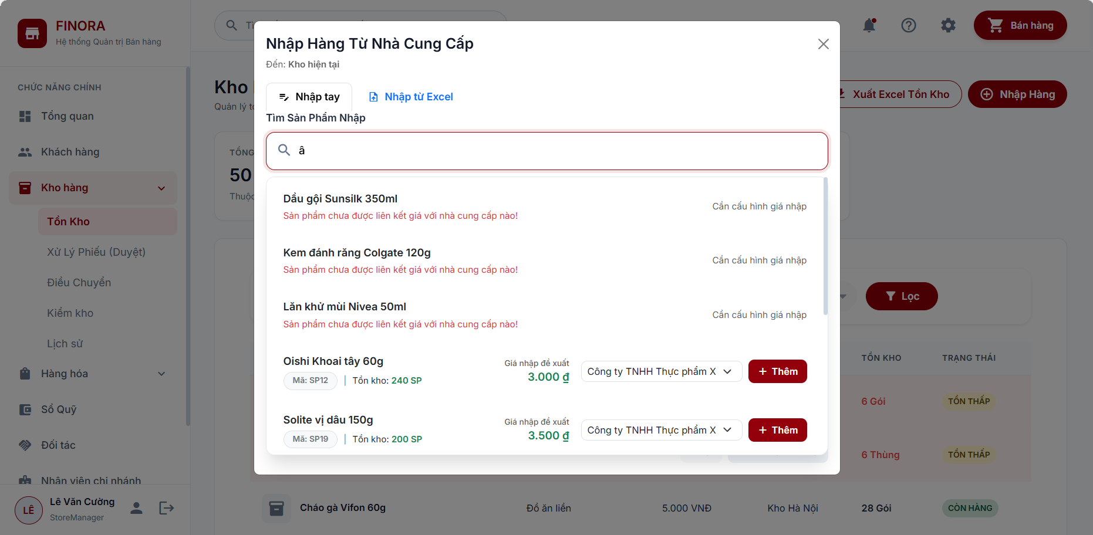
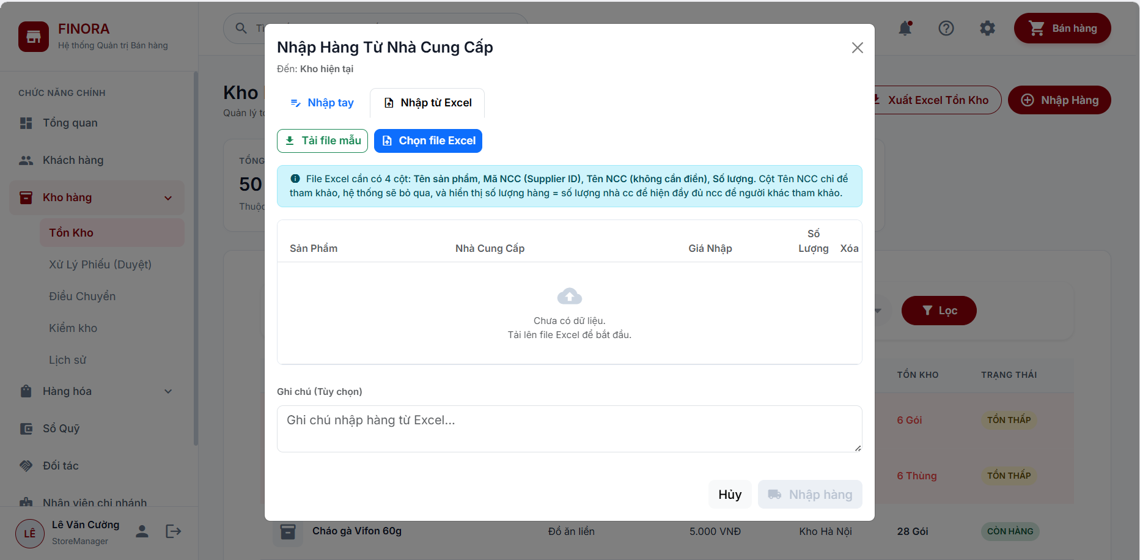

Field Name | Field Type | Description
Warehouse | Dropdown | Target warehouse for intake or release.
Supplier | Dropdown | Select supplier (for stock import).
Product List | Table In Modal | Select products, enter quantity change (+/-), and unit price.
Reason / Notes | Textarea | Notes detailing transaction reason (PO #, stock adjustment, damage write-off).
Excel File (.xlsx) | File Upload | Upload Excel spreadsheet for bulk stock intake.
Save Ticket | Button | Submits request to update stock levels and log transaction.

Database Access
Table | CRUD | Description
inventory | C, U, R | Checks existing stock, increments/decrements quantity_in_stock or inserts new item.
stock_transaction | C | Logs transaction record (Type: IMPORT, EXPORT, EXCEL_IMPORT).

SQL Commands
1/ Check if product inventory record exists in warehouse:
SELECT inventory_id, quantity_in_stock FROM inventory WHERE warehouse_id = ? AND product_id = ?;
2/ Increment stock on Import (or INSERT if new product):
UPDATE inventory SET quantity_in_stock = quantity_in_stock + ?, updated_at = GETDATE() WHERE inventory_id = ?;
-- If record does not exist:
INSERT INTO inventory (warehouse_id, product_id, quantity_in_stock, status, updated_at) VALUES (?, ?, ?, 'ACTIVE', GETDATE());
3/ Decrement stock on Export:
UPDATE inventory SET quantity_in_stock = quantity_in_stock - ?, updated_at = GETDATE() WHERE inventory_id = ? AND quantity_in_stock >= ?;
4/ Insert stock transaction log:
INSERT INTO stock_transaction (warehouse_id, product_id, transaction_type, quantity, reference_type, reference_id, notes, created_by, created_at)
VALUES (?, ?, ?, ?, ?, ?, ?, ?, GETDATE());

7.3 Stock Transfer Management

a. Stock Transfer Management
Manages inter-warehouse stock transfer workflow: Create transfer request -> Dispatch confirmation -> Destination receiving verification (handling discrepancy) -> Print transfer voucher.
Related use case(s):
UC-5.7 – Warehouse Transfer

UI Design

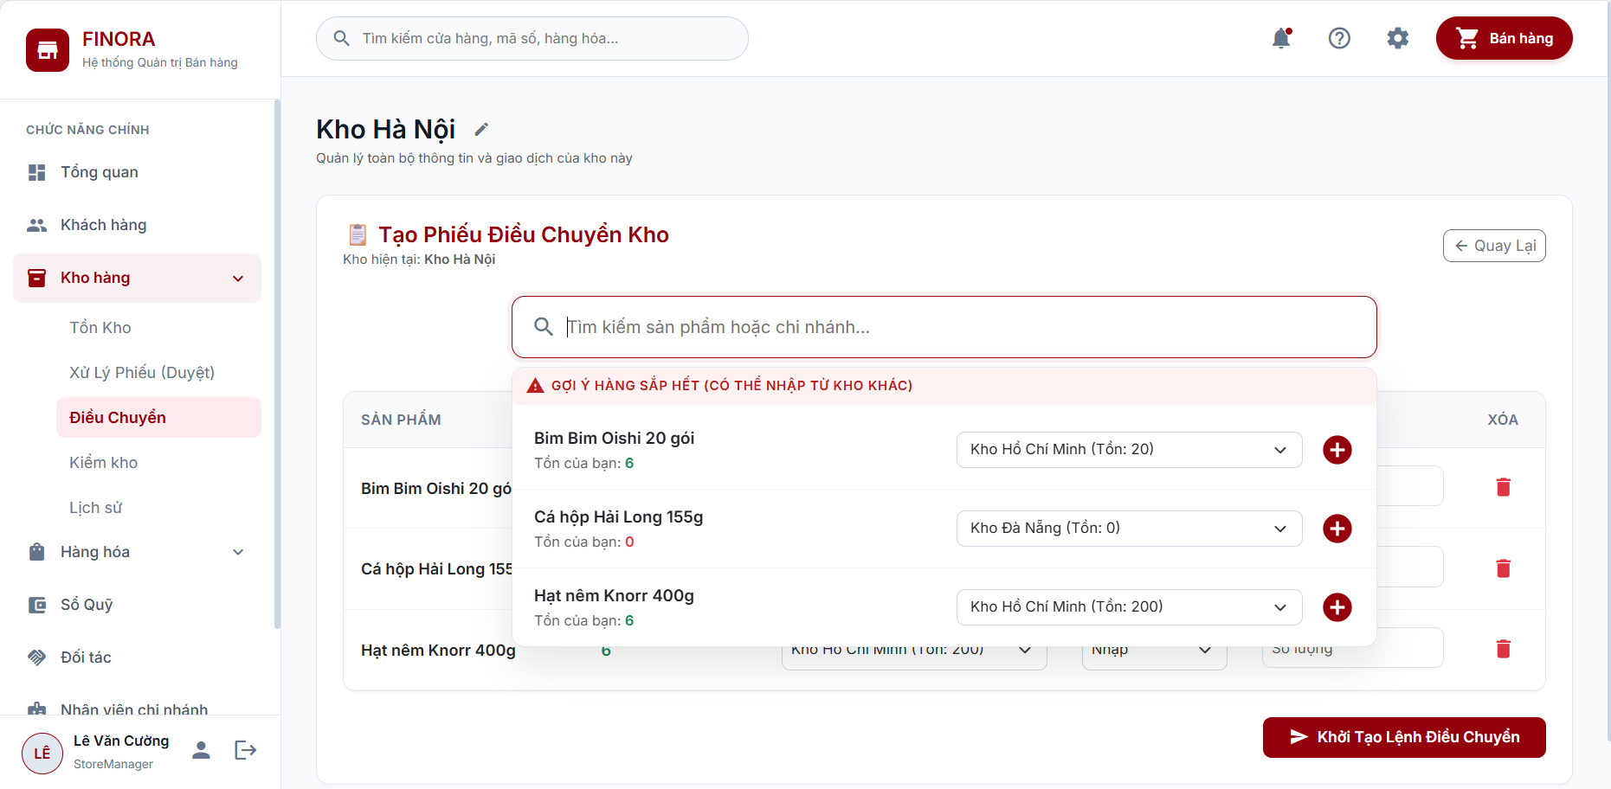

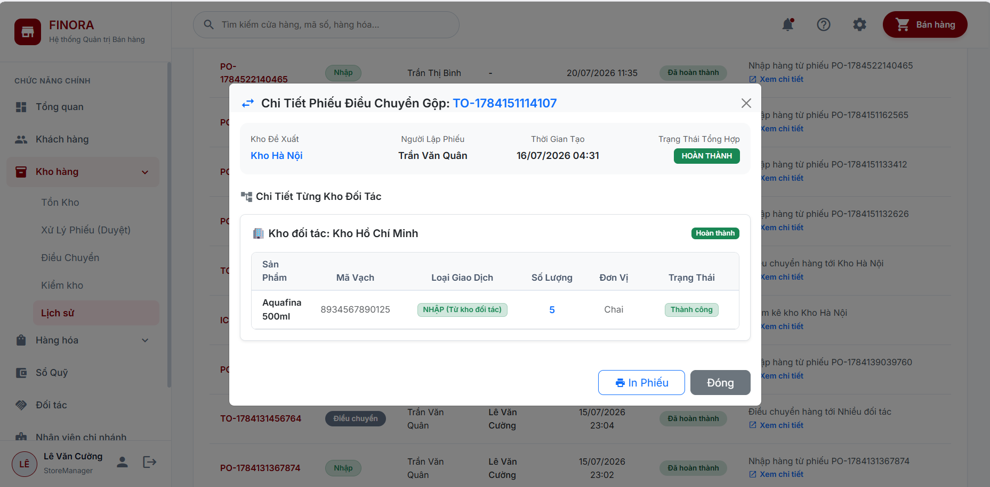

Field Name | Field Type | Description
Transfer Code | Display | Unique auto-generated ticket code (e.g., TRF-20260722-001).
From Warehouse | Dropdown | Select source warehouse dispatching stock.
To Warehouse | Dropdown | Select target warehouse receiving stock.
Transfer Products | Data Table | Select items, enter transfer quantity, view current source warehouse stock.
Notes | Textarea | Notes detailing transfer rationale.
Transfer Status | Badge | PENDING (Awaiting approval), DISPATCHED (In transit), COMPLETED (Received), REJECTED.
Print Ticket | Button | Opens printable Stock Transfer Ticket formatted for printing/PDF.

Database Access
Table | CRUD | Description
stock_transfer | C, R, U | Stores transfer ticket header and status updates.
stock_transfer_detail | C, R | Stores line items and quantities being transferred.
inventory | U | Deducts stock at source warehouse and adds stock at target warehouse upon completion.
stock_transaction | C | Logs 2 transactions: TRANSFER_OUT at source warehouse and TRANSFER_IN at target warehouse.

SQL Commands
1/ Insert stock transfer request header:
INSERT INTO stock_transfer (transfer_code, from_warehouse_id, to_warehouse_id, status, notes, created_by, created_at)
VALUES (?, ?, ?, 'PENDING', ?, ?, GETDATE());
2/ Insert transfer ticket line details:
INSERT INTO stock_transfer_detail (transfer_id, product_id, quantity) VALUES (?, ?, ?);
3/ Update stock transfer status (APPROVED / DISPATCHED / COMPLETED / REJECTED / CANCELLED):
UPDATE stock_transfer
SET status = ?, approved_by = ?, completed_at = GETDATE()
WHERE transfer_id = ?;
4/ Deduct source warehouse stock and add target warehouse stock on completion:
-- Deduct source warehouse stock:
UPDATE inventory SET quantity_in_stock = quantity_in_stock - ?, updated_at = GETDATE() WHERE warehouse_id = ? AND product_id = ?;
-- Add target warehouse stock:
UPDATE inventory SET quantity_in_stock = quantity_in_stock + ?, updated_at = GETDATE() WHERE warehouse_id = ? AND product_id = ?;

7.4 Inventory Audit / Check

a. Inventory Audit / Check
Periodic physical stock counting process comparing system stock against actual physical count. Warehouse staff enters actual counted quantities; the system calculates variance (positive/negative) and submits to Store Manager for approval to adjust inventory.
Related use case(s):
UC-5.6 – Check Inventory

UI Design

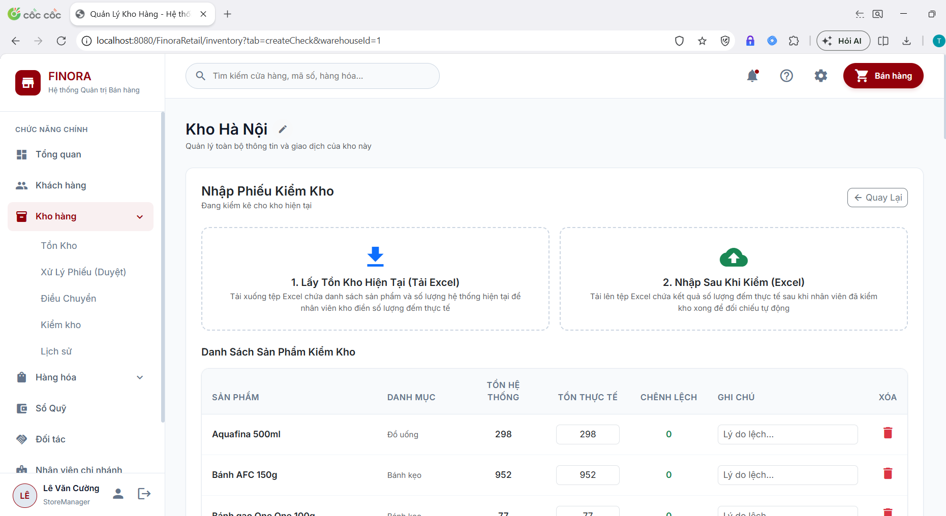

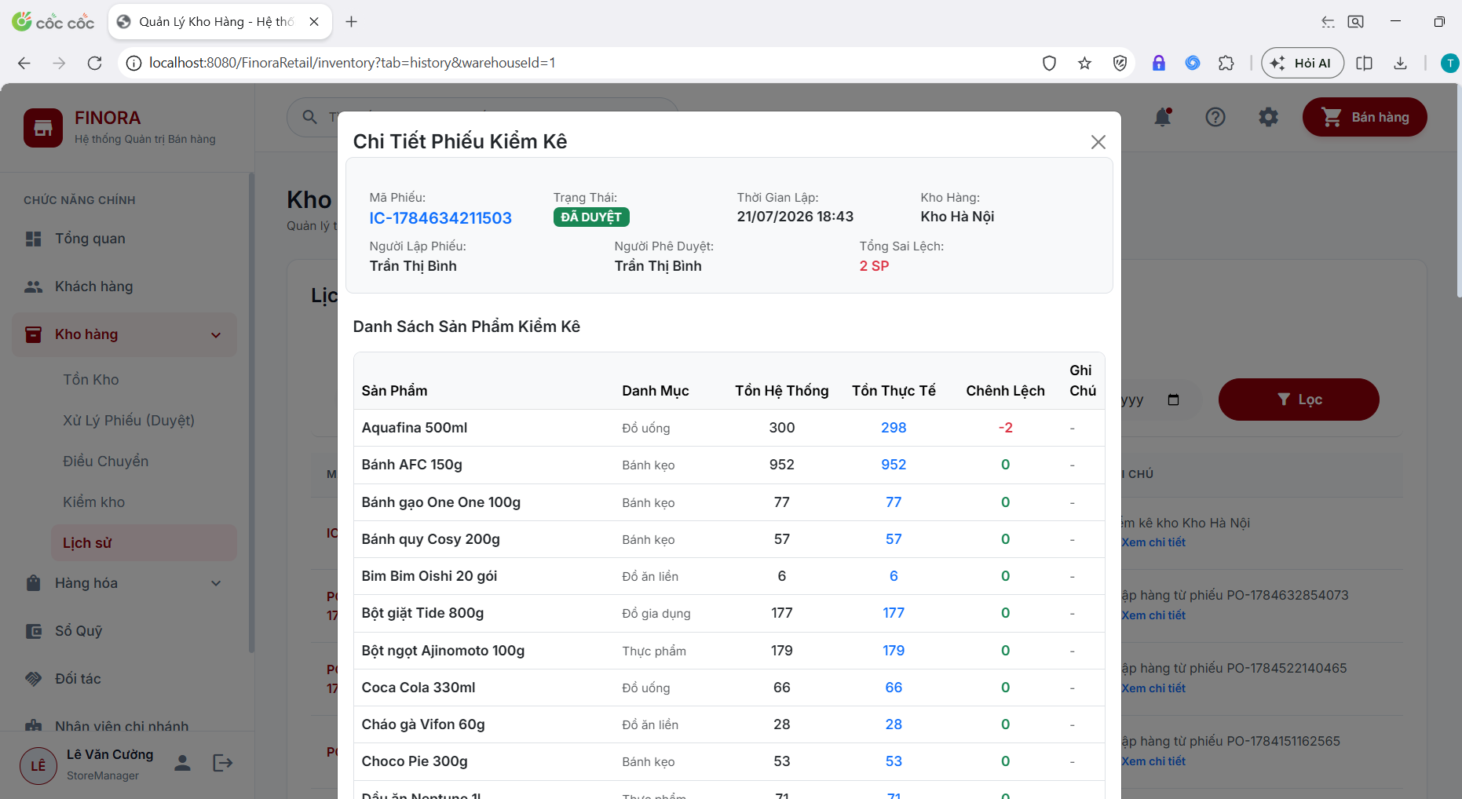

Field Name | Field Type | Description
Check Code | Display | Unique audit ticket identifier (e.g., CHK-20260722-001).
Audited Warehouse | Dropdown | Warehouse undergoing physical stock audit.
System Quantity | Display Number | System-recorded stock quantity at audit creation.
Actual Quantity | Textbox (Number) | Staff inputs actual physically counted stock quantity.
Variance | Calculated Badge | Formula: Variance = Actual Quantity - System Quantity.
Discrepancy Reason | Textbox | Notes explaining variance reason (damage, loss, entry error).
Audit Status | Badge | DRAFT, PENDING_APPROVAL, COMPLETED, CANCELLED.
Approve Audit | Button | Store Manager clicks to approve audit and automatically balance system stock.

Database Access
Table | CRUD | Description
inventory_check | C, R, U | Stores audit header information and approval status.
inventory_check_detail | C, R | Stores system stock vs actual count details and discrepancy reasons.
inventory | U | Adjusts system stock quantity to match actual count upon audit approval.
stock_transaction | C | Logs stock adjustment transactions (Type: ADJUSTMENT).

SQL Commands
1/ Insert inventory check ticket header:
INSERT INTO inventory_check (check_code, warehouse_id, status, notes, created_by, created_at)
VALUES (?, ?, 'PENDING_APPROVAL', ?, ?, GETDATE());
2/ Insert audit line details (actual count & variance):
INSERT INTO inventory_check_detail (check_id, product_id, system_quantity, actual_quantity, difference_quantity, reason)
VALUES (?, ?, ?, ?, ?, ?);
3/ Update system inventory quantity to match actual physical count upon approval:
UPDATE inventory
SET quantity_in_stock = ?, updated_at = GETDATE()
WHERE warehouse_id = ? AND product_id = ?;

7.5 Approval Dashboard & Pending Vouchers

a. Approval Dashboard & Pending Vouchers
Centralized management screen for Store Managers and Chain Owner to review, approve, or reject pending stock transfers and pending purchase/sales order stock release vouchers before final execution.
Related use case(s):
UC-5.7 – Warehouse Transfer
UC-5.3 – Receive Goods

UI Design

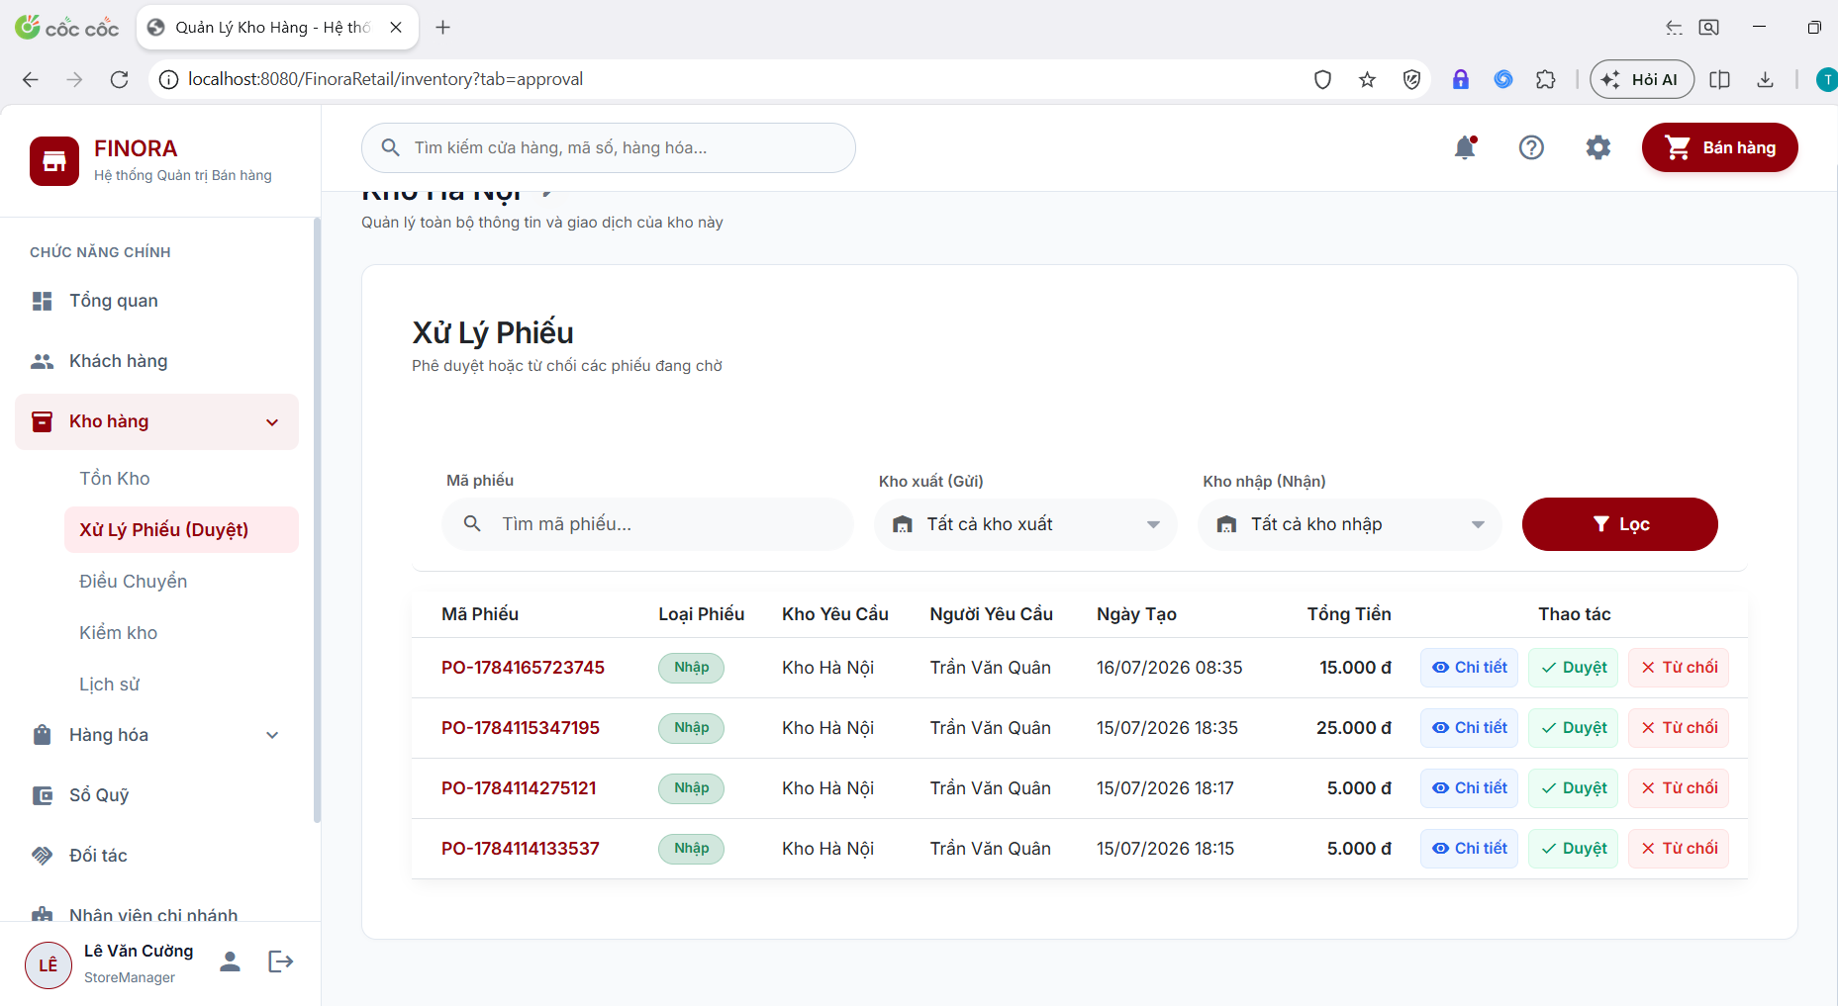

Field Name | Field Type | Description
Ticket / Voucher ID | Table Cell | Unique identifier code of transfer or order pending approval.
From / To Warehouse | Table Cell | Warehouse locations involved in transfer.
Requester | Table Cell | Name of staff who submitted request.
Created Date | Table Cell | Date and timestamp request was generated.
Approve Button | Button (Green) | Approves request and proceeds to stock update.
Reject Button | Button (Red) | Rejects request and prompts for rejection reason notes.

Database Access
Table | CRUD | Description
stock_transfer | R, U | Queries PENDING transfer requests and updates status to APPROVED or REJECTED.
orders / purchase_order | R, U | Queries and approves stock release vouchers.

SQL Commands
1/ Query pending stock transfer requests (Status = 'PENDING'):
SELECT st.transfer_id, st.transfer_code, fw.warehouse_name AS FromWarehouse, tw.warehouse_name AS ToWarehouse,
e.fullName AS CreatorName, st.created_at, st.notes
FROM stock_transfer st
JOIN warehouse fw ON st.from_warehouse_id = fw.warehouse_id
JOIN warehouse tw ON st.to_warehouse_id = tw.warehouse_id
LEFT JOIN employee e ON st.created_by = e.emp_id
WHERE st.status = 'PENDING'
ORDER BY st.created_at DESC;
2/ Update status to APPROVED:
UPDATE stock_transfer SET status = 'APPROVED', approved_by = ?, updated_at = GETDATE() WHERE transfer_id = ?;
3/ Update status to REJECTED:
UPDATE stock_transfer SET status = 'REJECTED', notes = ?, updated_at = GETDATE() WHERE transfer_id = ?;

7.6 Transaction History & Stock Audit Trail

a. Transaction History & Stock Audit Trail
Complete audit log tracking all inventory movements (IMPORT, EXPORT, TRANSFER_IN, TRANSFER_OUT, ADJUSTMENT, SALE). Features advanced filtering by warehouse, transaction type, date range, and keyword search.
Related use case(s):
UC-5.1 – View Inventory Logs

UI Design

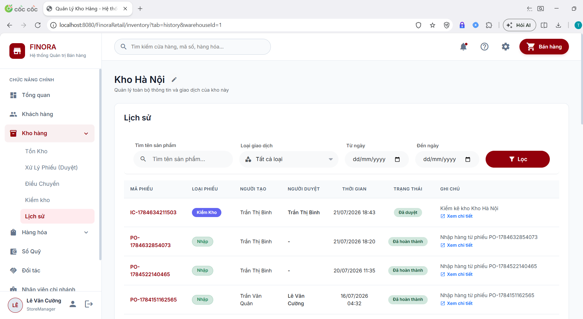

Field Name | Field Type | Description
Warehouse Selector | Dropdown | Filter transaction log by warehouse.
Transaction Type | Dropdown | Filter by IMPORT, EXPORT, TRANSFER, ADJUSTMENT.
Date Range | Datepicker | Filter transactions from start date to end date.
Timestamp Column | Table Cell | Date and time of transaction execution.
Product / SKU Column | Table Cell | Product name and SKU code.
Transaction Type Badge | Badge | Badge color indicating movement type (green for +, red for -, blue for transfer).
Quantity Change | Number | Quantity change (+X or -X).
Performer | Table Cell | Name of staff executing transaction.
Notes | Table Cell | Transaction notes or voucher reference.

Database Access
Table | CRUD | Description
stock_transaction | R | Queries full transaction audit log with pagination and filtering.
warehouse | R | Retrieves warehouse name.
product | R | Retrieves product name and SKU.
employee | R | Retrieves performer staff name.

SQL Commands
1/ Query transaction audit log with pagination and multi-criteria filters:
SELECT st.transaction_id, st.created_at, w.warehouse_name, p.product_name, p.sku,
st.transaction_type, st.quantity, st.reference_type, st.reference_id, st.notes,
e.fullName AS PerformerName
FROM stock_transaction st
JOIN warehouse w ON st.warehouse_id = w.warehouse_id
JOIN product p ON st.product_id = p.product_id
LEFT JOIN employee e ON st.created_by = e.emp_id
WHERE (? IS NULL OR st.warehouse_id = ?)
AND (? IS NULL OR st.transaction_type = ?)
AND (? IS NULL OR st.created_at >= ?)
AND (? IS NULL OR st.created_at <= ?)
AND (? IS NULL OR LOWER(p.product_name) LIKE ? OR LOWER(p.sku) LIKE ?)
ORDER BY st.created_at DESC
OFFSET ? ROWS FETCH NEXT ? ROWS ONLY;

8. Supplier Management
Related use case(s):
- UC-3.18 – Supplier Management

8.1 Supplier List

a.Supplier list
Displays a paginated list of active supplier with search, filter, and quick-action controls.

UI Design
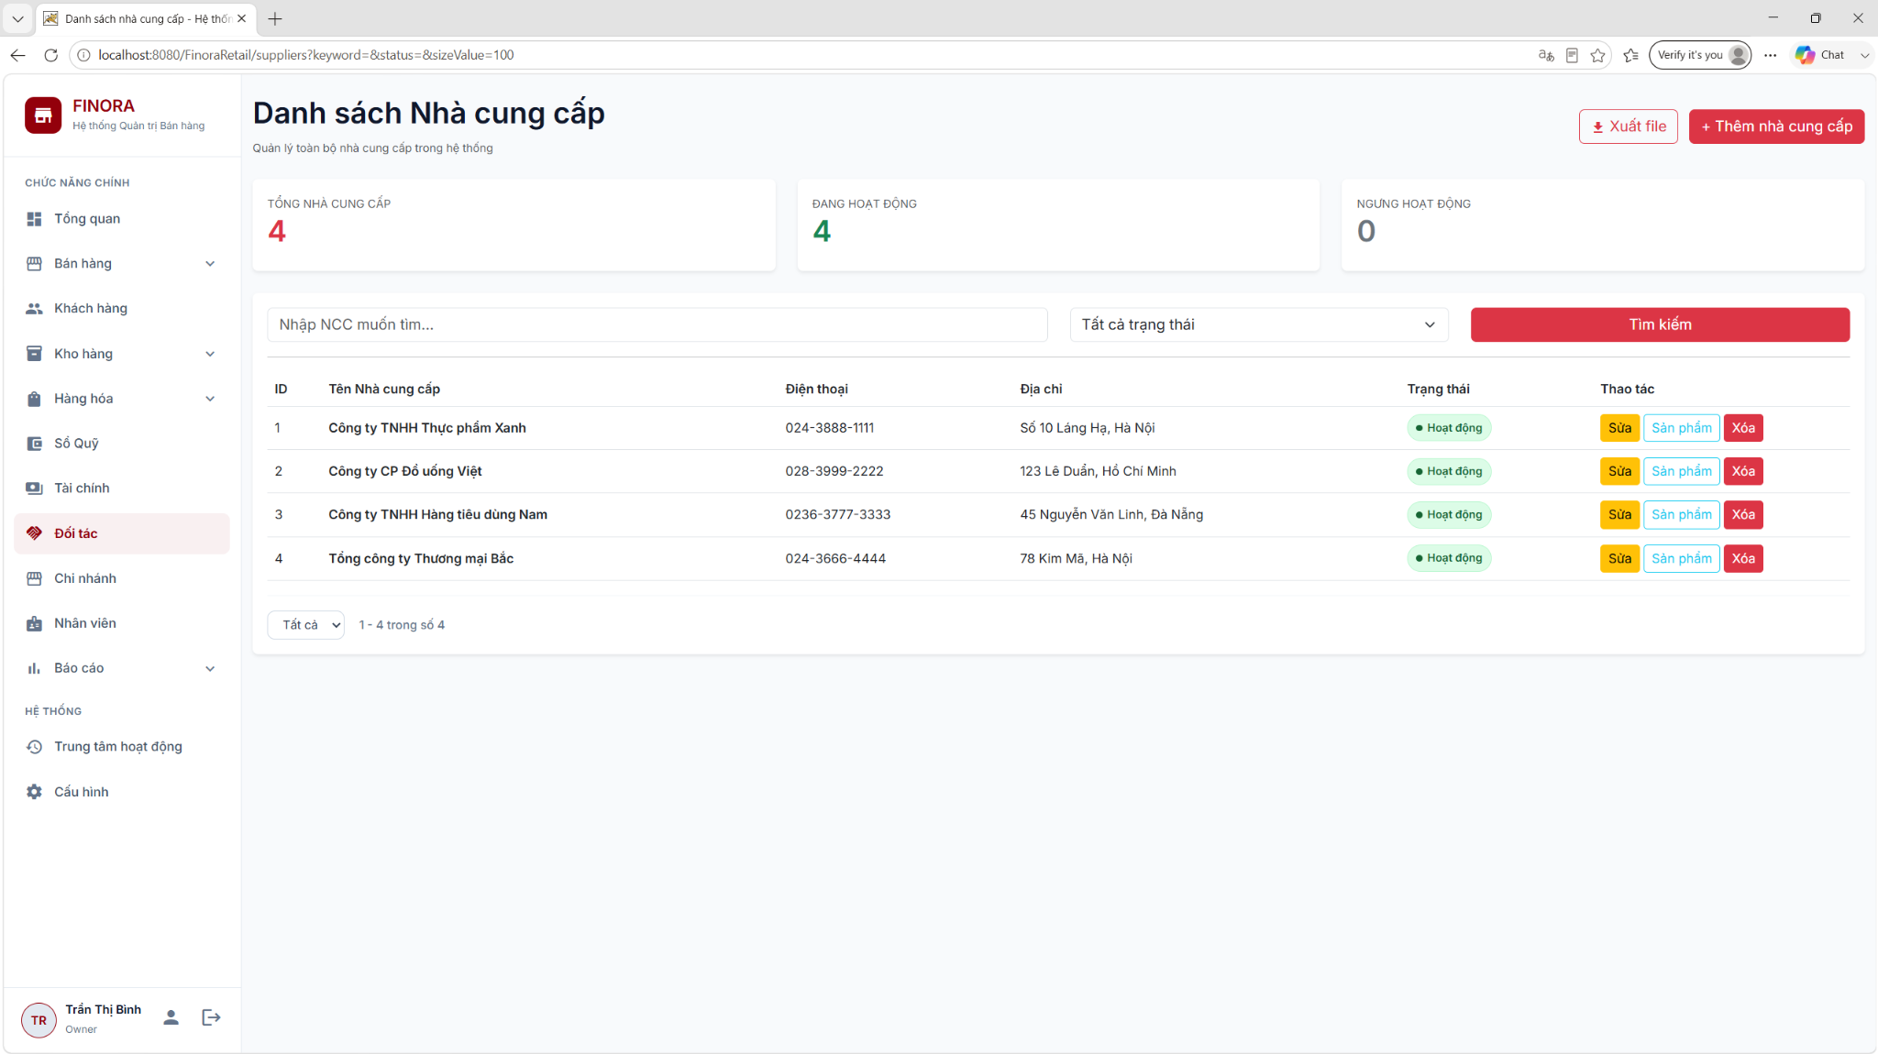

Field Name | Field Type | Description
Search & Filter
Keyword | Textbox | Search for a provider by name, phone number, or address.
Status | Dropdown | Filter suppliers by status: active / inactive (partnership terminated)
Data Table Columns
Supplier Name | Display | Full name of the supplier
Phone | Display | Unique phone number
Address | Display | Supplier's warehouse/office address
Status | Badges | Partnership status: active (green) / inactive (red)
Actions
Actions | Button Group | View, Edit, Delete icons
Add Customer | Button | Opens the Create Customer form (Owner only)

Database Access
Table | CRUD | Description
supplier | R | Download the paginated supplier list, including keyword and status filters.
[order] | R | (Optional) Check if the supplier has any associated purchase orders (order_type = 'PURCHASE') before performing the data operation.

SQL Commands
1/ Count the total number of suppliers for pagination (with keyword and status filters)
SELECT COUNT(*)
FROM supplier
WHERE
(
? = ''
OR supplier_name LIKE ?
OR phone_number LIKE ?
OR address LIKE ?
)
AND
(
? = ''
OR status = ?
);

2/ Retrieve a paginated list of suppliers, sorted by ID.
SELECT
supplier_id AS SupplierID,
supplier_name AS Name,
phone_number AS Phone,
address AS Address,
status AS Status,
created_at AS CreatedAt,
updated_at AS UpdatedAt
FROM supplier
WHERE
(
? = ''
OR supplier_name LIKE ?
OR phone_number LIKE ?
OR address LIKE ?
)
AND
(
? = ''
OR status = ?
)
ORDER BY supplier_id ASC
OFFSET ? ROWS
FETCH NEXT ? ROWS ONLY;

8.2 Create Supplier

a.Add supplier
Add, create a new supplier

UI Design
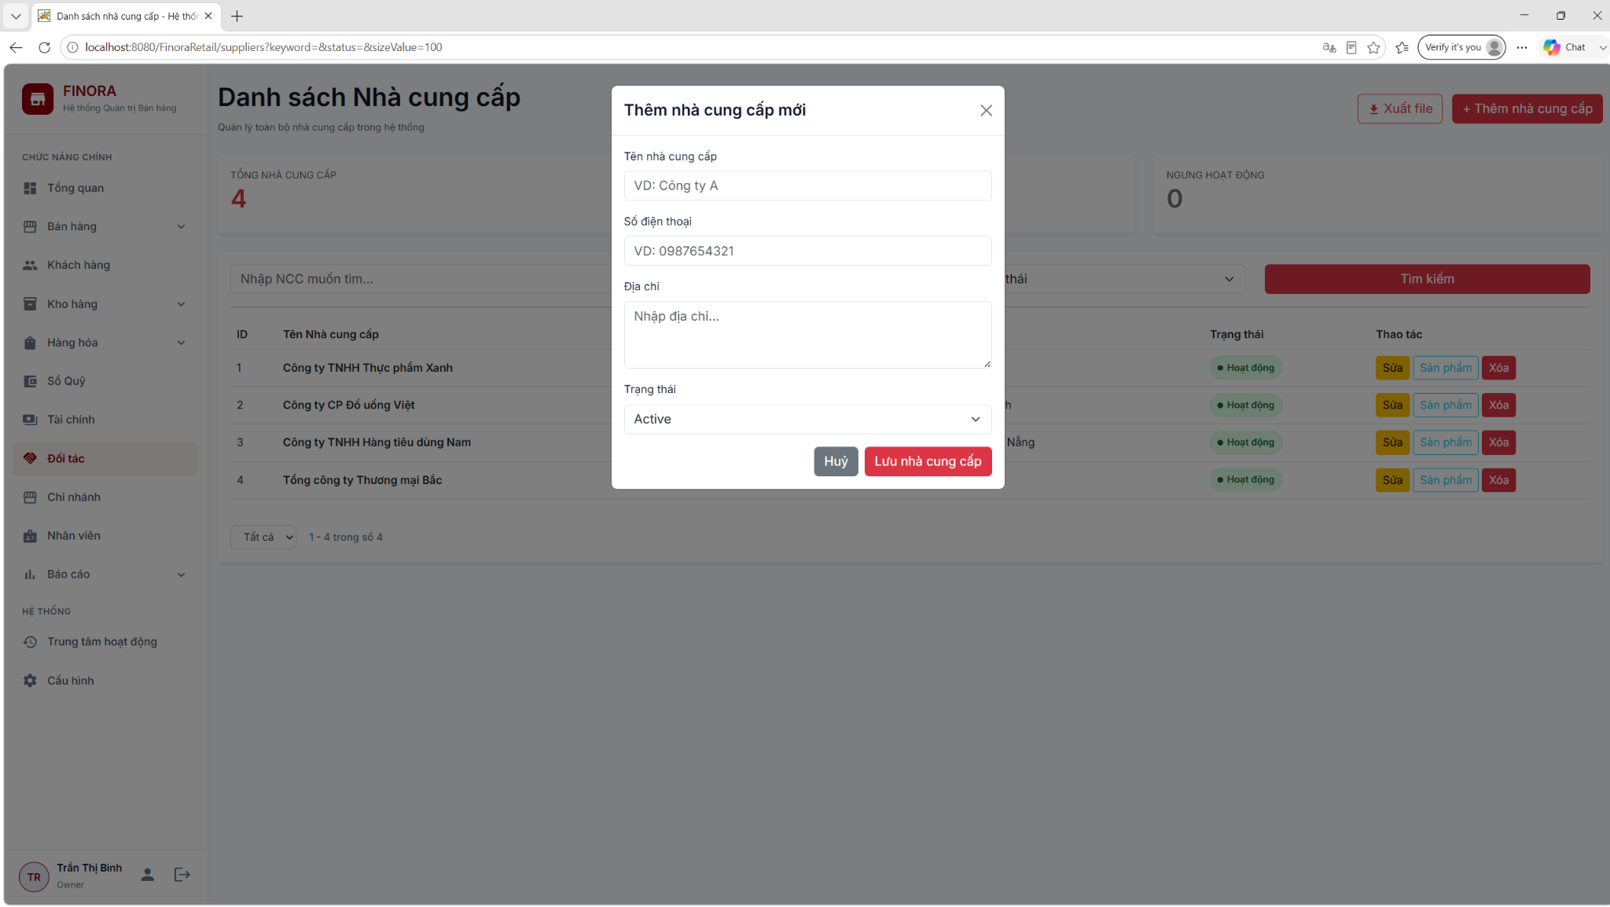

Field Name | Field Type | Description
Form Inputs
Supplier Name | Textbox | Enter the supplier's full name (Required)
Phone Number | Textbox | Enter contact phone number
Address | Textbox | Enter the warehouse or representative office address.
Status | Dropdown | Select the initial status: active or inactive.
Actions
Submit Button | Button | Save supplier information.
Cancel | Button | Return to the supplier list screen

Database Access
Table | CRUD | Description
supplier | C | Add a new supplier record to the database.

SQL Commands
1/ Insert supplier
INSERT INTO supplier (supplier_name, phone_number, address, status, created_at, updated_at)
VALUES (?, ?, ?, ?, CURRENT_TIMESTAMP, CURRENT_TIMESTAMP);

8.3 Edit Supplier

a.Edit supplier
Edit and update supplier information.

UI Design
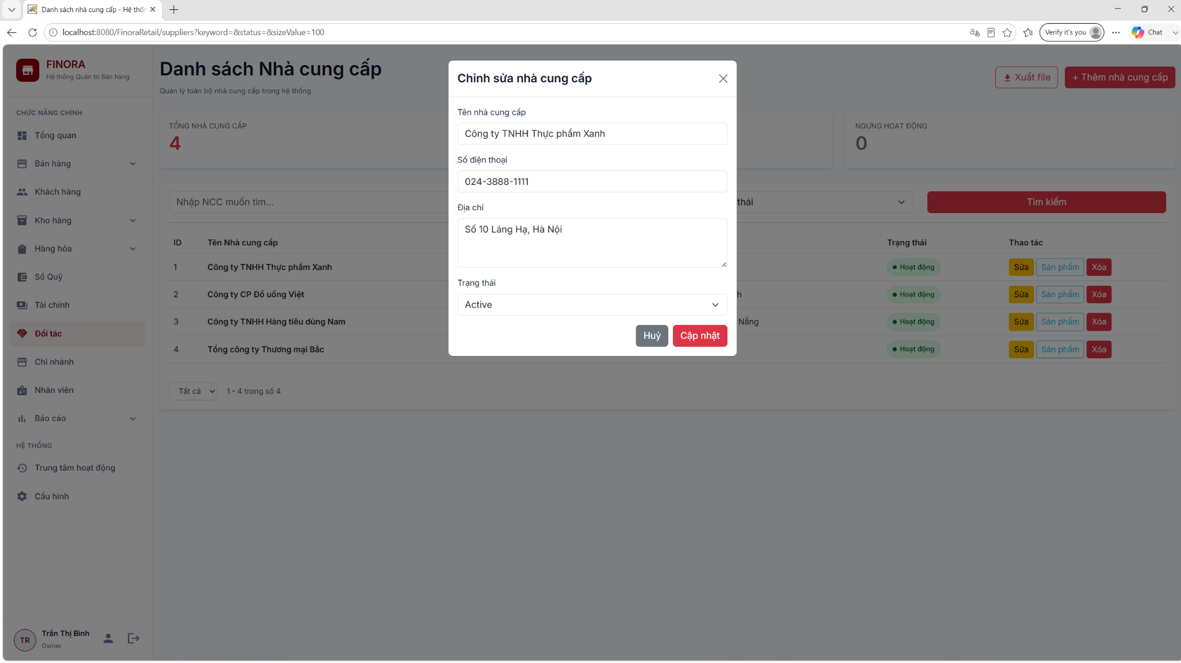

Field Name | Field Type | Description
Form Input
Supplier Name | Textbox | Edit supplier name (Required)
Phone Number | Textbox | Edit phone number
Address | Textbox | Edit address
Status | Dropdown | Change status: active / inactive
Actions
Save Changes | Button | Save the changes.
Cancel | Button | Discard changes and return to the list screen.

Database Access
Table | CRUD | Description
supplier | R | Retrieve supplier details by ID to pre-fill the form.
supplier | U | Update the database with the changes.

SQL Commands
1/ Update customer
SELECT
supplier_id AS SupplierID,
supplier_name AS Name,
phone_number AS Phone,
address AS Address,
status AS Status
FROM supplier
WHERE supplier_id = ?;
2/ Update detailed supplier information
UPDATE supplier
SET supplier_name = ?,
phone_number = ?,
address = ?,
status = ?,
updated_at = CURRENT_TIMESTAMP
WHERE supplier_id = ?;

8.4 Delete Supplier

a.Delete supplier
Remove the supplier from the list

UI Design
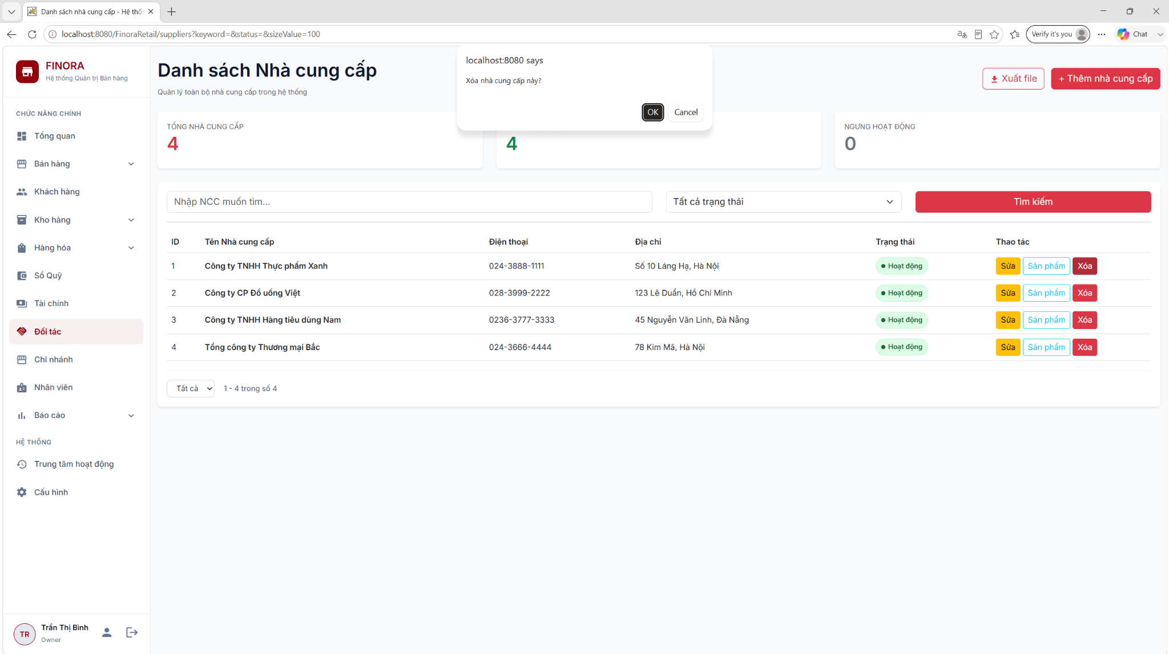

Field Name | Field Type | Description
Confirmation
Confirm Message | Display | Display a confirmation message: "Delete this supplier?"
Actions
Delete Button | Button | Trigger the deletion request
Cancel Button | Button | Close the confirmation dialog

Database Access
Table | CRUD | Description
order | R | Check whether this supplier is linked to any purchase order (order_type = 'PURCHASE').
supplier_product | D | Delete all product links associated with this supplier before deleting the supplier (to ensure foreign key integrity).
supplier | D | Permanently delete the supplier from the database if there is no violation of order constraints.

SQL Commands
1/ Check the supplier's related orders.
SELECT COUNT(*) FROM [order] WHERE supplier_id = ?;
2/ Delete the supplier's linked products
DELETE FROM supplier_product WHERE supplier_id = ?;
3/ Remove the supplier from the system
DELETE FROM supplier WHERE supplier_id = ?;

8.5 Supplier product management

a.Product supplier
Multi-tier supplier product management

UI Design
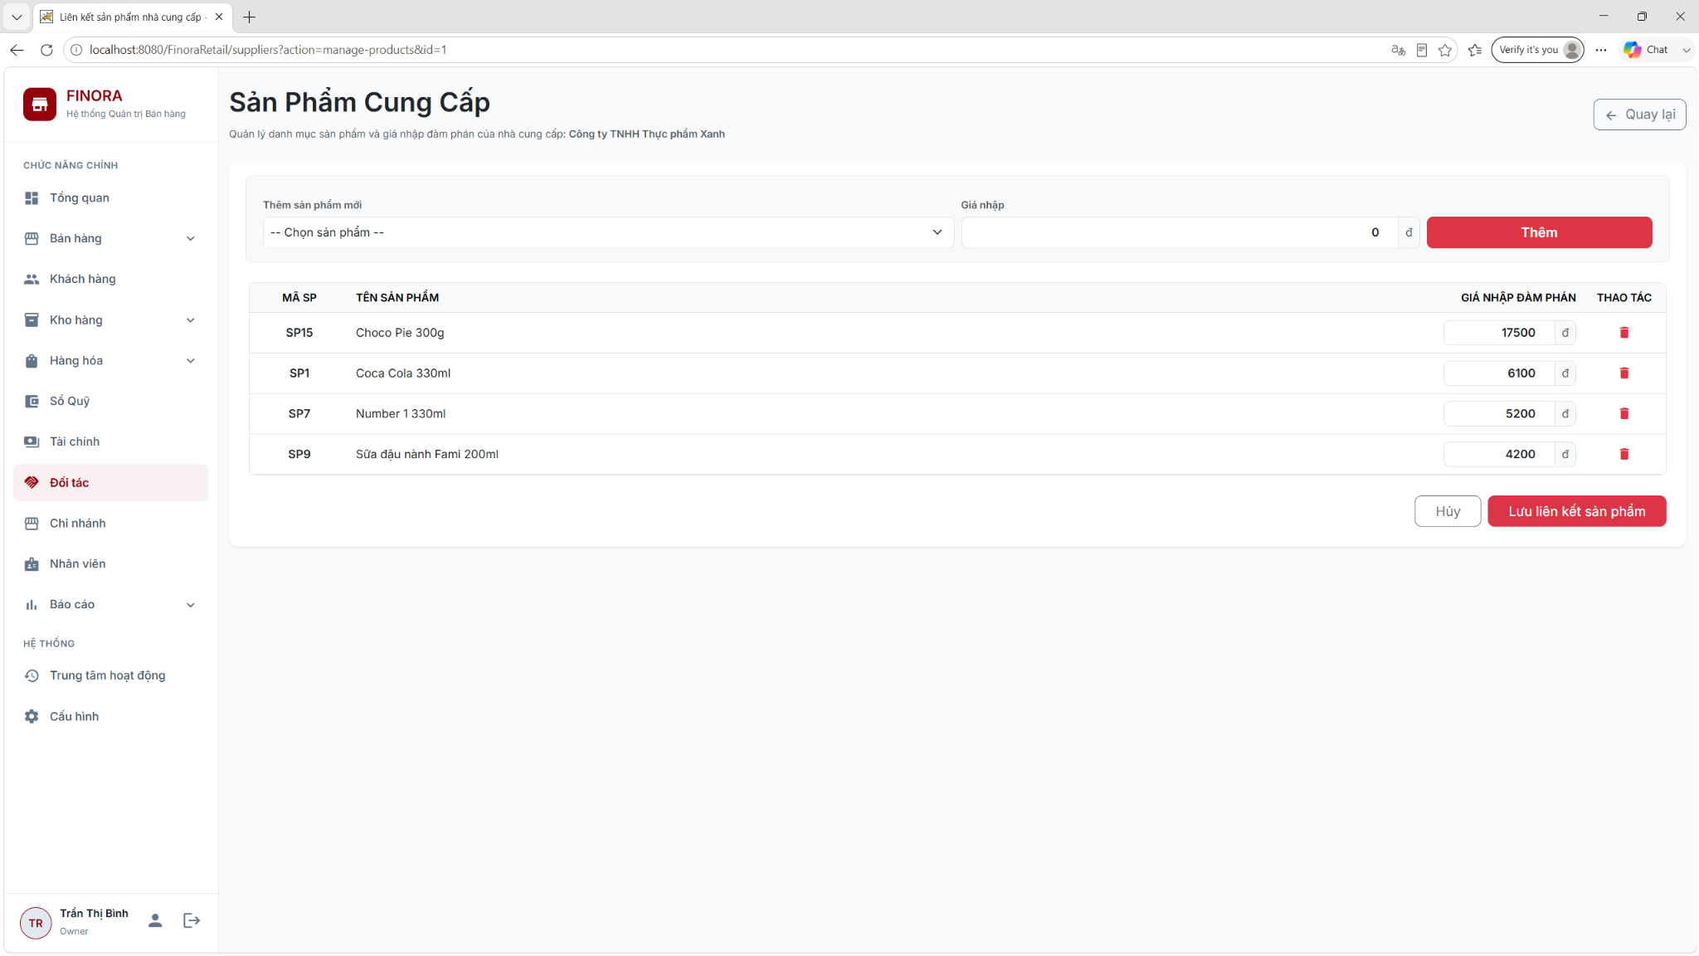

Field Name | Field Type | Description
Header Information
Supplier Info | Display | Display current supplier name and phone number
Product Association Table
Select / Checkbox | Checkbox | Select an affiliate product provided by this supplier.
Product Code | Display | System product code
Product Name | Display | Product name
System Price | Display | System default retail price
Negotiation Price | Input (Decimal) | Negotiated unit import price with this supplier (VND)
Actions
Save Changes | Button | Save the complete list of affiliated products along with their import prices.
Cancel | Button | Return to the supplier list page

Database Access
Table | CRUD | Description
supplier_product | R | Retrieve the list of affiliate product IDs and this supplier's specific import unit prices.
product | R | Download the list of all products currently in "ACTIVE" status within the system so that users can select them for linking.
supplier_product | D | Delete old links before updating with new ones (within a transaction).
supplier_product | C | Add new product-negotiated price links (Part of Transaction - Batch Insert).

SQL Commands
1/ Retrieve the list of linked products and the negotiated import prices from the supplier.
SELECT product_id AS ProductID, import_price AS ImportPrice
FROM supplier_product
WHERE supplier_id = ?;
2/ Remove all existing links for this supplier.
DELETE FROM supplier_product WHERE supplier_id = ?;
3/ Add new product links with negotiated prices (Batch Insert)
INSERT INTO supplier_product (supplier_id, product_id, import_price)
VALUES (?, ?, ?);

8.6 Export data to Excel

a.Export data
Export the list of suppliers to an Excel file.

UI Design

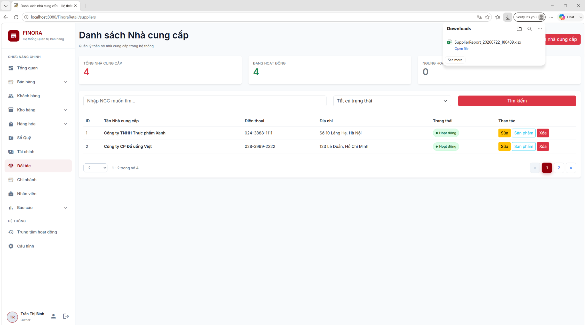

Field Name | Field Type | Description
Trigger Action
Export Excel | Button | Submit file download request (based on the current filtered list)

Database Access
Table | CRUD | Description
supplier | R | Retrieve the complete list of suppliers matching the keyword and status filtered on the screen and export it to an Excel file.

SQL Commands
1/ Truy vấn toàn bộ dữ liệu nhà cung cấp khớp bộ lọc
SELECT
supplier_id AS SupplierID,
supplier_name AS Name,
phone_number AS Phone,
address AS Address,
status AS Status,
created_at AS CreatedAt,
updated_at AS UpdatedAt
FROM supplier
WHERE
(
? = ''
OR supplier_name LIKE ?
OR phone_number LIKE ?
OR address LIKE ?
)
AND
(
? = ''
OR status = ?
)
ORDER BY supplier_id ASC;

9. Manage Store Chain

9.1 List & search
Displays all store branches and allows authorized users to search and filter branches by code, name, location, or status.
Related use case(s):
UC-2.5 – Owner creates, edits, and deletes branches.

UI Design
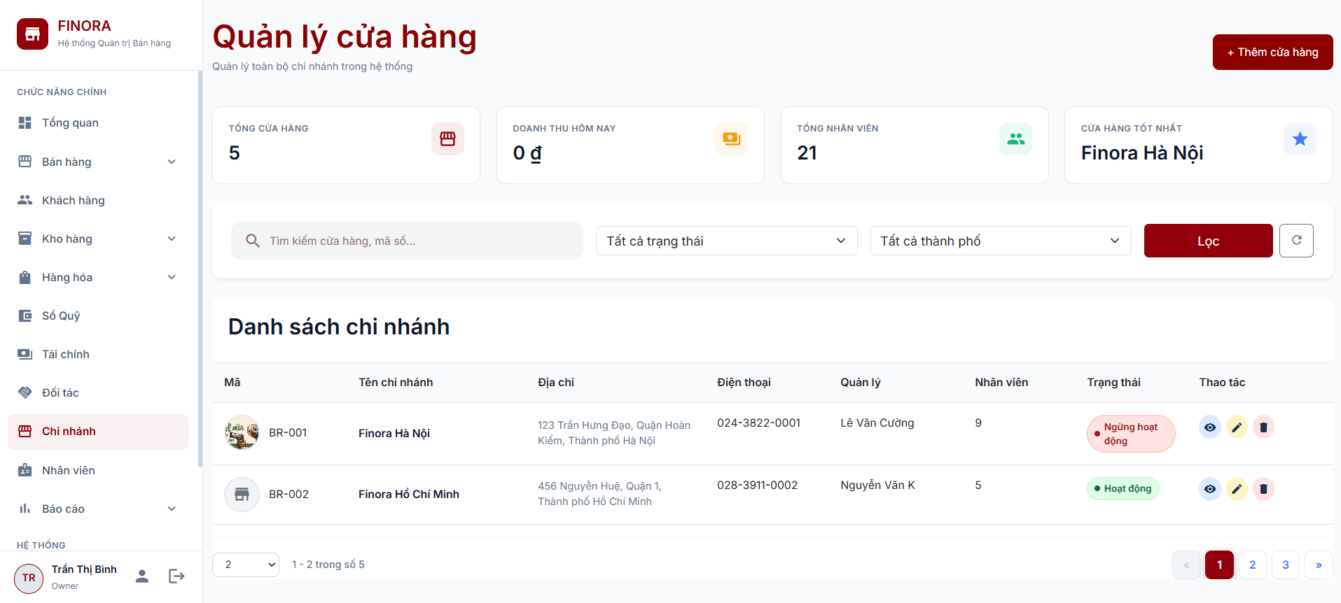

Field Name | Field Type | Description
Search & Filter
Keyword | Textbox | Search branches by branch name (branch_name) or branch code (branch_code) using the LIKE operator.
Status | Select | Filter branches by status: ACTIVE, or INACTIVE.
City | Select | Filter branches by city. The city list contains cities with existing branches.
Filter | Button (Submit) | Applies the search keyword and selected filters.
Refresh | Button (Link) | Resets all filters and reloads the default branch list.
Action | Hidden | Stores the search action (list).
Data Table
Branch Code | Display (Text + Avatar) | Displays the branch code with the branch image or a default store icon.
Branch Name | Display (Text) | Displays the branch name. A tooltip is shown if the name is too long.
Address | Display (Text) | Displays the full branch address, including street, district, and city.
Phone | Display (Text) | Displays the branch phone number.
Manager | Display (Text) | Displays the assigned store manager or "Not Assigned" if unavailable.
Employee Count | Display (Number) | Displays the number of employees in the branch. The column is hidden if all branches have zero employees.
Status | Display (Badge) | Displays an ACTIVE or INACTIVE status badge.
View | Button (Link) | Opens the branch details page.
Edit | Button (Link) | Opens the branch edit page.
Delete | Button (Modal Trigger) | Opens a confirmation dialog to delete the selected branch.
Overview Cards
Total Branches | Display (Number) | Displays the total number of branches.
Today's Revenue | Display (Currency) | Displays the total completed sales revenue for the current day.
Total Employees | Display (Number) | Displays the total number of employees across all branches.
Best Branch | Display (Text) | Displays the branch with the highest revenue for the current day.

Database Access
Table | CRUD | Description
branch | R | Retrieves branch information, supports search, filtering, pagination, city filter options, and total branch count.
employee | R | Retrieves employee count and assigned store manager for each branch, and total employee count.
order | R | Retrieves today's completed sales revenue and identifies the best-performing branch.
role | R | Retrieves the StoreManager role to identify the assigned branch manager.

SQL Commands
1. Count Branches with Filters (Search & Pagination)
SELECT COUNT(*) FROM branch
WHERE 1 = 1
[AND (branch_name LIKE ? OR branch_code LIKE ?)]
[AND status = ?]
[AND city = ?];
2. Retrieve Paginated Branch List
SELECT b.*,
(SELECT COUNT(*) FROM employee e
WHERE e.branch_id = b.branch_id) AS employee_count,
(SELECT TOP 1 e2.fullName FROM employee e2 INNER JOIN role r
ON e2.role_id = r.role_id
WHERE e2.branch_id = b.branch_id
AND r.role_name = 'StoreManager'
AND e2.status = 'ACTIVE') AS manager_name
FROM branch b
WHERE 1 = 1
[AND (branch_name LIKE ? OR branch_code LIKE ?)]
[AND status = ?]
[AND city = ?]
ORDER BY branch_id
OFFSET ? ROWS
FETCH NEXT ? ROWS ONLY;
3. Count Total Branches (Dashboard KPI)
SELECT COUNT(*) FROM branch;
4. Calculate Today's Revenue (Dashboard KPI)
SELECT ISNULL(SUM(total_amount), 0) FROM [order]
WHERE CAST(created_at AS DATE) = CAST(GETDATE() AS DATE)
AND UPPER(status) = 'COMPLETED';
5. Retrieve Best Branch Today (Dashboard KPI)
SELECT TOP 1 b.branch_name
FROM branch b
INNER JOIN [order] o
ON b.branch_id = o.branch_id
WHERE CAST(o.created_at AS DATE) = CAST(GETDATE() AS DATE)
AND UPPER(o.status) = 'COMPLETED'
GROUP BY b.branch_id, b.branch_name
ORDER BY SUM(o.total_amount) DESC;
-- Fallback (if no completed orders today)
SELECT TOP 1 b.branch_name
FROM branch b
LEFT JOIN employee e ON b.branch_id = e.branch_id
GROUP BY b.branch_id, b.branch_name
ORDER BY COUNT(e.emp_id) DESC;
6. Retrieve Distinct Cities
SELECT DISTINCT city FROM branch
ORDER BY city;
7. Count Total Employees (Dashboard KPI)
SELECT COUNT(*) FROM employee;

9.2 Create & edit
Allows authorized users to create new branches and update existing branch information, including branch details, manager assignment, contact information, operating hours, address, status, and branch image.
Related use case(s):
UC-2.5 – Owner creates, edits, and deletes branches.

UI Design
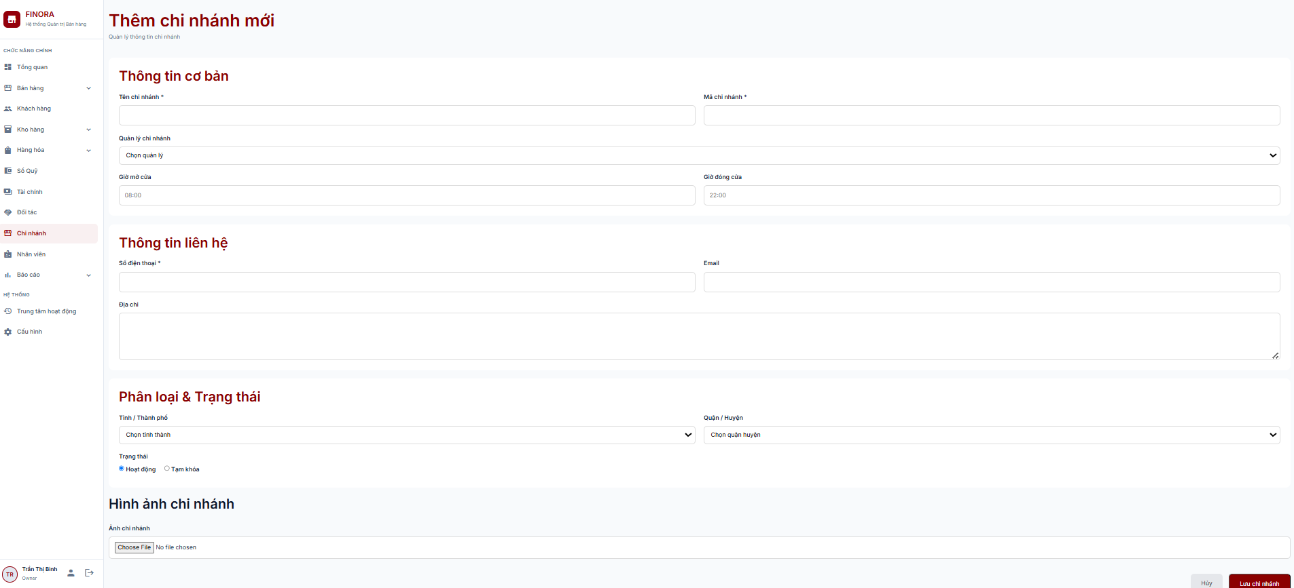

Field Name | Field Type | Description
Branch Information
Branch Name | Textbox | Required. Enter the branch name.
Branch Code | Textbox | Required. Enter a unique branch code (e.g., BR-001).
Manager | Select | Select the assigned Store Manager.
Opening Time | Time/Textbox | Enter the branch opening time (HH:mm).
Closing Time | Time/Textbox | Enter the branch closing time (HH:mm).
Phone | Textbox | Required. Enter the branch contact number.
Email | Email | Enter the branch email address.
Address | Textarea | Enter the branch address.
City | Select | Required. Select the city.
District | Select | Required. Select the district.
Status | Radio Button | Select ACTIVE or INACTIVE.
Image | File Upload | Upload a branch image (JPG, JPEG, PNG, GIF, or WEBP).
Hidden Fields
Action | Hidden | Indicates whether the operation is insert or update.
ID | Hidden | Stores the branch ID when updating a branch.
CSRF Token | Hidden | Prevents Cross-Site Request Forgery (CSRF) attacks.
Return Parameters | Hidden | Preserves the search filters and pagination state after saving.
Selected City | Hidden | Stores the selected city when reloading the form.
Selected District | Hidden | Stores the selected district when reloading the form.

Database Access
Table | CRUD | Description
branch | C | Creates a new branch record.
branch | R | Retrieves branch information for editing and validates duplicate branch code, phone number, and email.
branch | U | Updates an existing branch record.
employee | R | Retrieves the list of Store Managers and the current assigned manager.
employee | U | Assigns or unassigns a Store Manager to a branch.
role | R | Retrieves the StoreManager role for manager assignment.

SQL Commands
1. Check Duplicate Branch Code
SELECT 1 FROM branch
WHERE branch_code = ? AND branch_id <> ?;
2. Check Duplicate Email or Phone
SELECT 1 FROM branch
WHERE branch_id <> ? AND (email = ? OR phone = ?);
3. Retrieve Branch Information
SELECT b.*, (SELECT COUNT(*) FROM employee e
WHERE e.branch_id = b.branch_id) AS employee_count,
(SELECT TOP 1 e2.fullName FROM employee e2
INNER JOIN role r
ON e2.role_id = r.role_id
WHERE e2.branch_id = b.branch_id
AND r.role_name = 'StoreManager' AND e2.status = 'ACTIVE') AS manager_name
FROM branch b
WHERE b.branch_id = ?;
4. Retrieve Current Branch Manager
SELECT e.emp_id
FROM employee e
INNER JOIN role r
ON e.role_id = r.role_id
WHERE e.branch_id = ?
AND r.role_name = 'StoreManager';
5. Insert Branch
INSERT INTO branch
( branch_name, branch_code, address, phone, email, opening_time, closing_time, status, city, district, image_url)
VALUES ( ?, ?, ?, ?, ?, ?, ?, ?, ?, ?, ?);
6. Update Branch
UPDATE branch
SET branch_name = ?, branch_code = ?, address = ?, phone = ?, email = ?, opening_time = ?, closing_time = ?, status = ?, city = ?, district = ?, image_url = ?
WHERE branch_id = ?;
7. Assign Store Manager
UPDATE employee
SET branch_id = ? WHERE emp_id = ?;
8. Unassign Store Manager
UPDATE employee
SET branch_id = NULL
WHERE branch_id = ?
AND role_id = ( SELECT role_id FROM role WHERE role_name = 'StoreManager';

9.3 Delete branch (delete-modal.jsp)
Allows authorized users to delete a branch after confirming the action. The system displays a confirmation dialog before permanently removing the selected branch.
Related use case(s):
UC-2.5 – Owner creates, edits, and deletes branches.

UI Design
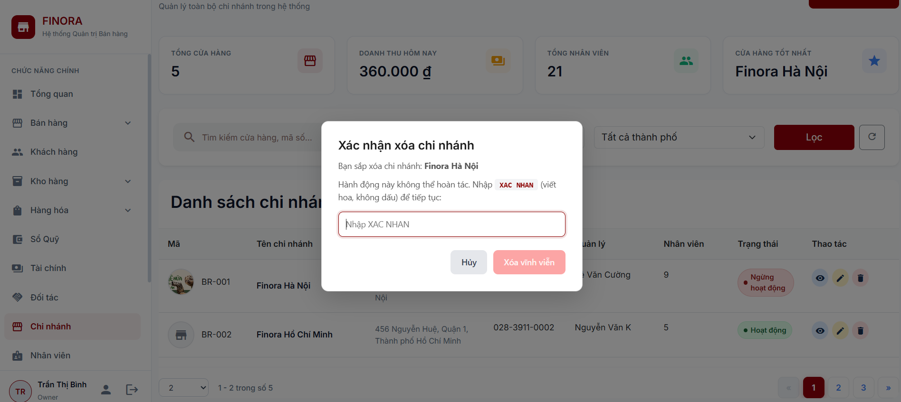

Field Name | Field Type | Description
Confirmation Dialog
Delete Confirmation | Modal Dialog | Displays a confirmation dialog before deleting the selected branch.
Confirmation Input | Textbox | Required. Users must enter "XAC NHAN" to enable the delete action.
Cancel | Button | Closes the confirmation dialog without deleting the branch.
Delete Permanently | Button | Deletes the selected branch after successful confirmation. The button is disabled until the correct confirmation text is entered.

Database Access
Table | CRUD | Description
branch | D | Deletes the selected branch. The operation is rejected if the branch is referenced by related records.

SQL Commands
1. Delete Branch
DELETE FROM branch WHERE branch_id = ?;

9.4 Detail & report.
Displays detailed branch information, including branch profile, manager, employees, warehouse, and business performance. The module also provides reports and key statistics to support branch monitoring and decision-making.
Related use case(s):
UC-2.5 – Owner creates, edits, and deletes branches.
UI Design

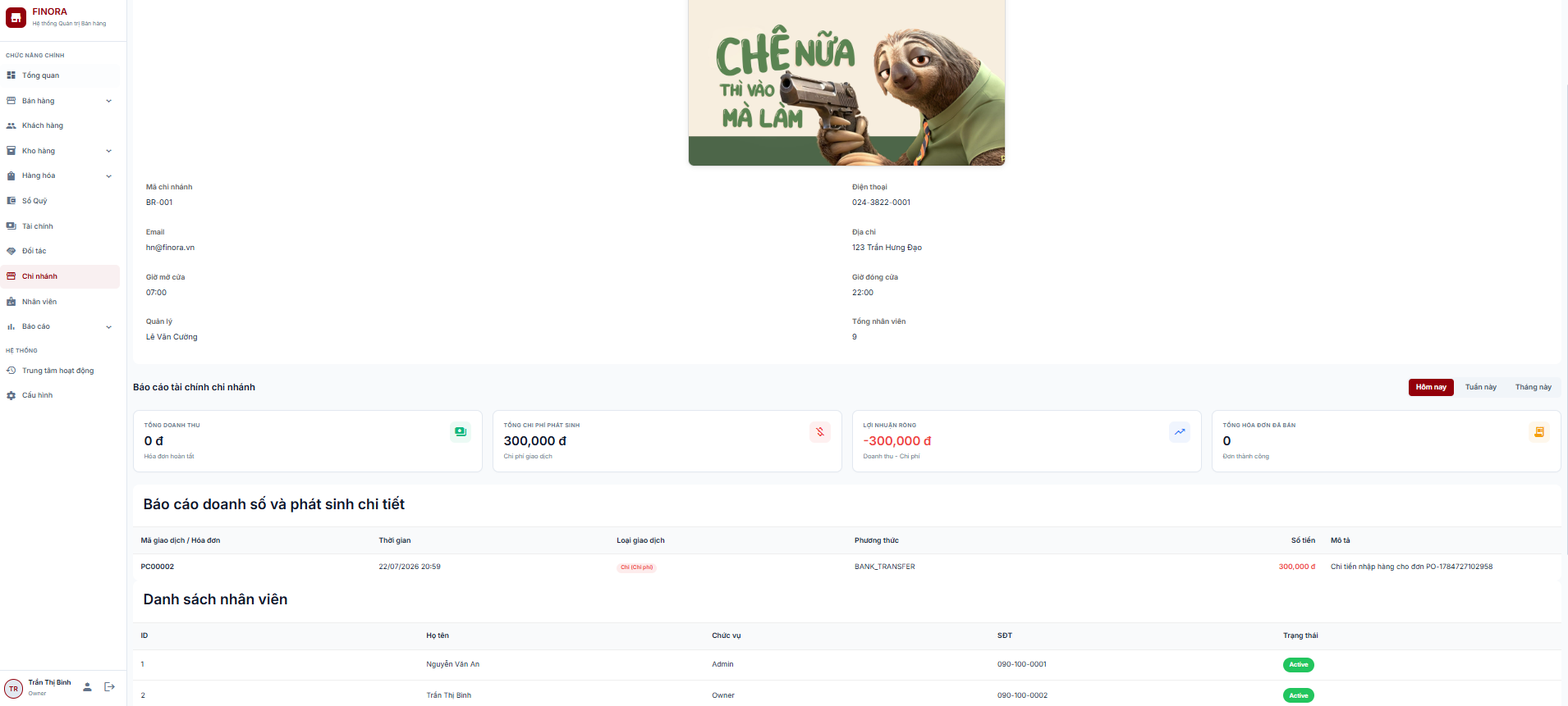

Field Name | Field Type | Description
Branch Information
Branch Name | Display (Heading) | Displays the branch name.
Branch Code | Display (Badge) | Displays the branch code.
Branch Image | Display (Image) | Displays the branch image, if available.
Phone | Display (Text) | Displays the branch phone number.
Email | Display (Text) | Displays the branch email address.
Address | Display (Text) | Displays the branch address.
Opening Time | Display (Text) | Displays the branch opening time.
Closing Time | Display (Text) | Displays the branch closing time.
Manager | Display (Text) | Displays the assigned Store Manager.
Employee Count | Display (Number) | Displays the total number of employees in the branch.
Financial Overview
Total Revenue | Display (Currency) | Displays the total revenue for the selected period.
Total Expenses | Display (Currency) | Displays the total expenses for the selected period.
Net Profit | Display (Currency) | Displays the net profit (Revenue − Expenses).
Total Invoices | Display (Number) | Displays the number of completed sales orders for the selected period.
Time Filter
Today | Button (Link) | Displays financial data for today.
This Week | Button (Link) | Displays financial data for the current week.
This Month | Button (Link) | Displays financial data for the current month.
Transaction History
Transaction / Invoice | Display (Text) | Displays the transaction or invoice name.
Date & Time | Display (Date) | Displays the transaction date and time.
Transaction Type | Display (Badge) | Indicates whether the transaction is Income or Expense.
Payment Method | Display (Text) | Displays the payment method.
Amount | Display (Currency) | Displays the transaction amount.
Description | Display (Text) | Displays the transaction description.
Employee List
Employee ID | Display (Number) | Displays the employee ID.
Full Name | Display (Text) | Displays the employee's full name.
Role | Display (Text) | Displays the employee's role.
Phone | Display (Text) | Displays the employee's phone number.
Status | Display (Badge) | Displays the employee's current status.
Actions
Back | Button (Link) | Returns to the branch list.
Edit | Button (Link) | Opens the branch edit form.

Database Access
Table | CRUD | Description
branch | R | Retrieves branch details, including general information, manager, and employee count.
employee | R | Retrieves the employee list, employee count, and assigned manager for the selected branch.
order | R | Retrieves revenue, completed order count, and financial statistics for the selected branch and time period.
payment | R | Retrieves payment transactions and expense records for the selected branch and time period.

SQL Commands
1. Retrieve Branch Details
SELECT b.*, (SELECT COUNT(*) FROM employee e
WHERE e.branch_id = b.branch_id) AS employee_count,
(SELECT TOP 1 e2.fullName FROM employee e2
INNER JOIN role r
ON e2.role_id = r.role_id
WHERE e2.branch_id = b.branch_id
AND r.role_name = 'StoreManager'
AND e2.status = 'ACTIVE') AS manager_name
FROM branch b
WHERE b.branch_id = ?;
2. Retrieve Employees by Branch
SELECT e.*, r.role_name FROM employee e
LEFT JOIN role r
ON e.role_id = r.role_id
WHERE e.branch_id = ?
ORDER BY e.emp_id;
3. Count Employees by Branch
SELECT COUNT(*) FROM employee
WHERE branch_id = ?;
4. Retrieve Branch Transactions
SELECT p.* FROM payment p
WHERE p.branch_id = ?
[AND payment_date BETWEEN ? AND ?]
ORDER BY p.payment_date DESC;
5. Calculate Monthly Revenue
SELECT ISNULL(SUM(total_amount), 0) FROM [order]
WHERE branch_id = ?
AND MONTH(created_at) = MONTH(GETDATE())
AND YEAR(created_at) = YEAR(GETDATE())
AND UPPER(status) = 'COMPLETED';
6. Count Monthly Orders
SELECT COUNT(*) FROM [order]
WHERE branch_id = ?
AND MONTH(created_at) = MONTH(GETDATE())
AND YEAR(created_at) = YEAR(GETDATE())
AND UPPER(status) = 'COMPLETED';
7. Calculate Monthly Net Profit
SELECT ISNULL(SUM(total_amount), 0)
- ISNULL(SUM(discount_amount), 0)
FROM [order]
WHERE branch_id = ?
AND MONTH(created_at) = MONTH(GETDATE())
AND YEAR(created_at) = YEAR(GETDATE())
AND UPPER(status) = 'COMPLETED';

10. Cashbook
The Cashbook module serves as the cash flow management hub for the FinoraRetail system. It records all of the business's cash inflows (income) and outflows (expenses) over time.

10.1 View List

a. View list cashbook
Displays a paginated list of active income and expense records, complete with search, filter, and quick-action tools.

UI Design
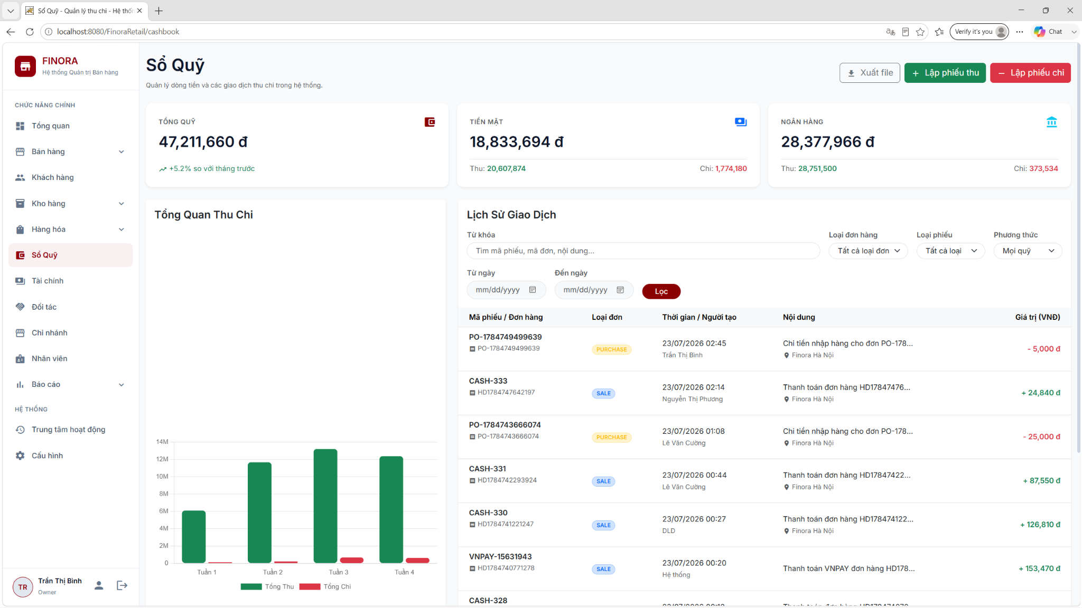

Field Name | Field Type | Description
Seacrh & Filter
Keyword | Textbox | Search by Transaction_code, Order_code, or Description.
Transaction Type | Dropdown | Filter by type of cash flow: INCOME / EXPENSE
Order Type | Dropdown | Filter by source purpose: SALE, PURCHASE, OTHER
Payment Method | Dropdown | Filter payment methods: CASH / BANK TRANSFER
Time Range | Dropdown | Quick time period: today, yesterday, this_week, this_month, all
Date From & Date To | Date Picker | Select a custom date range (fromDate, toDate)
Employee | Dropdown | Filter by employee ID (employee ID)
Range Amount | Input Range | Filter the amount range from (amountFrom) to (amountTo)
Branch Filter | Dropdown | Select branch (Only displayed and selectable for Owner account)

Table | CRUD | Description
payment | R | Retrieve the list of transactions, count the total number of records, calculate the fund balance (cash/bank) and total income/expenses based on the filter.
[order] | R | Join with the payment table to display the order code and order type.
Employee | R | Join uses the full name of the employee performing the transaction.
Branch | R | Join retrieves the name of the branch where the transaction originated (branch_name).
payment | C | Create a new receipt (INCOME) or payment voucher (EXPENSE) from the receipt/payment voucher template.

SQL Commands
1/ Query the list of fund ledger transactions with pagination and advanced filtering.
SELECT
p.payment_id AS PaymentID,
p.order_id AS OrderID,
o.order_code AS OrderCode,
o.order_type AS OrderType,
p.payment_amount AS PaymentAmount,
p.payment_date AS PaymentDate,
p.payment_status AS PaymentStatus,
p.transaction_code AS TransactionCode,
p.PaymentType AS PaymentType,
p.Description AS Description,
p.EmployeeID AS EmployeeID,
p.BranchID AS BranchID,
p.payment_method AS PaymentMethod,
e.fullName AS CreatorName,
b.branch_name AS BranchName
FROM payment p WITH (NOLOCK)
LEFT JOIN [order] o WITH (NOLOCK) ON p.order_id = o.order_id
LEFT JOIN Employee e WITH (NOLOCK) ON p.EmployeeID = e.emp_id
LEFT JOIN Branch b WITH (NOLOCK) ON p.BranchID = b.branch_id
WHERE p.payment_status IN ('COMPLETED', 'PAID')
-- Điều kiện lọc động (Chỉ add vào khi tham số khác NULL/Rỗng):
AND (p.transaction_code LIKE ? OR o.order_code LIKE ? OR p.description LIKE ?) -- keyword
AND p.PaymentType = ? -- type
AND o.order_type = ? -- orderType
AND p.payment_method = ? -- paymentMethod
AND p.EmployeeID = ? -- employeeId
AND p.payment_amount >= ? -- amountFrom
AND p.payment_amount <= ? -- amountTo
AND p.BranchID = ? -- branchId (Ràng buộc theo phân quyền hoặc bộ lọc của Owner)
ORDER BY p.payment_date DESC, p.payment_id DESC
OFFSET ? ROWS FETCH NEXT ? ROWS ONLY;

2/ Count the total number of transactions for paging.
SELECT COUNT(*)
FROM payment p WITH (NOLOCK)
LEFT JOIN [order] o WITH (NOLOCK) ON p.order_id = o.order_id
WHERE p.payment_status IN ('COMPLETED', 'PAID')
AND (p.transaction_code LIKE ? OR o.order_code LIKE ? OR p.description LIKE ?)
AND p.PaymentType = ?
AND o.order_type = ?
AND p.payment_method = ?
AND p.EmployeeID = ?
AND p.payment_amount >= ?
AND p.payment_amount <= ?
AND p.BranchID = ?;

3. Calculate the total cash inflow/outflow by branch (for displaying the Cash Balance Dashboard).
SELECT COALESCE(SUM(payment_amount), 0) AS TotalAmount
FROM payment WITH (NOLOCK)
WHERE payment_method = ?
AND PaymentType = ? -- 'INCOME' hoặc 'EXPENSE'
AND payment_status IN ('COMPLETED', 'PAID')
AND (? IS NULL OR BranchID = ?);

10.2 Create a cash receipt

UI
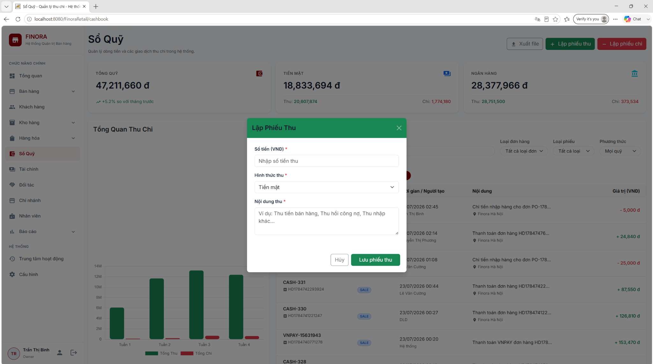
Field Name | Field Type | Description
Form Input
Amount | Input (Currency) | Actual amount collected (VND)
Payment Method | Dropdown | Payment methods: Cash, Bank Transfer
Description | Textarea | Payment details/Reason for collection
Actions
Save | Button | Confirm receipt recording and update the fund.
Cancel | Button | Cancel and close the form

10.3 Create payment

UI
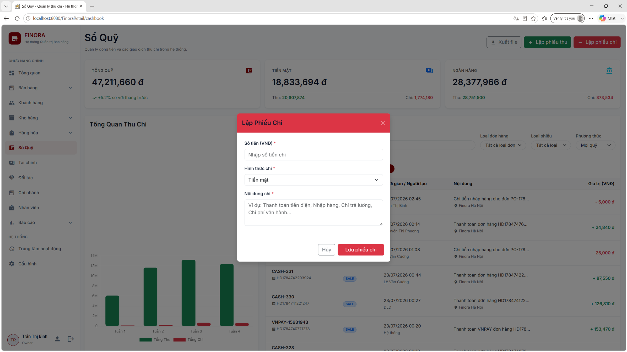
Field Name | Field Type | Description
Overview Cards
Amount | Input (Currency) | Actual amount collected (VND)
Payment Method | Dropdown | Payment methods: Cash, Bank Transfer
Description | Textarea | Payment details/Reason for collection
Actions
Save | Button | Confirm receipt recording and update the fund.
Cancel | Button | Cancel and close the form

Database Access

Table | CRUD | Description
[order] | C | Automatically generate an auxiliary invoice (order_type = 'OTHER', status = 'COMPLETED') with a value equal to the exact amount received/paid to link the foreign key.
payment | C | Add a new receipt (INCOME) or payment (EXPENSE) record with the status PAID, linked to the newly created supplementary invoice.
audit_log | C | Record the successful creation of receipt/payment vouchers in the system log.

SQL Commands
- Create a supplementary invoice in the [order] table.
INSERT INTO [order] (
order_code,
order_type,
status,
branch_id,
emp_id,
warehouse_id,
subtotal,
discount_amount,
total_amount,
payment_method,
created_at
)
VALUES (
?, -- Mã đơn hàng tự sinh (Ví dụ: 'ORD-RV-123456' hoặc 'ORD-PV-123456')
'OTHER', -- Loại đơn hàng phụ trợ
'COMPLETED', -- Trạng thái đơn hoàn thành
?, -- BranchID của nhân viên đang đăng nhập
?, -- EmployeeID của nhân viên đang đăng nhập
1, -- Mặc định WarehouseID = 1
?, -- Số tiền nhập từ Form [Số tiền (VND)]
0.0, -- Chiết khấu mặc định bằng 0
?, -- Tổng tiền bằng đúng số tiền thu/chi
?, -- Phương thức thanh toán từ Form ('CASH' hoặc 'BANK_TRANSFER')
CURRENT_TIMESTAMP
);

2. Create detailed records of receipts/payments in the payment table.
INSERT INTO payment (
order_id,
payment_method,
payment_amount,
payment_date,
payment_status,
transaction_code,
PaymentType,
Description,
EmployeeID,
BranchID
)
VALUES (
?, -- order_id lấy từ Bước 1
?, -- Phương thức thanh toán ('CASH' hoặc 'BANK_TRANSFER')
?, -- Số tiền nhập từ Form [Số tiền (VND)]
CURRENT_TIMESTAMP,
'PAID', -- Đã thanh toán
?, -- Mã phiếu tự sinh (Ví dụ: 'PT00001' hoặc 'PC00001')
?, -- Loại phiếu: 'INCOME' (Phiếu thu) hoặc 'EXPENSE' (Phiếu chi)
?, -- Nội dung nhập từ Form [Nội dung thu/chi]
?, -- EmployeeID người thực hiện
? -- BranchID nơi phát sinh
);
3. Record the activity in the audit_log table (after the Transaction Commit).
INSERT INTO audit_log (
emp_id,
action,
table_name,
record_id,
old_data,
new_data,
created_at
)
VALUES (
?, -- EmployeeID người thực hiện
?, -- Tên hành động: 'TẠO_PHIẾU_THU' hoặc 'TẠO_PHIẾU_CHI'
'cashbook', -- Phân hệ tác động
?, -- ID của payment vừa tạo ở Bước 2
NULL,
?, -- Chuỗi mô tả hành động (Ví dụ: 'Tạo phiếu thu PT00001 - Số tiền: 100,000 VND')
CURRENT_TIMESTAMP
);

11. Product Management

11.1 Product List

a. Product List
Displays a paginated list of products with multi-criteria search (by product name, category name), filter by status, category, and unit of measure. Supports quick actions to view, edit, or delete products.
Related use case(s): UC-3.2 – Manage Products, UC-4.1 – Search Product

UI Design
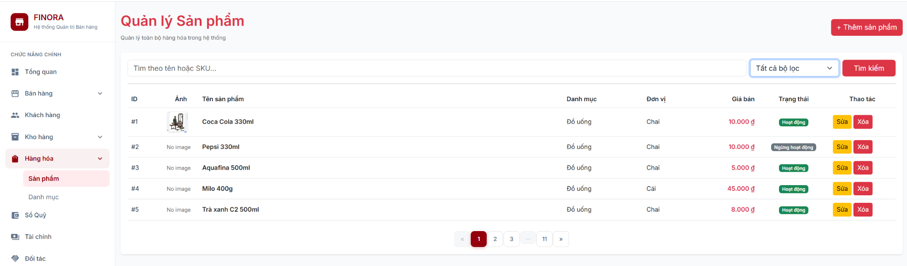

Field Name | Field Type | Description
Keyword | Textbox | Search by product name or category name
Status | Dropdown | Filter by ACTIVE / INACTIVE
Category | Dropdown | Filter by product category
Unit | Dropdown | Filter by unit of measure
Product ID | Table Cell | Unique primary key identifier (product_id)
Product Name | Table Cell | Name of the product
Category | Table Cell | Associated category name
Unit | Table Cell | Unit of measure (e.g., box, piece, bottle)
Selling Price | Currency | Current selling price (VND)
Quantity | Number | Total stock across all warehouses (SUM from inventory)
Status | Badge | ACTIVE (green) / INACTIVE (red)
Image | Thumbnail | Product image preview
Actions | Button Group | Edit (pencil icon), Delete (trash icon)

Database Access
Table | CRUD | Description
product | R | Queries product list with LEFT JOIN category, unit tables
category | R | Retrieves category name for display and filtering
unit | R | Retrieves unit name for display and filtering
inventory | R | Calculates total quantity_in_stock per product (SUM)

SQL Commands
1/ Get paginated products with search and filters:
SELECT p.product_id AS ProductID, p.product_name AS Name,
ISNULL((SELECT SUM(quantity_in_stock) FROM inventory WHERE product_id = p.product_id), 0) AS Quantity,
p.category_id AS CategoryID, c.category_name AS CategoryName,
p.unit_id AS UnitID, u.unit_name AS UnitName,
p.selling_price AS SellingPrice, p.ImageUrl AS ImageUrl,
ISNULL(p.status, 'ACTIVE') AS Status, p.created_at AS CreatedAt, p.update_at AS UpdatedAt
FROM product p
LEFT JOIN category c ON p.category_id = c.category_id
LEFT JOIN unit u ON p.unit_id = u.unit_id
WHERE 1=1
AND (? IS NULL OR p.product_name LIKE ? OR c.category_name LIKE ?)
AND (? IS NULL OR p.status = ?)
AND (? IS NULL OR p.category_id = ?)
AND (? IS NULL OR p.unit_id = ?)
ORDER BY p.product_id ASC
OFFSET ? ROWS FETCH NEXT ? ROWS ONLY;

2/ Count total products for pagination:
SELECT COUNT(*)
FROM product p
LEFT JOIN category c ON p.category_id = c.category_id
WHERE 1=1
AND (? IS NULL OR p.product_name LIKE ? OR c.category_name LIKE ?)
AND (? IS NULL OR p.status = ?)
AND (? IS NULL OR p.category_id = ?)
AND (? IS NULL OR p.unit_id = ?);

11.2 Add Product

a. Add Product
Opens a modal dialog allowing Store Managers to create a new product by entering name, selecting category and unit, setting selling price, uploading images, and specifying initial stock quantity. Automatically creates an initial inventory record in the main warehouse (warehouse_id = 1).
Related use case(s): UC-3.2 – Manage Products

UI Design
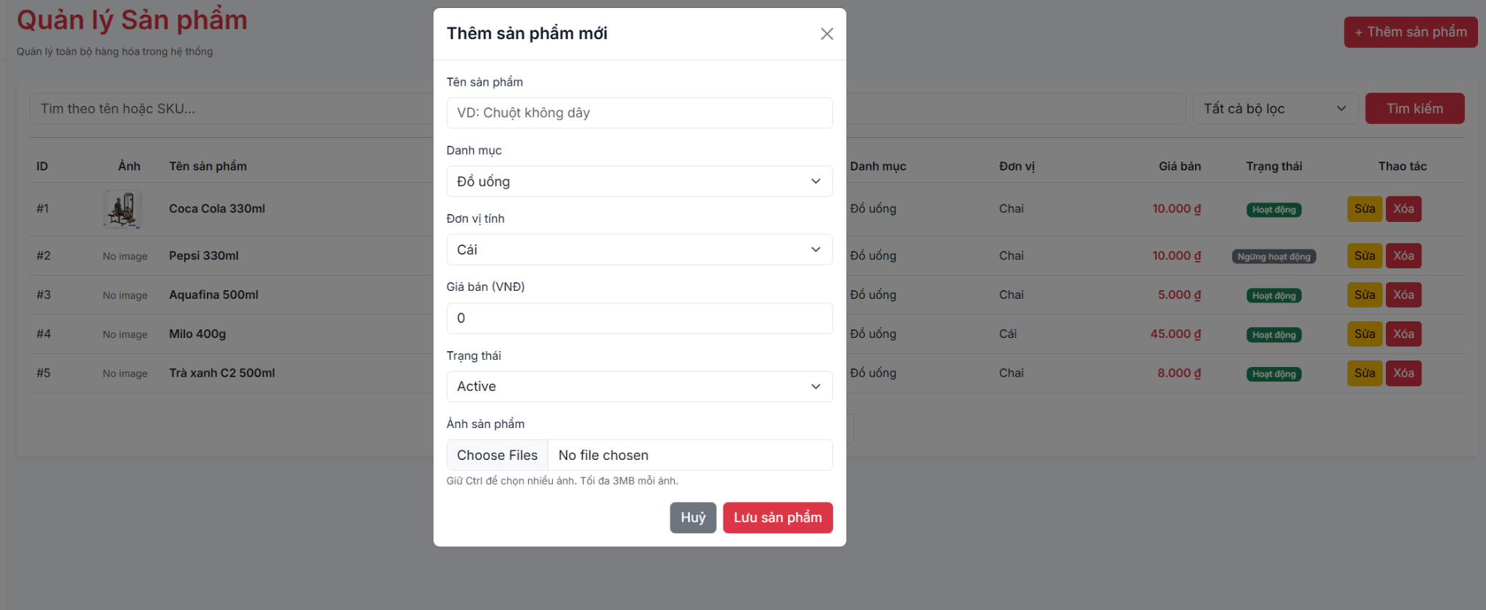

Field Name | Field Type | Description
Product Name | Textbox | Required. Name of the new product
Category | Dropdown | Select product category (from category table)
Unit | Dropdown | Select unit of measure (from unit table)
Selling Price | Currency | Retail selling price (VND)
Image | File Upload | Product image(s) stored as JSON array
Status | Radio / Select | ACTIVE or INACTIVE
Initial Stock | Number | Initial quantity in stock for main warehouse
Cancel | Button | Closes modal without saving
Save | Button | Submits POST request to insert new product and inventory record

Database Access
Table | CRUD | Description
product | C | Insert new product record with generated product_id
inventory | C | Insert initial inventory record for warehouse 1
category | R | Get category list for dropdown
unit | R | Get unit list for dropdown

SQL Commands
1/ Insert product record:
INSERT INTO product (product_name, category_id, unit_id, selling_price, ImageUrl, status, created_at, update_at)
VALUES (?, ?, ?, ?, ?, ?, GETDATE(), GETDATE());

2/ Insert initial inventory record:
INSERT INTO inventory (warehouse_id, product_id, quantity_in_stock, status, updated_at)
VALUES (1, ?, ?, 'active', GETDATE());

11.3 Edit Product
a. Edit Product
Updates details of an existing product including name, category, unit, selling price, images, and status.
Related use case(s): UC-3.2 – Manage Products

UI Design
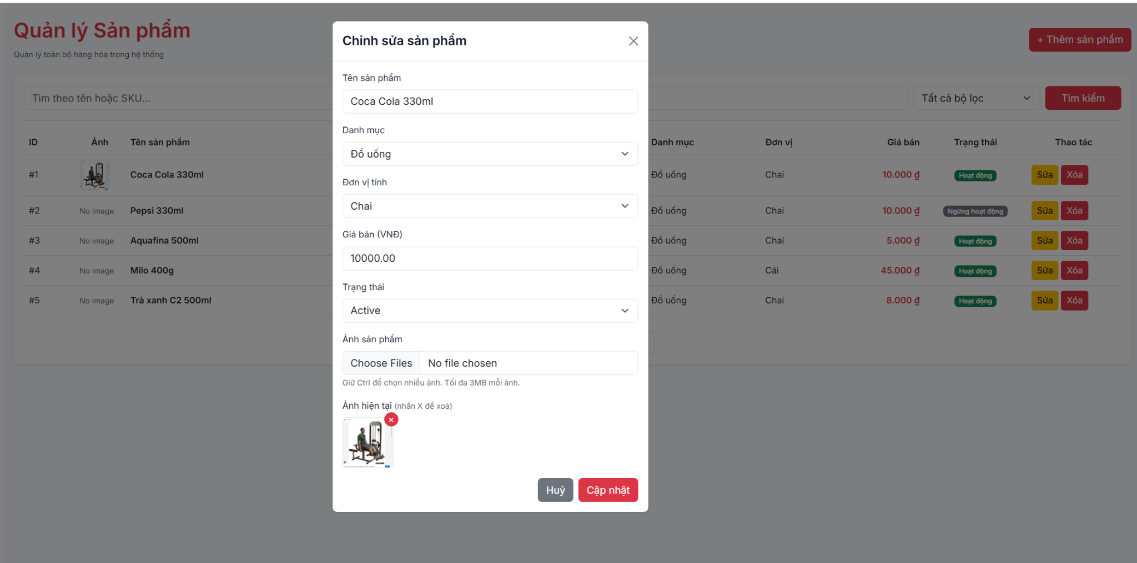

Field Name | Field Type | Description
Product ID | Hidden Input | ID of the product being edited
Product Name | Textbox | Updated product name
Category | Dropdown | Updated category selection
Unit | Dropdown | Updated unit selection
Selling Price | Currency | Updated selling price
Image | File Upload | Updated product images
Status | Dropdown | Update status (ACTIVE / INACTIVE)
Update | Button | Submits updated product information

Database Access

Table | CRUD | Description
product | U, R | Fetches product details and updates product record

SQL Commands
1/ Update product record:
UPDATE product SET product_name=?, category_id=?, unit_id=?, selling_price=?, ImageUrl=?, status=?, update_at=GETDATE()
WHERE product_id=?;

11.4 Delete Product
a. Delete Product
Permanently deletes a product and all related records (inventory, stock transactions, order details) within a database transaction. If the product has existing sales orders, deletion is safely handled by cascade delete.
Related use case(s): UC-3.2 – Manage Products

Database Access
Table | CRUD | Description
inventory | D | Delete inventory records for the product
stock_transaction | D | Delete stock transaction records for the product
order_detail | D | Delete order detail records for the product
product | D | Delete the product record

SQL Commands
1/ Delete related records in a transaction:
BEGIN TRANSACTION;
DELETE FROM inventory WHERE product_id = ?;
DELETE FROM stock_transaction WHERE product_id = ?;
DELETE FROM order_detail WHERE product_id = ?;
DELETE FROM product WHERE product_id = ?;
COMMIT;

11.5 Product Detail
a. Product Detail
Displays detailed information of a single product including name, category, unit, price, images, stock quantity, and status.
Related use case(s): UC-4.1 – Search Product

Database Access

Table | CRUD | Description
product | R | Reuses the same SELECT query as Product List (10.1) with WHERE p.product_id = ?

SQL Commands
1/ Get product by ID:
Reuses the same SELECT query as Product List (10.1) with WHERE p.product_id = ?;

11.6 Search Product (POS)
a. Search Product
Provides quick product search for POS and Sales modules. Searches by product name and returns stock quantity for the specified warehouse.
Related use case(s): UC-4.1 – Search Product

Database Access

Table | CRUD | Description
product | R | Queries product with LEFT JOIN inventory for stock quantity
inventory | R | Retrieves quantity_in_stock for the specified warehouse

SQL Commands
1/ Search products by keyword and warehouse:
SELECT p.product_id, p.product_codebar, p.product_name, p.category_id,
p.unit_id, p.selling_price, p.ImageUrl AS image_url,
ISNULL(i.quantity_in_stock, 0) AS quantity_in_stock
FROM product p
LEFT JOIN inventory i ON p.product_id = i.product_id AND i.warehouse_id = ?
WHERE p.product_name LIKE ? OR p.product_codebar LIKE ?
ORDER BY p.product_name;

12. System Log

12.1 Activity Log List
a. Activity Log
Displays a paginated list of all user activity logs with multi-criteria filtering (by keyword, table name, action type, date range). Uses keyset pagination (audit_log_id) for optimal performance on large datasets. Owner/ can track all user operations in the system.
Related use case(s): UC-1.5 – View Activity Log

UI Design

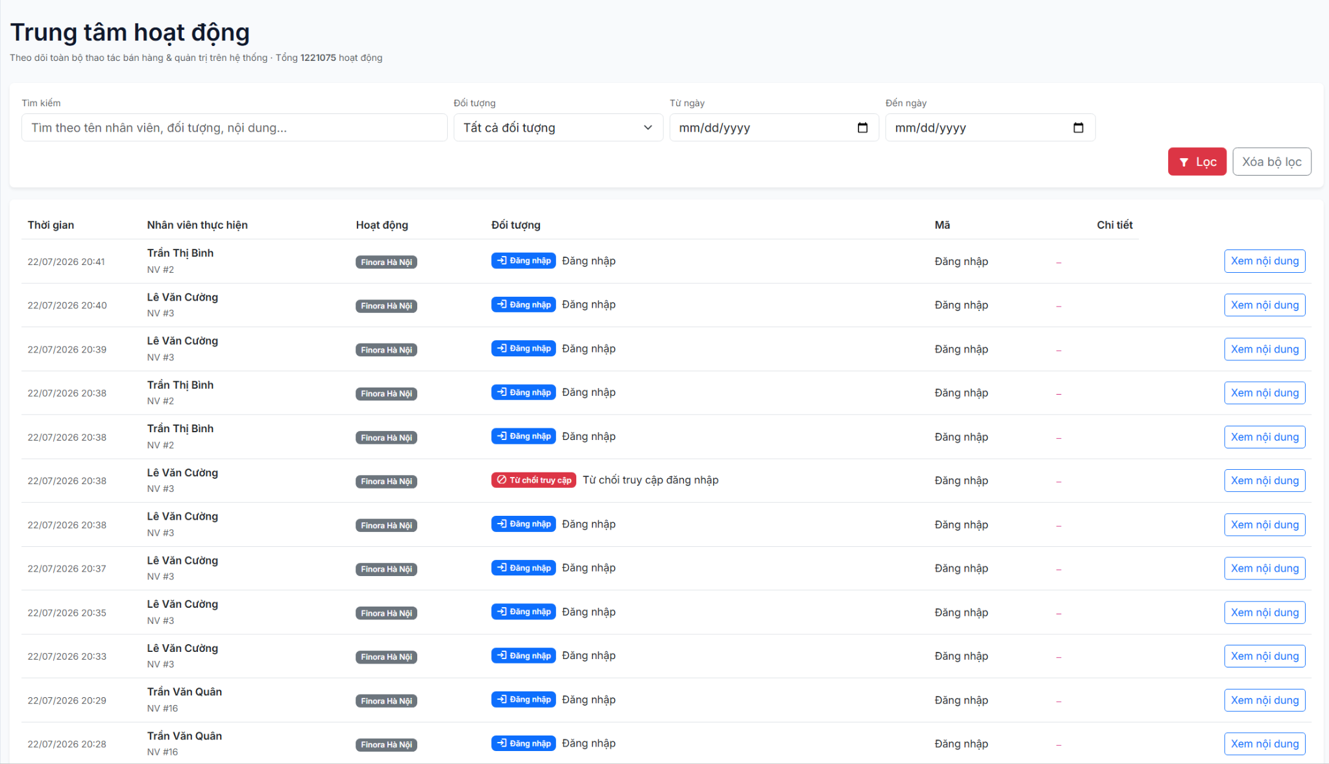
Field Name | Field Type | Description
Keyword | Textbox | Search by action name, table name, employee name, or data content
Table Filter | Dropdown | Filter by table_name (distinct values from audit_log)
Action Filter | Dropdown | Filter by action_name (INSERT, UPDATE, DELETE, LOGIN, LOGOUT)
Date From | Datepicker | Filter logs from this date (inclusive)
Date To | Datepicker | Filter logs to this date (inclusive)
Timestamp | Table Cell | Date and time of the activity
Employee | Table Cell | Employee name who performed the action
Branch | Table Cell | Branch of the employee
Action | Badge | Action type: INSERT (green), UPDATE (orange), DELETE (red), LOGIN (blue)
Table Name | Table Cell | Database table that was affected
Record ID | Table Cell | ID of the affected record
Description | Table Cell | Human-readable description (e.g., 'Cập nhật sản phẩm SP005')

Database Access
Table | CRUD | Description
audit_log | R | Queries audit logs with keyset pagination and multi-criteria filters
employee | R | Retrieves employee name and branch_id for display
branch | R | Retrieves branch name for display

SQL Commands
1/ Get activity logs with keyset pagination:
SELECT a.audit_log_id, a.emp_id, a.action_name, a.table_name, a.record_id,
a.old_data, a.new_data, a.created_at,
e.fullName AS emp_name, e.branch_id, b.branch_name
FROM audit_log a
LEFT JOIN employee e ON a.emp_id = e.emp_id
LEFT JOIN branch b ON e.branch_id = b.branch_id
WHERE 1=1
AND (? IS NULL OR (a.action_name LIKE ? OR a.table_name LIKE ? OR e.fullName LIKE ? OR a.new_data LIKE ?))
AND (? IS NULL OR a.table_name = ?)
AND (? IS NULL OR a.action_name = ?)
AND (? IS NULL OR a.created_at >= ?)
AND (? IS NULL OR a.created_at < ?)
AND (? IS NULL OR a.audit_log_id < ?)
ORDER BY a.audit_log_id DESC
OFFSET 0 ROWS FETCH NEXT ? ROWS ONLY;

2/ Count total logs matching filters:
SELECT COUNT(*)
FROM audit_log a
LEFT JOIN employee e ON a.emp_id = e.emp_id
WHERE 1=1
AND (? IS NULL OR (a.action_name LIKE ? OR a.table_name LIKE ? OR e.fullName LIKE ? OR a.new_data LIKE ?))
AND (? IS NULL OR a.table_name = ?)
AND (? IS NULL OR a.action_name = ?)
AND (? IS NULL OR a.created_at >= ?)
AND (? IS NULL OR a.created_at < ?);

3/ Get distinct table names for filter dropdown:
SELECT DISTINCT table_name FROM audit_log WHERE table_name IS NOT NULL ORDER BY table_name;

4/ Get distinct action names for filter dropdown:
SELECT DISTINCT action_name FROM audit_log WHERE action_name IS NOT NULL ORDER BY action_name;

12.2 Auto Activity Logging
a. Auto Activity Logging
The system automatically records an activity log for all user operations that modify data (INSERT, UPDATE, DELETE) as well as security events (LOGIN, LOGOUT, FAILED_LOGIN). This is a backend behavior with no dedicated UI.
Related use case(s): UC-1.5 – View Activity Log, BR-03

Database Access

Table | CRUD | Description
audit_log | C | Insert log record after each data-modifying operation

SQL Commands
1/ Insert activity log record:
INSERT INTO audit_log (emp_id, action_name, table_name, record_id, old_data, new_data, created_at)
VALUES (?, ?, ?, ?, ?, ?, GETDATE());

13. System Configuration

13.1 VAT Setting

a. VAT Configuration
Manages VAT percentage settings for the system. Supports a default VAT rate (applies to all products when category_id IS NULL) and category-specific overrides. The VAT rate is used in order calculation: Total Invoice = (Unit Price x Quantity) - Discounts + VAT.
Related use case(s): BR-SALES-03 – VAT Calculation

UI Design
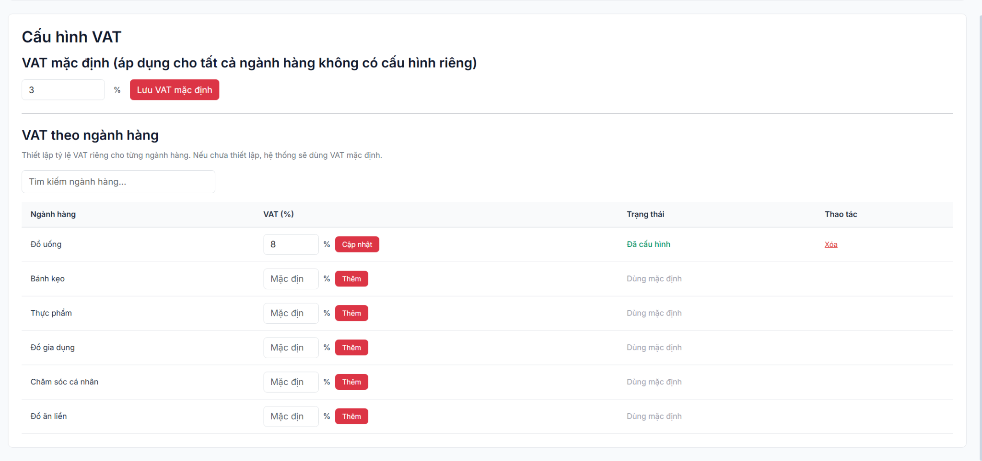

Field Name | Field Type | Description
VAT Percentage | Number (%) | VAT rate percentage (e.g., 8 = 8%). Default applies to all categories
Category | Dropdown | NULL = default rate for all; selected category = category-specific override
Updated By | Display | Employee who last updated the setting
Updated At | Display | Timestamp of the last update
Save | Button | Upsert VAT setting
Delete | Button | Delete category-specific VAT setting

Database Access
Table | CRUD | Description
vat_setting | R, C, U, D | Queries default and category-specific VAT settings; upserts and deletes
category | R | Retrieves category name for display

SQL Commands
1/ Get default VAT setting (category_id IS NULL):
SELECT TOP 1 s.setting_id, s.vat_percentage, s.category_id, s.updated_by, s.updated_at, c.category_name
FROM vat_setting s
LEFT JOIN category c ON s.category_id = c.category_id
WHERE s.category_id IS NULL
ORDER BY s.setting_id DESC;

2/ Get all VAT settings (default first, then by category):
SELECT s.setting_id, s.vat_percentage, s.category_id, s.updated_by, s.updated_at, c.category_name
FROM vat_setting s
LEFT JOIN category c ON s.category_id = c.category_id
ORDER BY CASE WHEN s.category_id IS NULL THEN 0 ELSE 1 END, c.category_name;

3/ Upsert VAT setting:
-- Update existing:
UPDATE vat_setting SET vat_percentage = ?, updated_by = ?, updated_at = GETDATE() WHERE setting_id = ?;
-- Insert new:
INSERT INTO vat_setting (vat_percentage, category_id, updated_by, updated_at) VALUES (?, ?, ?, GETDATE());

4/ Delete VAT setting:
DELETE FROM vat_setting WHERE setting_id = ?;

5/ Get VAT percentage by category (fallback to default):
SELECT vat_percentage FROM vat_setting WHERE category_id = ?;
-- If not found, use default:
SELECT TOP 1 vat_percentage FROM vat_setting WHERE category_id IS NULL ORDER BY setting_id DESC;

13.2 Loyalty Point Setting

a. Loyalty Point Configuration
Configures the loyalty point earning and redemption rates. Defines how much spending earns one point and the monetary value of each point when redeemed. These settings affect the automatic loyalty point calculation for customer orders.
Related use case(s): UC-4.9 – Accumulate Loyalty Points, BR-POINT-04

UI Design

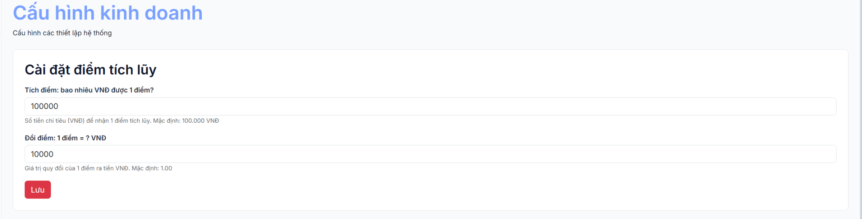
Field Name | Field Type | Description
Amount Per Point | Currency | Amount of money spent to earn 1 loyalty point (e.g., 100,000 VND)
Point To Currency | Currency | Monetary value of 1 point when redeemed (e.g., 2,000 VND)
Updated By | Display | Employee who last updated the setting
Updated At | Display | Timestamp of the last update
Save | Button | Upsert loyalty point setting

Database Access
Table | CRUD | Description
loyalty_point_setting | R, C, U | Queries the current loyalty point settings; upserts new values

SQL Commands
1/ Get current loyalty point setting:
SELECT TOP 1 setting_id, amount_per_point, point_to_currency, updated_by, updated_at
FROM loyalty_point_setting
ORDER BY setting_id DESC;

2/ Upsert loyalty point setting:
-- Update existing:
UPDATE loyalty_point_setting
SET amount_per_point = ?, point_to_currency = ?, updated_by = ?, updated_at = GETDATE()
WHERE setting_id = ?;
-- Insert new (if no setting exists):
INSERT INTO loyalty_point_setting (amount_per_point, point_to_currency, updated_by, updated_at)
VALUES (?, ?, ?, GETDATE());

14. Sale (POS)

14.1 Look Up Product
Allows sales staff to search and view product information by barcode, product code, or product name. The system displays product details, available stock, price, and product status to support the sales process.
Related use case(s):
UC-4.1: Look Up Product

UI Design
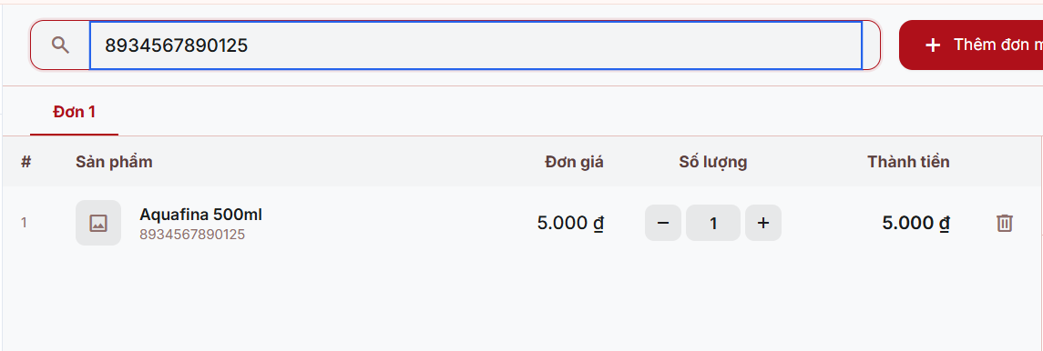

Database Access
Table | CRUD | Description
product | R | Retrieves product information, including barcode, name, category, unit, selling price, image, and product details. Supports searching by product name or barcode.
inventory | R | Retrieves the current stock quantity of each product in the selected warehouse.
warehouse | R | Retrieves the warehouse associated with the employee's branch to determine the inventory source.

SQL Commands
1. Retrieve Warehouse ID
SELECT TOP 1 warehouse_id FROM warehouse
WHERE branch_id = ?;
2. Search Products by Keyword
SELECT p.product_id, p.product_codebar, p.product_name,
p.category_id, p.unit_id, p.selling_price, p.ImageUrl AS image_url,
p.created_at, p.update_at,
ISNULL(i.quantity_in_stock, 0) AS quantity_in_stock
FROM product p
LEFT JOIN inventory i
ON p.product_id = i.product_id
AND i.warehouse_id = ?
WHERE p.product_name LIKE ?
OR p.product_codebar LIKE ?
ORDER BY p.product_name;
3. Retrieve Product by Barcode
SELECT p.product_id, p.product_codebar, p.product_name, p.category_id, p.unit_id,
p.selling_price, p.ImageUrl AS image_url, p.created_at, p.update_at,
ISNULL(i.quantity_in_stock, 0) AS quantity_in_stock
FROM product p
LEFT JOIN inventory i
ON p.product_id = i.product_id AND i.warehouse_id = ?
WHERE p.product_codebar = ?;
4. Retrieve Product List
SELECT p.product_id, p.product_codebar, p.product_name, p.category_id, p.unit_id, p.selling_price,
p.ImageUrl AS image_url, p.created_at, p.update_at,
ISNULL(i.quantity_in_stock, 0) AS quantity_in_stock
FROM product p
LEFT JOIN inventory i
ON p.product_id = i.product_id AND i.warehouse_id = ?
ORDER BY p.product_name;

14.2 Create Sales Order (POS)
Allows sales staff to create a new sales order by adding products to a multi-tab cart, selecting or adding a customer, applying loyalty point redemption, and choosing a payment method (CASH or BANK_TRANSFER via VNPAY). The system validates stock availability, calculates subtotal, discount, VAT, and total amount, then processes the payment within a single database transaction, deducts inventory, updates loyalty points, and records payment information.
Related use case(s):
UC-4.2: Create Sales Order (POS)

UI Design
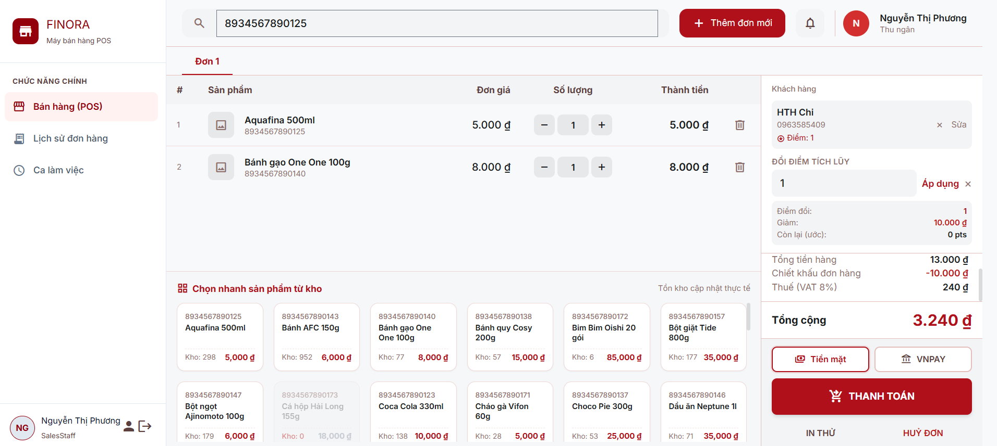

Field Name | Field Type | Description
Order
Tab ID | Integer | Unique identifier of the shopping cart tab.
Order Code | String | Automatically generated sales order code.
Order Type | String | Sales order type.
Customer ID | Integer | Customer identifier (optional).
Branch ID | Integer | Branch where the order is created.
Employee ID | Integer | Sales employee handling the order.
Warehouse ID | Integer | Warehouse supplying the products.
Subtotal | Currency | Total amount before discounts and VAT.
Discount Amount | Currency | Discount applied to the order.
Total Amount | Currency | Final payable amount after discounts and VAT.
Payment Method | String | Payment method (Cash or Bank Transfer).
Status | Enum | Current order status.
Created At | DateTime | Order creation date and time.
VAT Rate | Percentage | VAT applied to the order.
Redeem Points | Integer | Loyalty points redeemed.
Redeem Discount | Currency | Discount amount from redeemed points.
Order Details
Product ID | Integer | Product identifier.
Quantity | Integer | Quantity purchased.
Unit Price | Currency | Selling price per unit.
Line Total | Currency | Total amount for the product line.
Import Price | Currency | Product import cost.
Payment
Cash Received | Currency | Amount received from the customer.
Change Amount | Currency | Change returned to the customer.
Payment Amount | Currency | Total payment amount.
Transaction Code | String | Payment transaction code.
Payment Type | String | Transaction type (Income).
Method | String | Payment method used.
Cart Item
Product ID | Integer | Product identifier.
Product Name | String | Product name.
Barcode | String | Product barcode.
Selling Price | Currency | Product selling price.
Quantity | Integer | Quantity added to the cart.
Line Total | Currency | Total amount for the cart item.
Stock Available | Integer | Current available stock quantity.
Customer
Selected Customer | Object | Selected customer information.
Full Name | String | Customer full name.
Phone | String | Customer phone number.
Loyalty Points | Integer | Customer's current loyalty points.

Database Access
Table | CRUD | Description
warehouse | R | Retrieves the warehouse associated with the employee's branch.
vat_setting | R | Retrieves the current VAT rate for sales transactions.
loyalty_point_setting | R | Retrieves loyalty point earning and redemption settings.
product | R | Retrieves product information and selling price.
inventory | R, U | Validates product stock and updates inventory after checkout.
stock_transaction | C | Records inventory deduction transactions for sales.
order | C, U | Creates a sales order and updates its status after payment.
order_detail | C | Stores the products included in the sales order.
payment | C | Records payment information for completed sales.
customer_point | R, C, U | Retrieves, updates, or creates customer loyalty point records.
point_transaction | C | Records loyalty point earning and redemption history.
customer | C | Creates a new customer record when required.

SQL Commands
1. Retrieve Warehouse
SELECT TOP 1 warehouse_id
FROM warehouse WHERE branch_id = ?;
2. Retrieve VAT Setting
SELECT TOP 1 vat_percentage
FROM vat_setting
ORDER BY setting_id DESC;
3. Retrieve Loyalty Point Settings
SELECT TOP 1 setting_id, amount_per_point, point_to_currency
FROM loyalty_point_setting
ORDER BY setting_id DESC;
4. Retrieve Product by Barcode
SELECT p.product_id, p.product_codebar, p.product_name, p.selling_price,
ISNULL(i.quantity_in_stock, 0) AS quantity_in_stock
FROM product p
LEFT JOIN inventory i
ON p.product_id = i.product_id AND i.warehouse_id = ?
WHERE p.product_codebar = ?;
5. Check Inventory
SELECT quantity_in_stock
FROM inventory
WHERE product_id = ? AND warehouse_id = ?;
6. Create Sales Order
INSERT INTO [order]
( order_code, order_type, customer_id, branch_id, supplier_id, emp_id, voucher_id, warehouse_id,
subtotal, discount_amount, total_amount, payment_method, status, created_at)
VALUES (?, ?, ?, ?, ?, ?, ?, ?, ?, ?, ?, ?, ?, GETDATE());
7. Create Order Details
INSERT INTO order_detail
(order_id, product_id, quantity, unit_price, total_price, import_price)
VALUES (?, ?, ?, ?, ?, ?);
8. Update Inventory
UPDATE inventory
SET quantity_in_stock = quantity_in_stock - ?,
updated_at = GETDATE()
WHERE product_id = ? AND warehouse_id = ? AND quantity_in_stock >= ?;
9. Create Stock Transaction
INSERT INTO stock_transaction
(warehouse_id, product_id, reference_type, reference_id, transaction_type, quantity,
before_quantity, ter_quantity, note, created_by,created_at)
VALUES (?, ?, 'ORDER', ?, 'SALE_DEDUCT', ?, ?, ?, N'Bán hàng POS', ?, GETDATE());
10. Create Payment
INSERT INTO payment
(order_id, payment_amount, payment_date, payment_status, transaction_code, PaymentType,
Description, EmployeeID, BranchID, payment_method)
VALUES (?, ?, GETDATE(), ?, ?, ?, ?, ?, ?, ?);
11. Retrieve Customer Points
SELECT cus_point_id, current_points
FROM customer_point WHERE cus_id = ?;
12. Update Customer Points
UPDATE customer_point
SET current_points = ?, updated_at = GETDATE()
WHERE cus_point_id = ?;
13. Create Point Redemption Transaction
INSERT INTO point_transaction
( cus_point_id, order_id, before_points, after_points, description, created_at)
VALUES (?, ?, ?, ?, N'Đổi điểm POS', GETDATE());
14. Add Loyalty Points
UPDATE customer_point
SET current_points = current_points + ?,
lifetime_points = lifetime_points + ?,
updated_at = GETDATE()
WHERE cus_point_id = ?;
15. Create Loyalty Point Transaction
INSERT INTO point_transaction
( cus_point_id, order_id, before_points, after_points, description, created_at)
VALUES
(?, ?, ?, ?, N'Tích điểm đơn hàng POS', GETDATE());
16. Complete Sales Order
UPDATE [order]
SET status = ?
WHERE order_id = ?;
17. Create Customer
INSERT INTO customer
( full_name, phone, email, bod, gender, address, cus_type, created_at, status)
VALUES (?, ?, ?, ?, ?, ?, 'REGULAR', GETDATE(), 'ACTIVE');

14.3 Print Invoice
Allows sales staff to print a sales invoice/receipt for a completed order. The system generates a formatted receipt (80mm thermal) containing store name, order code, date/time, customer information, product list with quantities and prices, subtotal, discount, VAT, and total amount. The invoice can be printed after successful checkout or viewed for any completed order from the order history.
Related use case(s):
UC-4.6: Print Invoice

UI Design

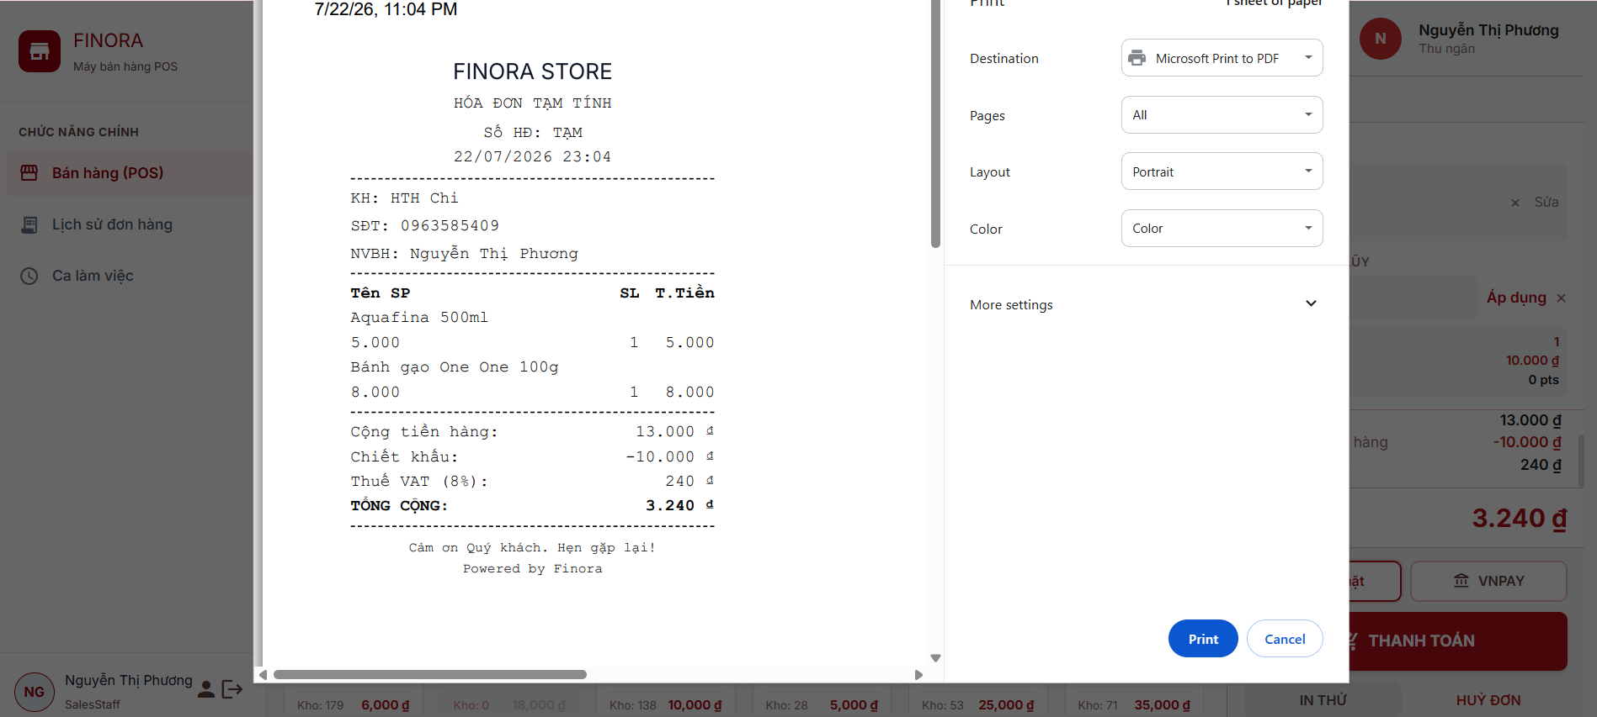

Field Name | Field Type | Description
Header
Store Name | Display | Displays the store name.
Invoice Title | Display | Displays the invoice type.
Order Code | Display | Displays the invoice number.
Created At | Display (DateTime) | Displays the invoice creation date and time.
Customer Information
Customer Name | Display | Displays the customer name or Walk-in Customer.
Customer Phone | Display | Displays the customer's phone number.
Employee Name | Display | Displays the sales employee's name.
Product List
Product Name | Display | Displays the product name.
Unit Price | Display (Currency) | Displays the unit price.
Quantity | Display (Number) | Displays the purchased quantity.
Total Price | Display (Currency) | Displays the total amount for each product.
Order Summary
Subtotal | Display (Currency) | Displays the subtotal before discounts and taxes.
Discount Amount | Display (Currency) | Displays the discount amount.
VAT Percentage | Display (Percentage) | Displays the applied VAT rate.
VAT Amount | Display (Currency) | Displays the VAT amount.
Total Amount | Display (Currency) | Displays the final payable amount.
Footer
Footer Message | Display | Displays a thank-you message.
Powered By | Display | Displays the system branding.

Database Access
Table | CRUD | Description
order | R | Retrieves sales order information, including order details, totals, payment method, status, and creation date.
customer | R | Retrieves customer information for the invoice.
customer_point | R | Retrieves the customer's current loyalty points.
employee | R | Retrieves the sales employee's information.
branch | R | Retrieves the branch information for the invoice.
order_detail | R | Retrieves the list of products included in the order.
product | R | Retrieves product information for each order item.
vat_setting | R | Retrieves the current VAT rate applied to the invoice.

SQL Commands
1. Retrieve Order Information
SELECT o.*, c.full_name AS customerName, c.phone AS customerPhone,
cp.current_points AS customerPoints, e.fullName AS employeeName,
b.branch_name AS branchName
FROM [order] o
LEFT JOIN customer c
ON o.customer_id = c.cus_id
LEFT JOIN customer_point cp
ON c.cus_id = cp.cus_id
INNER JOIN employee e
ON o.emp_id = e.emp_id
INNER JOIN branch b
ON o.branch_id = b.branch_id
WHERE o.order_id = ?;
2. Retrieve Order Details
SELECT od.*, p.product_name, p.product_codebar
FROM order_detail od
INNER JOIN product p
ON od.product_id = p.product_id
WHERE od.order_id = ?;
3. Retrieve VAT Setting
SELECT TOP 1 vat_percentage
FROM vat_setting
ORDER BY setting_id DESC;

14.4 Cancel Orders
Allows authorized staff to cancel a completed sales order. The system restores inventory, reverses loyalty point changes, updates the order status to CANCELLED, and records the cancellation in the audit log.
Related use case(s):
UC-4.7: Cancel Orders

UI Design
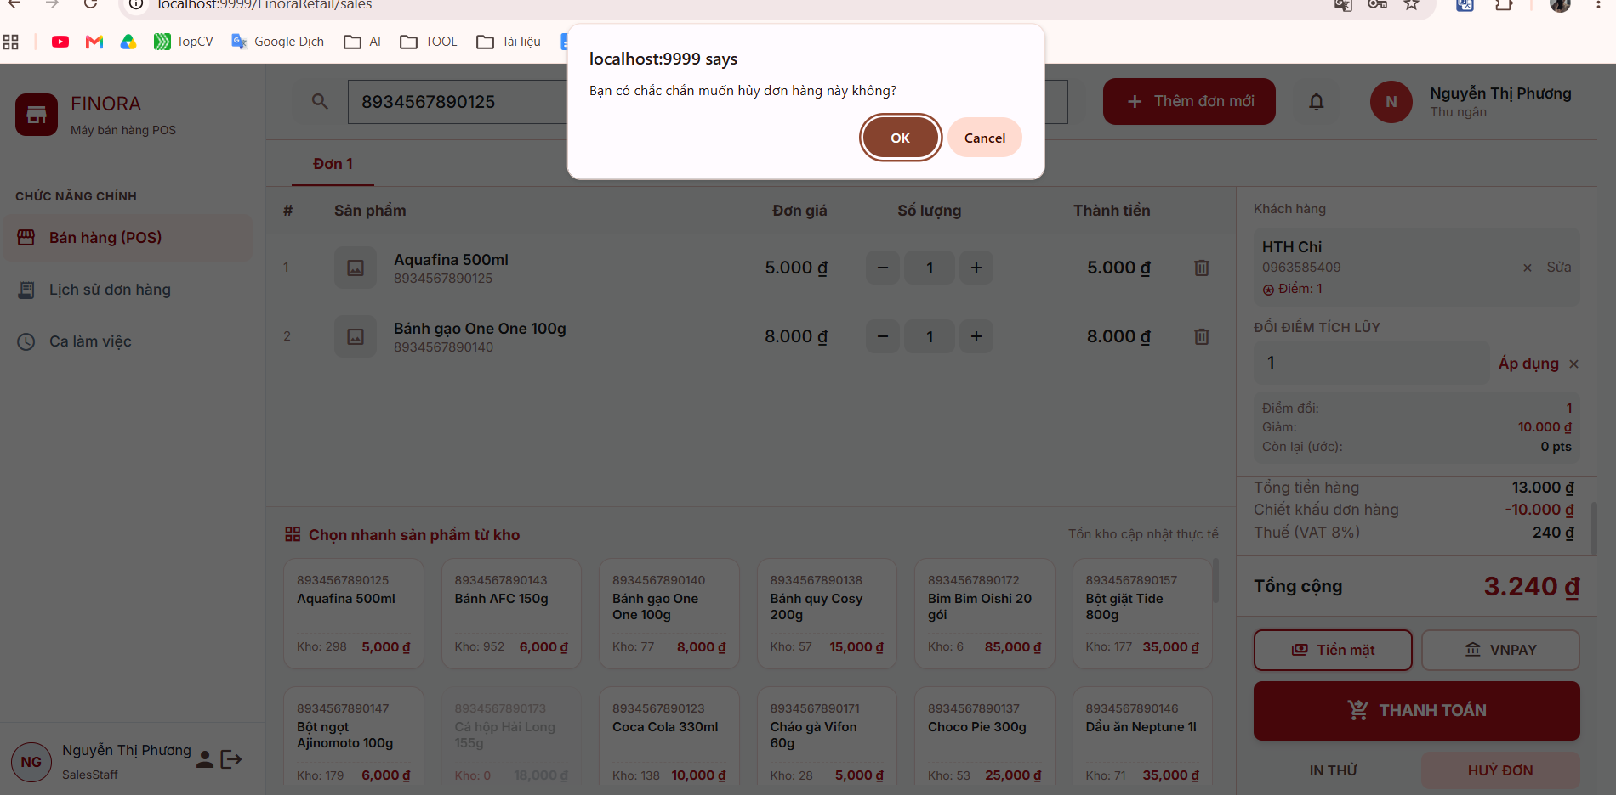
Field Name | Field Type | Description
Order Information
Order ID | Integer | Identifies the sales order to be cancelled.
Employee ID | Integer | Identifies the employee performing the cancellation.
Validation
Status | Enum | Validates that only completed orders can be cancelled.
Inventory Restoration
Product ID | Integer | Identifies the returned product.
Quantity | Integer | Quantity returned to inventory.
Warehouse ID | Integer | Warehouse receiving the returned stock.
Transaction Type | String | Indicates a refund inventory transaction.
Before Quantity | Integer | Stock quantity before the refund.
After Quantity | Integer | Stock quantity after the refund.
Loyalty Point Adjustment
Customer ID | Integer | Identifies the customer associated with the order.
Points Earned | Number | Loyalty points earned from the cancelled order.
Before Points | Number | Customer's loyalty points before the adjustment.
After Points | Number | Customer's loyalty points after the adjustment.
Audit Log
Action Name | String | Records the refund action.
Table Name | String | Records the affected table.
Record ID | Integer | Identifies the affected order.
Old Data | String | Stores the previous order status.
New Data | String | Stores the updated order status.
Result
New Status | Enum | Displays the updated order status after cancellation.

Database Access
Table | CRUD | Description
order | R, U | Retrieves sales order information and updates the order status to CANCELLED.
customer | R | Retrieves customer information associated with the order.
customer_point | R, U | Retrieves and updates customer loyalty points after order cancellation.
order_detail | R | Retrieves the list of products included in the cancelled order.
product | R | Retrieves product information for refund processing.
inventory | U | Restores product quantities to inventory.
stock_transaction | C | Records inventory refund transactions.
point_transaction | C | Records loyalty point adjustment transactions.
audit_log | C | Records the order cancellation activity for auditing purposes.

SQL Commands
1. Retrieve Order Information
SELECT o.*, c.full_name AS customerName, c.phone AS customerPhone,
cp.current_points AS customerPoints, e.fullName AS employeeName,
b.branch_name AS branchName
FROM [order] o
LEFT JOIN customer c
ON o.customer_id = c.cus_id
LEFT JOIN customer_point cp
ON c.cus_id = cp.cus_id
INNER JOIN employee e
ON o.emp_id = e.emp_id
INNER JOIN branch b
ON o.branch_id = b.branch_id
WHERE o.order_id = ?;
2. Retrieve Order Details
SELECT od.*, p.product_name, p.product_codebar
FROM order_detail od
INNER JOIN product p
ON od.product_id = p.product_id
WHERE od.order_id = ?;
3. Retrieve Inventory Quantity
SELECT quantity_in_stock
FROM inventory
WHERE product_id = ? AND warehouse_id = ?;
4. Restore Inventory
UPDATE inventory
SET quantity_in_stock = quantity_in_stock + ?,
updated_at = GETDATE()
WHERE warehouse_id = ? AND product_id = ?;
5. Create Stock Transaction
INSERT INTO stock_transaction
( warehouse_id, product_id, reference_type, reference_id, transaction_type, quantity,
before_quantity, after_quantity, note, created_by, created_at)
VALUES (?, ?, 'ORDER', ?, 'REFUND', ?, ?, ?, N'Hoàn trả đơn hàng', ?, GETDATE());
6. Retrieve Customer Points
SELECT cus_point_id, current_points
FROM customer_point
WHERE cus_id = ?;
7. Update Customer Points
UPDATE customer_point
SET current_points = current_points - ?,
lifetime_points = lifetime_points - ?,
updated_at = GETDATE()
WHERE cus_point_id = ?;
8. Create Point Transaction
INSERT INTO point_transaction
( cus_point_id, order_id, before_points, after_points, description, created_at)
VALUES (?, ?, ?, ?, N'Hoàn điểm hoàn trả đơn hàng', GETDATE());
9. Update Order Status
UPDATE [order]
SET status = 'CANCELLED'
WHERE order_id = ?;
10. Create Audit Log
INSERT INTO audit_log
( emp_id, action_name, table_name, record_id, old_data, new_data, created_at)
VALUES (?, 'REFUND', 'order', ?, ?, ?, GETDATE());

14.5 View Sales History
Allows authorized sales staff and managers to view sales order history. The system supports searching and filtering orders by keyword, status, payment method, and date range. It displays a paginated list of sales orders and allows users to view detailed order information, including customer details, purchased products, payment summary, employee, and branch information. Access to sales orders is controlled based on the user's role.
Related use case(s):
UC-4.8: View Sales History

UI Design

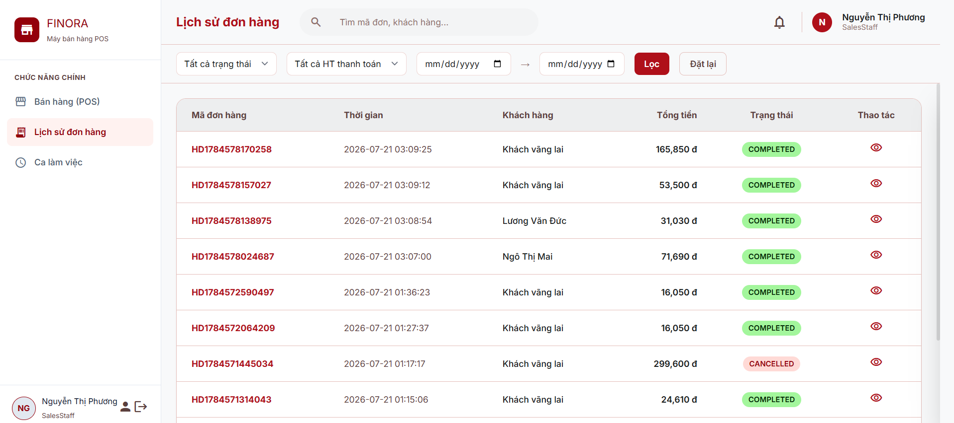

Field Name | Field Type | Description
Order Information
Order ID | Integer | Identifies the sales order.
Order Code | String | Displays the sales order code.
Order Type | String | Displays the order type.
Customer ID | Integer | Identifies the customer associated with the order.
Customer Name | String | Displays the customer name.
Customer Phone | String | Displays the customer's phone number.
Customer Points | Integer | Displays the customer's current loyalty points.
Branch ID | Integer | Identifies the branch where the order was created.
Branch Name | String | Displays the branch name.
Employee ID | Integer | Identifies the sales employee.
Employee Name | String | Displays the sales employee's name.
Warehouse ID | Integer | Identifies the warehouse associated with the order.
Subtotal | Currency | Displays the subtotal before discounts and taxes.
Discount Amount | Currency | Displays the discount amount.
Total Amount | Currency | Displays the final payable amount.
Payment Method | String | Displays the payment method.
Status | Enum | Displays the current order status.
Created At | DateTime | Displays the order creation date and time.
VAT Percentage | Percentage | Displays the applied VAT rate.
Search & Filter
Keyword | String | Searches orders by order code or customer name.
Status | Enum | Filters orders by status.
Payment Method | Enum | Filters orders by payment method.
Date From | Date | Filters orders from the selected date.
Date To | Date | Filters orders up to the selected date.
Page Number | Integer | Displays the current page number.
Page Size | Integer | Specifies the number of records displayed per page.
Total Orders | Integer | Displays the total number of matching orders.
Total Pages | Integer | Displays the total number of pages.
Order Details
Product ID | Integer | Identifies the product.
Product Name | String | Displays the product name.
Product Code | String | Displays the product code or barcode.
Quantity | Integer | Displays the purchased quantity.
Unit Price | Currency | Displays the unit price.
Total Price | Currency | Displays the total amount for the product.

Database Access
Table | CRUD | Description
order | R | Retrieves sales orders with pagination, sorting, and filtering by keyword, status, payment method, date range, branch, and employee.
customer | R | Retrieves customer information associated with each sales order.
customer_point | R | Retrieves the customer's current loyalty points for the order details.
employee | R | Retrieves the sales employee's information.
branch | R | Retrieves the branch information for each sales order.
order_detail | R | Retrieves the list of products included in the selected sales order.
product | R | Retrieves product information for each order item.
vat_setting | R | Retrieves the current VAT rate displayed in the order details.

SQL Commands
1. Count Sales Orders
SELECT COUNT(*) FROM [order] o
LEFT JOIN customer c
ON o.customer_id = c.cus_id
INNER JOIN employee e
ON o.emp_id = e.emp_id
INNER JOIN branch b
ON o.branch_id = b.branch_id
WHERE o.order_type = 'SALE';
2. Retrieve Sales Orders
SELECT o.*,
c.full_name AS customerName,
e.fullName AS employeeName,
b.branch_name AS branchName
FROM [order] o
LEFT JOIN customer c
ON o.customer_id = c.cus_id
INNER JOIN employee e
ON o.emp_id = e.emp_id
INNER JOIN branch b
ON o.branch_id = b.branch_id
WHERE o.order_type = 'SALE'
ORDER BY o.order_id DESC
OFFSET ? ROWS FETCH NEXT ? ROWS ONLY;
3. Retrieve Order Details
SELECT o.*,
c.full_name AS customerName,
c.phone AS customerPhone,
cp.current_points AS customerPoints,
e.fullName AS employeeName,
b.branch_name AS branchName
FROM [order] o
LEFT JOIN customer c
ON o.customer_id = c.cus_id
LEFT JOIN customer_point cp
ON c.cus_id = cp.cus_id
INNER JOIN employee e
ON o.emp_id = e.emp_id
INNER JOIN branch b
ON o.branch_id = b.branch_id
WHERE o.order_id = ?;
4. Retrieve Order Items
SELECT od.*, p.product_name, p.product_codebar
FROM order_detail od
INNER JOIN product p
ON od.product_id = p.product_id
WHERE od.order_id = ?;
5. Retrieve VAT Setting
SELECT TOP 1 vat_percentage
FROM vat_setting
ORDER BY setting_id DESC;

15. VNPay Payment Gateway
Integrates VNPay payment gateway for online order payment. The VNPay module supports creating payment requests, handling return callbacks, verifying digital signatures via HMAC-SHA512, and processing successful/failed transactions. All VNPay configuration parameters (TmnCode, HashSecret, PayUrl) are stored in server-side configuration.

15.1 Create Payment URL

a. Create Payment URL
Generates a VNPay payment URL and redirects the customer's browser to the VNPay sandbox/production gateway. The URL includes all required parameters (vnp_Version, vnp_TmnCode, vnp_Amount, vnp_TxnRef, vnp_OrderInfo, vnp_ReturnUrl, vnp_IpAddr, vnp_CreateDate, vnp_ExpireDate) and is secured with an HMAC-SHA512 signature.

UI Design

Field Name | Field Type | Description
Order Code | Hidden / URL Param | (vnp_TxnRef)
Trigger | Button | Customer clicks 'Thanh toán VNPay' on the order/checkout page
Redirect | Automatic | Browser redirected to VNPay payment gateway URL

Database Access
Table | CRUD | Description
[Order] | R | Retrieves order by order_code to get total_amount

Logic / Processing
1/ Build VNPay payment request parameters:
params = {
'vnp_Version': '2.1.0'
'vnp_Command': 'pay'
'vnp_TmnCode': 'FHVORUUC'
'vnp_Amount': String(amount * 100) -- Nhân 100 (VNPay yêu cầu)
'vnp_CurrCode': 'VND'
'vnp_TxnRef': orderCode
'vnp_OrderInfo': 'Thanh toan don hang ' + orderCode
'vnp_OrderType': 'other'
'vnp_Locale': 'vn'
'vnp_ReturnUrl': returnUrl
'vnp_IpAddr': clientIpAddress
'vnp_CreateDate': currentDateTime (yyyyMMddHHmmss)
'vnp_ExpireDate': currentDateTime + 15 phút
}

2/ Build hash data (sort params alphabetically, URL-encode values):
hashData = 'vnp_Amount=...&vnp_Command=pay&vnp_CreateDate=...&...'

3/ Generate secure hash (HMAC-SHA512):
secureHash = HMAC_SHA512(hashData, HASH_SECRET)

4/ Build final payment URL:
paymentUrl = PAY_URL + '?' + hashData + '&vnp_SecureHash=' + secureHash

5/ Redirect browser to paymentUrl

15.2 Return Handler

a. Return Handler (Callback)
Handles the return callback from VNPay after the customer completes payment on the VNPay gateway. Extracts all response parameters, verifies the HMAC-SHA512 signature to ensure data integrity, and processes the transaction result (success or failure).

UI Design

Database Access

Table | CRUD | Description
[Order] | U | Updates order status to COMPLETED (success) or CANCELLED/FAILED (failure)
payment | C | Creates payment record with VNPAY transaction details
customer_point | U | Awards loyalty points to customer on successful payment
inventory | U | Restores inventory quantities on failed/cancelled payment
voucher | U | Restores voucher usage count on failed/cancelled payment

Logic / Processing
1/ Extract all parameters from VNPay callback request:
Map<String, String> params = request.getParameterMap()

2/ Verify signature:
receivedHash = params['vnp_SecureHash']
params.remove('vnp_SecureHash')
params.remove('vnp_SecureHashType')
computedHash = HMAC_SHA512(buildHashData(params), HASH_SECRET)
isValid = computedHash.equalsIgnoreCase(receivedHash)

3/ Check transaction success:
isSuccess = isValid && vnp_ResponseCode == '00' && vnp_TransactionStatus == '00'

4/ Process success:
-- Update order status to COMPLETED
UPDATE [Order] SET status = 'COMPLETED' WHERE order_code = ?;
-- Insert payment record
INSERT INTO payment (order_id, payment_amount, payment_date, payment_status,
transaction_code, PaymentType, Description, payment_method)
VALUES (?, ?, GETDATE(), 'PAID', 'VNPAY-<TransactionNo>', 'INCOME',
'Thanh toán VNPAY đơn hàng <orderCode>', 'VNPAY');
-- Award loyalty points
UPDATE customer_point SET current_points = current_points + ? WHERE cus_id = ?;
5/ Process failure (vnp_ResponseCode = '24' = customer cancelled):
-- Update order status to CANCELLED
UPDATE [Order] SET status = 'CANCELLED' WHERE order_code = ?;
-- Restore inventory:
UPDATE inventory SET quantity_in_stock = quantity_in_stock + ?
WHERE warehouse_id = ? AND product_id = ?;
-- Restore voucher:
UPDATE voucher SET used_quantity = used_quantity - 1 WHERE voucher_id = ?;

15.3 Payment Result

a. Payment Result Display
Displays the VNPay payment result to the customer after the return callback has been processed. Shows success/failure status, order code, transaction amount, VNPay transaction number, and bank code. Result data is stored in HTTP session and cleaned after display to prevent duplicate processing.

UI Design

Field Name | Field Type | Description
Payment Status | Badge / Display | Success (green) or Failed (red)
Order Code | Display | (vnp_TxnRef)
Amount | Currency | pay amount (VND)
Transaction No | Display | VNPay (vnp_TransactionNo)
Bank Code | Display | (vnp_BankCode)
Message | Display | messes succes or fail

Database Access
Table | CRUD | Description
No direct DB access | -- | Reads result data from HTTP Session (set by Return Handler)

IV. Appendix

1. Assumptions & Dependencies

1.1 Assumptions
- AS-1: End-user browsers
The system is assumed to run on modern, popular web browsers that fully support HTML5 and CSS standards (such as Google Chrome and Microsoft Edge).
- AS-2: Staff proficiency and training
Store owners and employees are assumed to possess basic computer and web browser skills, as well as a fundamental understanding of retail business processes (such as stock procurement, inventory checks, and invoice issuance).
- AS-3: Availability of initial data
The store will provide complete information regarding product catalogs, supplier lists, existing customer data, and initial inventory figures in digital file formats (such as Excel or CSV) to facilitate initial data seeding into the DBFinoraV3 database.
- AS-4: Demo login and initial-stage security
The demo login mechanism within AuthController is assumed to be sufficient for testing business workflows during the initial acceptance phases. More advanced security mechanisms (such as BCrypt password encryption) will be implemented in subsequent versions.

1.2 Dependencies
- DE-1: Microsoft SQL Server Database Management System
The system relies entirely on the stable and continuous operation of Microsoft SQL Server, which hosts the DBFinoraV3 database. Any connectivity issues, misconfigured access credentials in `context.xml`, or schema changes made without synchronizing the DAO layer will disrupt the entire system.
- DE-2: Apache Tomcat 10.1 Web Server (Jakarta EE 10)
The application must be deployed on a Web Container that supports Jakarta EE 10, such as Apache Tomcat 10.1.x. It cannot run on older versions of Tomcat (e.g., Tomcat 9 or earlier) that utilize the legacy `javax.servlet` namespace.
- DE-3: Java Runtime Environment (JDK 17)
The application requires JDK 17 for compilation and execution. The runtime environment (JRE/JDK) on the Tomcat deployment server must be version 17 or higher to ensure class file compatibility.
- DE-4: Internet Connection and CDN (Content Delivery Network)
The system utilizes frontend libraries via CDNs, such as Bootstrap 5.3.0, jQuery 3.7.0, Google Material Icons, and Google Fonts (Inter/Manrope). Users' browsers require an active Internet connection to load these resources.
- DE-5: API and Third-Party Service Integration (if applicable)
When integrating electronic payment gateways (e.g., VNPAY) or email notification services, the system depends directly on the uptime and reliability of the respective providers' sandbox and production APIs.

2. Limitations & Exclusions
2.1. System Limitations (LI)
- LI-1: Offline Capability
The system operates entirely in a web-based environment and requires a continuous network connection to the Tomcat application server and SQL Server database. It does not support offline operations; if the network connection is lost, staff cannot process transactions or conduct sales at the counter.
- LI-2: Store Scale
The system is optimized for small-to-medium-sized store chains. Its current architecture is not optimized for real-time synchronization across large-scale retail chains comprising hundreds of branches with extremely high transaction volumes.
- LI-3: Concurrent User Limits
The system performs best with fewer than 100 concurrent users (concurrent sessions). Handling higher loads would require upgrading server hardware configurations and optimizing the database connection pool.
2.2. Exclusions (EX)
- EX-1: Automated Shipping Integration
The system does not have built-in API integration with third-party shipping providers. Delivery and shipping charges are handled manually or recorded as simple text information on the order.
- EX-2: Advanced Tax & Accounting
The system is not a professional accounting software. It only records basic cash flow and revenue (supporting financial accounting). Complex double-entry accounting, tax declarations, and fixed asset depreciation are outside the scope of this system.
- EX-3: Native Mobile Applications
The project does not develop native mobile applications for iOS and Android operating systems. The system only provides a responsive web interface compatible with the device's browser.
- EX-4: AI-based Supply Chain Automation
The system does not integrate machine learning or AI algorithms to automatically forecast customer purchasing demand and automatically generate purchase orders to send to suppliers. Purchasing is entirely based on actual inventory reports and manual decisions by the Owner.
- EX-5: Cryptocurrency Support
The system completely excludes support for cryptocurrency payments (Bitcoin, Ethereum, etc.). Supported payment methods include only cash, bank transfers, and common domestic e-wallets.

3. Business Rules

No. | Rule Code | Module / Rule Name | Business Rule Description
1 | BR-01 | System | All generated data (orders, intake vouchers, receipt/payment vouchers, etc.) must be associated with a store identifier (store_id).
2 | BR-02 | System | The system must implement Role-Based Access Control (RBAC).
3 | BR-03 | System | All user operations affecting system data (except customer point changes) must be recorded in the Activity Log.
4 | BR-04 | Data Integrity | Deleting data that has already generated actual transactions is not permitted.
5 | BR-05 | Account Constraint | Each user account can only be assigned exactly one role at any given time.
6 | BR-06 | Owner Privilege | The Chain Owner has the right to view and manage all data and financial reports across all branches without restriction.
7 | BR-07 | Store Manager Finance Restriction | Store Managers are permitted to create receipt/payment vouchers for their assigned branch but are not allowed to access or view Financial Reports (Financial module).
8 | BR-08 | Sales Scope | Sales Staff may only operate within the scope of their assigned store/branch.
9 | BR-09 | Inventory Limit | Sales quantities are not permitted to exceed the actual physical inventory quantity recorded in the system.
10 | BR-10 | Revenue Integrity | Sales Staff do not have the authority to modify revenue data after a transaction is finalized.
11 | BR-11 | Payment Gateway | VNPay transactions are only confirmed as successful upon receiving a valid Callback/Webhook from the payment gateway.
12 | BR-12 | Warehouse Intake | Warehouse intake vouchers must select an existing supplier from the system.
13 | BR-13 | Warehouse Transfer | When transferring stock, the source warehouse quantity must be greater than or equal to the requested transfer quantity.
14 | BR-14 | Inventory Audit | Inventory audit results only take effect for updating system stock after being approved by the Manager.
15 | BR-15 | Inventory Adjustment | When adjusting inventory, it is mandatory to record the specific reason, the performer, and the timestamp.
16 | BR-16 | Calculation Formula | Total Invoice = (Unit Price x Quantity) - Point Redemption Discount (if any) + Tax (if any).
17 | BR-17 | Point Calculation | Earned loyalty points are calculated based on a percentage of the actual payment value of the order.
18 | BR-18 | Encrypt Passwords | User passwords must be encrypted using BCrypt standard during storage and verification.
19 | BR-19 | Account Status | Users cannot log in if their account is in a locked/disabled state (INACTIVE/Locked).
20 | BR-20 | RBAC Permissions | The system determines the user's role upon login to display the corresponding authorized functional modules.
21 | BR-21 | Branch Identification | All login sessions must be associated with a specific store_id to filter data.
22 | BR-22 | Login Limits | Entering an incorrect password more than 5 consecutive times will automatically lock the account.
23 | BR-23 | Cancel Access | After logging out, all direct URL requests to access authenticated pages will be blocked and redirected to the Login page.
24 | BR-24 | POS Security | Sales Staff are strictly required to log out at the end of their shift to ensure revenue for the next shift is not misattributed.
25 | BR-25 | Auth Requirement | Password changes are strictly allowed only for authenticated active sessions.
26 | BR-26 | Old Password Verify | The entered old password must match the hashed password string stored in the database.
27 | BR-27 | BCrypt Standard | The new password must be hashed using the BCrypt algorithm (work factor 12) before being saved.
28 | BR-28 | Unique Credentials | Every employee account's email and phone number must be unique across the entire system.
29 | BR-29 | Password Delivery | Upon creating an employee or resetting a password, the system generates a random temporary password and sends it via email; the transaction is aborted if email sending fails.
30 | BR-30 | User Password Hashing | All user passwords must be hashed and verified using BCrypt.
31 | BR-31 | Branch Employee Isolation | Store Managers can only view and manage the employee list belonging to their assigned branch (branch_id).
32 | BR-32 | Account Lockout | Employees with a status other than ACTIVE will be denied authentication.
33 | BR-33 | Self-Profile Editable | Viewing one's own profile enables editing permissions for personal information.
34 | BR-34 | Viewed-Profile Read-Only | Management viewing another employee's profile is strictly in Read-Only mode.
35 | BR-35 | Sales Metrics Visibility | Sales performance metrics and order history are only displayed if the account holds the Sales Staff role.
36 | BR-36 | Avatar File Constraints | Profile avatar files must be in JPG, JPEG, PNG, or WEBP image formats.
37 | BR-37 | Branch Info Display | The system must display complete details: Branch Code, Name, Address, City, District, Phone, Email, Business Hours, and Status.
38 | BR-38 | Latest Branch Data | The system shall always display the latest branch information fetched from the database.
39 | BR-39 | Branch Code Unique | Each branch must have a unique Branch Code (branch_code) across the system.
40 | BR-40 | Branch Email Unique | Branch email addresses must be unique within the system.
41 | BR-41 | Branch Phone Unique | Branch phone numbers must be unique within the system.
42 | BR-42 | Required Branch Fields | Basic information fields are mandatory when creating or updating a branch.
43 | BR-43 | Business Hours Check | Branch Opening Time must be earlier than Closing Time.
44 | BR-44 | Auto Update Timestamp | The system shall automatically update the updated_at field whenever branch details are modified.
45 | BR-45 | Existing Branch Check | Update and delete operations are permitted only for existing branches in the system.
46 | BR-46 | Search Sorting Order | Customer search lookup results prioritize exact phone matches first, followed by partial phone matches, Name, Email, and Creation Date.
47 | BR-47 | Active Customer Filter | Only customer records with an ACTIVE status are eligible for lookup and checkout processing.
48 | BR-48 | Customer UI Restriction | The Customer Management UI is strictly restricted to Owner and Store Manager roles; Sales Staff can only perform lookups via the POS screen.
49 | BR-49 | Soft Deletion | Deleting a customer actually changes their status to INACTIVE (Soft Delete) to preserve historical transaction data.
50 | BR-50 | Point Calculation Formula | Earned Points = floor(Total Order Amount / Amount Per Point Setting).
51 | BR-51 | Point Balance Update | Successful point accumulation directly increments the customer's current points balance (current_points) (does not store lifetime points or write point activity logs).
52 | BR-52 | Redemption Limits | Redemption points must be greater than zero and cannot exceed the customer's available balance (current_points).
53 | BR-53 | Point Deduction | Point redemption directly deducts from the customer's current points balance (current_points).
54 | BR-54 | Sync Paid Orders | Manual point synchronization only calculates points for paid orders (PAID/COMPLETED).
55 | BR-55 | Product Existence | Products included in a POS sales order must exist in the system before checkout.
56 | BR-56 | Order Code Generation | The system automatically generates a unique Order Code for each sales transaction.
57 | BR-57 | VAT Calculation | VAT is automatically calculated based on the configured tax rate settings.
58 | BR-58 | Cash Payment Check | For cash payments, the amount received from the customer must be greater than or equal to the total payable amount.
59 | BR-59 | Immediate Stock Deduct | Inventory quantities are deducted immediately upon successful order checkout.
60 | BR-60 | Sales Transaction Integrity | Sales transactions must be processed as atomic transactions; if an error occurs at any step, the entire transaction is rolled back.
61 | BR-61 | Latest Sales Data | The system displays the latest order history data from the database.
62 | BR-62 | Sales Search | Supports searching sales order history by Order Code or Customer information.
63 | BR-63 | Detailed Order Display | The detailed order screen must display complete information: products, prices, discounts (from point redemption), taxes, payment method, and total amount.
64 | BR-64 | History Read-Only | Viewing sales history shall not modify any transaction data stored in the database.
65 | BR-65 | Invoice Completed Check | Only completed sales orders (COMPLETED) can be printed as invoices.
66 | BR-66 | Invoice Accuracy | Information printed on the invoice must accurately reflect the data stored in the system.
67 | BR-67 | Read-Only Printing | Printing an invoice shall not modify any order or transaction information.
68 | BR-68 | Invoice Reprint | Employees can reprint invoices multiple times without generating duplicate sales orders or transactions.
69 | BR-69 | Financial Data Association | All financial receipt/payment data must be associated with a branch identifier (store_id).
70 | BR-70 | Real-time Cashbook Balance | Sledgers and cash/bank balances must update instantly upon the generation of sales invoices or internal receipt/payment vouchers.

